UNITED STATES

SECURITIES AND EXCHANGE COMMISSION
Washington, D.C. 20549

Form 10-Q

(Mark One)

- QUARTERLY REPORT PURSUANT TO SECTION 13 OR 15(d) OF THE SECURITIES EXCHANGE ACT OF 1934 For the Quarterly Period Ended January 31, 2019
Or

- ]TRANSITION REPORT PURSUANT TO SECTION 13 OR 15(d) OF THE SECURITIES EXCHANGE ACT OF 1934

For the Transition Period From ___________ to ___________

Commission file number: 001-33417

OCEAN POWER TECHNOLOGIES, INC.

(Exact Name of Registrant as Specified in Its Charter)

Delaware | 22-2535818
(State or Other Jurisdiction of | (I.R.S. Employer
Incorporation or Organization) | Identification No.)

28 ENGELHARD DRIVE, SUITE B, MONROE TOWNSHIP, NJ 08831

(Address of Principal Executive Offices, Including Zip Code)

(609) 730-0400

(Registrant’s Telephone Number, Including Area Code)

Indicate by check mark whether the registrant (1) has filed all reports required to be filed by Section 13 or 15(d) of the Securities Exchange Act of 1934 during the preceding 12 months (or for such shorter period that the registrant was required to file such reports), and (2) has been subject to such filing requirements for the past 90 days. Yes [X] No [ ]

Indicate by check mark whether the registrant has submitted electronically every Interactive Data File required to be submitted pursuant to Rule 405 of Regulation S-T (§232.405 of this chapter) during the preceding 12 months (or for such shorter period that the registrant was required to submit such files). Yes [X] No [ ]

Indicate by check mark whether the registrant is a large accelerated filer, an accelerated filer, a non-accelerated filer, a smaller reporting company or an emerging growth company. See the definitions of “large accelerated filer,” “accelerated filer,” “smaller reporting company” and “emerging growth company” in Rule 12b-2 of the Exchange Act. (Check one):

Large accelerated filer [ ]

Accelerated filer [ ]

Non-accelerated filer [ ] (Do not check if a smaller reporting company)

Smaller reporting company [X]

Emerging growth company [ ]

Indicate by check mark whether the registrant is a shell company (as defined in Rule 12b-2 of the Exchange Act). Yes [ ] No [X]

If an emerging growth company, indicate by check mark if the registrant has elected not to use the extended transition period for complying with any new or revised financial accounting standards provided pursuant to Section 13(a) of the Exchange Act. [ ]

As of March 5, 2019, the number of outstanding shares of common stock of the registrant was 22,726,006.

OCEAN POWER TECHNOLOGIES, INC.

INDEX TO FORM 10-Q

 |  |  |  |  |  |  |  |  |  |  |  |  |  |  |  |  |  |  |  |  | Page
 |  |  |  |  |  |  |  |  |  |  |  |  |  |  |  |  |  |  |  |  | Number
 | PART I — FINANCIAL INFORMATION
 | Item 1. Financial Statements: |  |  |  |  |  |  |  |  |  |  |  |  |  |  |  |  |  |  |  | 2
 |  |  | Consolidated Balance Sheets as of January 31, 2019 (unaudited) and April 30, 2018 |  |  |  |  |  |  |  |  |  |  |  |  |  |  |  |  |  | 2
 |  |  | Unaudited Consolidated Statements of Operations for the three months and nine months ended January 31, 2019 and 2018 |  |  |  |  |  |  |  |  |  |  |  |  |  |  |  |  |  | 3
 |  |  | Unaudited Consolidated Statements of Comprehensive Loss for the three and nine months ended January 31, 2019 and 2018 |  |  |  |  |  |  |  |  |  |  |  |  |  |  |  |  |  | 4
 |  |  | Unaudited Consolidated Statement of Stockholders’ Equity for the nine months ended January 31, 2019 |  |  |  |  |  |  |  |  |  |  |  |  |  |  |  |  |  | 5
 |  |  | Unaudited Consolidated Statements of Cash Flows for the nine months ended January 31, 2019 and 2018 |  |  |  |  |  |  |  |  |  |  |  |  |  |  |  |  |  | 6
 |  |  | Notes to Unaudited Consolidated Financial Statements |  |  |  |  |  |  |  |  |  |  |  |  |  |  |  |  |  | 7
 |  | Item 2. Management’s Discussion and Analysis of Financial Condition and Results of Operations |  |  |  |  |  |  |  |  |  |  |  |  |  |  |  |  |  |  | 26
 |  | Item 3. Quantitative and Qualitative Disclosures About Market Risk |  |  |  |  |  |  |  |  |  |  |  |  |  |  |  |  |  |  | 41
 |  | Item 4. Controls and Procedures |  |  |  |  |  |  |  |  |  |  |  |  |  |  |  |  |  |  | 42
 | PART II — OTHER INFORMATION
 |  | Item 1. Legal Proceedings |  |  |  |  |  |  |  |  |  |  |  |  |  |  |  |  |  |  | 43
 | Item 1A. Risk Factors |  |  |  |  |  |  |  |  |  |  |  |  |  |  |  |  |  |  |  | 45
 |  | Item 2. Unregistered Sales of Equity Securities and Use of Proceeds |  |  |  |  |  |  |  |  |  |  |  |  |  |  |  |  |  |  | 47
 | Item 3. Defaults Upon Senior Securities |  |  |  |  |  |  |  |  |  |  |  |  |  |  |  |  |  |  |  | 47
 |  | Item 4. Mine Safety Disclosures |  |  |  |  |  |  |  |  |  |  |  |  |  |  |  |  |  |  | 47
 | Item 5. Other Information |  |  |  |  |  |  |  |  |  |  |  |  |  |  |  |  |  |  |  | 47
 | Item 6. Exhibits |  |  |  |  |  |  |  |  |  |  |  |  |  |  |  |  |  |  |  | 48

PowerBuoy® and the Ocean Power Technologies logo are trademarks of Ocean Power Technologies, Inc. All other trademarks appearing in this report are the property of their respective holders.

Special Note Regarding Forward-Looking Statements

We have made statements in this Quarterly Report on Form 10-Q that are forward-looking statements within the meaning of the Private Securities Litigation Reform Act of 1995. Forward-looking statements convey our current expectations or forecasts of future events. Forward-looking statements include statements regarding our future financial position, business strategy, pending, threatened, and current litigation, liquidity, budgets, projected costs, plans and objectives of management for future operations. The words “may,” “continue,” “estimate,” “intend,” “plan,” “will,” “believe,” “project,” “expect,” “anticipate”, and similar expressions may identify forward-looking statements, but the absence of these words does not necessarily mean that a statement is not forward-looking.

The forward-looking statements contained in or incorporated by reference are largely based on our expectations, which reflect estimates and assumptions made by our management. These estimates and assumptions reflect our best judgment based on currently known market conditions and other factors. Although we believe such estimates and assumptions to be reasonable, they are inherently uncertain and involve a number of risks and uncertainties that are beyond our control, including:

- our ability to commercialize our PowerBuoys®, and achieve and sustain profitability;

- our continued development of our proprietary technologies, and expected continued use of cash from operating activities unless or until we achieve positive cash flow from the commercialization of our products and services;

- our ability to obtain additional funding, as and if needed which will be subject to a number of factors, including market conditions, and our operating performance;

- our estimates regarding expenses, future revenues and capital requirements;

- the adequacy of our cash balances and our need for additional financings;

- our ability to develop and manufacture a commercially viable PowerBuoy® product;

- our ability to successfully develop and market new products, such as a hybrid PowerBuoy® or subsea battery solutions;

- that we will be successful in our efforts to commercialize our PowerBuoy® or the timetable upon which commercialization can be achieved, if at all;

- our ability to identify and penetrate markets for our PowerBuoys® and our wave energy technology;

- the reliability of our technology and our PowerBuoys®;

- the power output, survivability and reliability of our PowerBuoys®;

- our ability to implement our commercialization strategy as planned, or at all;

- our relationships with our strategic partners may not be successful and we may not be successful in establishing additional relationships;

- our ability to maintain the listing of our common stock on the NASDAQ Capital Market;

- our ability to raise capital through our current equity facilities;

- the impact of pending and threatened litigation on our business, financial condition and liquidity;

- changes in current legislation, regulations and economic conditions that affect the demand for renewable energy;

- our ability to compete effectively in our target markets;

- our limited operating history and history of operating losses;

- our sales and marketing capabilities and strategy in the United States and internationally; and

- our ability to protect our intellectual property portfolio.

Any or all of our forward-looking statements in this report may turn out to be inaccurate. We have based these forward-looking statements largely on our current expectations and projections about future events and financial trends that we believe may affect our financial condition, results of operations, business strategy and financial needs. They may be affected by inaccurate assumptions we might make or unknown risks and uncertainties, including the risks, uncertainties and assumptions described in Item 1A “Risk Factors” of our Annual Report on Form 10-K for the year ended April 30, 2018, and in our subsequent reports under the Exchange Act. In light of these risks, uncertainties and assumptions, the forward-looking events and circumstances discussed in this report may not occur as contemplated and actual results could differ materially from those anticipated or implied by the forward-looking statements.

Many of these factors are beyond our ability to control or predict. These factors are not intended to represent a complete list of the general or specific factors that may affect us. You should not unduly rely on these forward-looking statements, which speak only as of the date of this filing. Unless required by law, we undertake no obligation to publicly update or revise any forward-looking statements to reflect new information or future events or otherwise.

1

PART I — FINANCIAL INFORMATION
Item 1. Financial Statements
Ocean Power Technologies, Inc. and Subsidiaries
Consolidated Balance Sheets
(in thousands, except share data)
 |  | January 31, 2019 |  |  |  | April 30, 2018
 |  | (Unaudited)
ASSETS
Current assets:
Cash and cash equivalents | $ | 2,220 |  | $ |  | 11,499
Marketable securities |  | - |  |  |  | 25
Restricted cash- short-term |  | 353 |  |  |  | 572
Accounts receivable |  | 66 |  |  |  | 171
Unbilled receivables |  | - |  |  |  | 71
Contract assets |  | 85 |  |  |  | -
Litigation receivable |  | - |  |  |  | 350
Other current assets |  | 1,066 |  |  |  | 567
Total current assets |  | 3,790 |  |  |  | 13,255
Property and equipment, net |  | 632 |  |  |  | 712
Restricted cash- long-term |  | 155 |  |  |  | 154
Total assets | $ | 4,577 |  |  | $ | 14,121
LIABILITIES AND STOCKHOLDERS’ EQUITY
Current liabilities:
Accounts payable | $ | 173 |  | $ |  | 290
Accrued expenses |  | 2,533 |  |  |  | 2,261
Litigation payable |  | - |  |  |  | 350
Unearned revenue |  | - |  |  |  | 18
Contract liabilities |  | 256 |  |  |  | -
Warrant liabilities |  | 18 |  |  |  | 201
Current portion of capital lease obligations |  | 1 |  |  |  | 23
Deferred credits payable current |  | - |  |  |  | 600
Total current liabilities |  | 2,981 |  |  |  | 3,743
Deferred rent |  | 147 |  |  |  | 142
Total liabilities |  | 3,128 |  |  |  | 3,885
Commitments and contingencies
Ocean Power Technologies, Inc. stockholders’ equity:
Preferred stock, $0.001 par value; authorized 5,000,000 shares, none issued or outstanding |  | - |  |  |  | -
Common stock, $0.001 par value; authorized 100,000,000 shares, issued 20,390,109 and
18,424,939 shares, respectively |  | 20 |  |  |  | 18
Treasury stock, at cost; 75,782 and 74,012 shares, respectively |  | (301) |  |  |  | (300)
Additional paid-in capital |  | 209,173 |  |  |  | 208,216
Accumulated deficit |  | (207,279) |  |  |  | (197,538)
Accumulated other comprehensive loss |  | (164) |  |  |  | (160)
Total stockholders’ equity |  | 1,449 |  |  |  | 10,236
Total liabilities and stockholders’ equity | $ | 4,577 |  |  | $ | 14,121

See accompanying notes to unaudited consolidated financial statements.

2

Ocean Power Technologies, Inc. and Subsidiaries

Unaudited Consolidated Statements of Operations

(in thousands, except per share data)

(Unaudited)

 |  |  | Three months ended January 31, |  |  |  |  |  |  | Nine months ended January 31,
 |  |  | 2019 |  |  | 2018 |  |  |  | 2019 |  |  |  | 2018
 | Revenues | $ | 268 |  | $ | - |  | $ |  | 440 |  | $ |  | 289
 | Cost of revenues |  | 400 |  |  | - |  |  |  | 1,180 |  |  |  | 193
 | Gross profit/(loss) |  | (132 | ) |  | - |  |  |  | (740 | ) |  |  | 96
 | Operating expenses:
 | Engineering and product development costs |  | 1,382 |  |  | 1,318 |  |  |  | 4,105 |  |  |  | 3,398
 | Selling, general and administrative costs |  | 2,008 |  |  | 1,576 |  |  |  | 5,909 |  |  |  | 4,964
 | Total operating expenses |  | 3,390 |  |  | 2,894 |  |  |  | 10,014 |  |  |  | 8,362
 | Operating loss |  | (3,522) |  |  | (2,894) |  |  |  | (10,754) |  |  |  | (8,266)
 | Gain due to the change in fair value of warrant
 | liabilities |  | 47 |  |  | 14 |  |  |  | 183 |  |  |  | 82
 | Interest income, net |  | 2 |  |  | 42 |  |  |  | 23 |  |  |  | 51
 | Other income |  | - |  |  | 4 |  |  |  | - |  |  |  | 4
 | Foreign exchange gain/(loss) |  | 12 |  |  | 52 |  |  |  | (43) |  |  |  | 107
 | Loss before income taxes |  | (3,461) |  |  | (2,782) |  |  |  | (10,591) |  |  |  | (8,022)
 | Income tax benefit |  | 850 |  |  | 1,119 |  |  |  | 850 |  |  |  | 1,119
 | Net loss | $ | (2,611 | ) | $ | (1,663 | ) |  | $ | (9,741 | ) |  | $ | (6,903 | )
 | Basic and diluted net loss per share |  |  | ) |  |  | ) |  |  |  | ) |  |  |  | )
 | Basic and diluted net loss per share | $ | (0.14 | ) | $ | (0.09 | ) |  | $ | (0.52 | ) |  | $ | (0.48 | )
 | Weighted average shares used to compute basic and
 | diluted net loss per share |  | 19,185,741 |  |  | 18,150,494 |  |  |  | 18,621,033 |  |  |  | 14,441,383

See accompanying notes to unaudited consolidated financial statements.

3

Ocean Power Technologies, Inc. and Subsidiaries

Unaudited Consolidated Statements of Comprehensive Loss

(in thousands)

(Unaudited)

 |  | Three months ended January 31, |  |  |  |  |  |  |  | Nine months ended January 31,
 |  | 2019 |  |  |  | 2018 |  |  |  | 2019 |  |  |  | 2018
 | Net loss | $ | (2,611) |  | $ | (1,663) |  | $ |  | (9,741) |  | $ |  | (6,903)
 | Foreign currency translation adjustment |  | 1 |  |  | 11 |  |  |  | (4) |  |  |  | 19
 | Total comprehensive loss | $ | (2,610 | ) | $ | (1,652 | ) |  | $ | (9,745 | ) |  | $ | (6,884 | )

See accompanying notes to unaudited consolidated financial statements.

4

Ocean Power Technologies, Inc. and Subsidiaries

Unaudited Consolidated Statement of Stockholders’ Equity

(in thousands, except per share data)

 |  |  |  |  |  |  |  |  |  |  |  |  |  |  |  |  |  |  |  |  |  | Accumulated
 |  | Common Shares |  |  |  |  | Treasury Shares |  |  |  |  |  | Additional |  |  |  |  |  |  |  |  |  | Other |  |  | Total
 |  |  |  |  |  |  |  |  |  |  |  |  |  |  | Paid-In |  | Accumulated |  |  |  | Comprehensive |  |  |  | Stockholders’
 |  | Shares |  | Amount |  |  | Shares |  | Amount |  |  |  |  |  | Capital |  |  |  | Deficit |  |  |  | Loss |  |  | Equity
 | Balances, April 30, 2018 | 18,424,939 |  | $ | 18 |  | (74,012) |  | $ |  | (300) |  | $ |  | 208,216 |  | $ |  | (197,538) |  | $ |  | (160) |  | $ | 10,236
 | Net loss |  |  |  |  |  |  |  |  |  |  |  |  |  |  |  |  |  | (9,741) |  |  |  |  |  |  | (9,741)
 | Stock based compensation |  |  |  |  |  |  |  |  |  |  |  |  |  | 200 |  |  |  |  |  |  |  |  |  |  | 200
 | Issuance of restricted stock, net | (82,939) |  |  | - |  |  |  |  |  |  |  |  |  | - |  |  |  |  |  |  |  |  |  |  | -
 | Sale of stock, net of financing costs | 1,619,538 |  |  | 2 |  |  |  |  |  |  |  |  |  | 462 |  |  |  |  |  |  |  |  |  |  | 464
 | Common stock issued for commitment fee | 428,571 |  |  | - |  |  |  |  |  |  |  |  |  | 295 |  |  |  |  |  |  |  |  |  |  | 295
 | Acquisition of treasury stock |  |  |  |  |  | (1,770) |  |  |  | (1) |  |  |  |  |  |  |  |  |  |  |  |  |  |  | (1)
 | Other comprehensive loss |  |  |  |  |  |  |  |  |  |  |  |  |  |  |  |  |  |  |  |  |  | (4) |  |  | (4)
 | Balances, January 31, 2019 |  |  |  |  |  |  | ) |  |  |  | ) |  |  |  |  |  |  |  | ) |  |  |  | )
 | Balances, January 31, 2019 | 20,390,109 |  | $ | 20 |  | (75,782 | ) |  | $ | (301 | ) | $ |  | 209,173 |  | $ |  | (207,279 | ) | $ |  | (164 | ) | $ | 1,449

See accompanying notes to unaudited consolidated financial statements.

5

 | Ocean Power Technologies, Inc. and Subsidiaries
 | Unaudited Consolidated Statements of Cash Flows
 | (in thousands)
 | (Unaudited)
 |  | Nine months ended January 31,
 |  | 2019 |  |  | 2018
 | Cash flows from operating activities:
 | Net loss | $ | (9,741) |  | $ |  | (6,903)
 | Adjustments to reconcile net loss to net cash used in operating activities:
 | Foreign exchange loss/(gain) |  | 43 |  |  |  | (107)
 | Depreciation |  | 135 |  |  |  | 79
 | Loss on disposal of property, plant and equipment |  | - |  |  |  | 5
 | Compensation expense related to stock option grants and restricted stock |  | 200 |  |  |  | 250
 | Gain due to the change in fair value of warrant liabilities |  | (183) |  |  |  | (82)
 | Changes in operating assets and liabilities:
 | Accounts receivable |  | 105 |  |  |  | 48
 | Unbilled receivables |  | 71 |  |  |  | 294
 | Contract assets |  | (85) |  |  |  | -
 | Other assets |  | (203) |  |  |  | (8)
 | Accounts payable |  | (116) |  |  |  | (356)
 | Accrued expenses |  | 281 |  |  |  | (1,399)
 | Deferred rent |  | 5 |  |  |  | 2
 | Deferred credit payable |  | (600) |  |  |  | -
 | Unearned revenue |  | (18) |  |  |  | -
 | Contract liabilities |  | 256 |  |  |  | -
 | Net cash used in operating activities |  | (9,850 | ) |  |  | (8,177 | )
 | Cash flows from investing activities:
 | Purchases of marketable securities |  | (25) |  |  |  | (25)
 | Maturities of marketable securities |  | 50 |  |  |  | 25
 | Leasehold improvements and purchase of equipment |  | (54) |  |  |  | (554)
 | Net cash used in investing activities |  | (29 | ) |  |  | (554 | )
 | Cash flows from financing activities:
 | Proceeds from issuance of common stock, net of costs |  | 464 |  |  |  | 14,647
 | Payment of capital lease obligations |  | (23) |  |  |  | (26)
 | Acquisition of treasury stock |  | (1) |  |  |  | (37)
 | Net cash provided by financing activities |  | 440 |  |  |  | 14,584
 | Effect of exchange rate changes on cash, cash equivalents and restricted cash |  | (58 | ) |  |  | 143
 | Net (decrease)/increase in cash, cash equivalents and restricted cash |  | (9,497) |  |  |  | 5,996
 | Cash, cash equivalents and restricted cash, beginning of period |  | 12,225 |  |  |  | 8,909
 | Cash, cash equivalents and restricted cash, end of period | $ | 2,728 |  |  | $ | 14,905
 | Supplemental schedule of cash flows information:
 | Cash paid for interest | $ | 1 |  | $ |  | 3
 | Supplemental disclosure of noncash investing activities:
 | Acquisition of leasehold improvements and equipment through accounts payable | $ | - |  | $ |  | 3
 | Acquisition of leasehold improvements and equipment through accrued expenses |  | - |  |  |  | 13
 | Supplemental disclosure of noncash financing activities:
 | Common stock issued for payment of commitment fee | $ | 295 |  | $ |  | -

See accompanying notes to unaudited consolidated financial statements.

6

Ocean Power Technologies, Inc. and Subsidiaries

Notes to Unaudited Consolidated Financial Statements

(1) Background, Basis of Presentation and Liquidity

- Background

Ocean Power Technologies, Inc. (the “Company”) was founded in 1984 in New Jersey, commenced business operations in 1994 and re-incorporated in Delaware in 2007. The Company is developing and commercializing its proprietary systems that generate electricity by harnessing the renewable energy of ocean waves. The Company uses proprietary technologies that convert the mechanical energy created by the heaving motion of ocean waves into electricity. The Company has designed and continues to develop the PowerBuoy® product line which is based on modular, ocean-going buoys, which the Company has been periodically ocean testing since 1997. The Company markets its PowerBuoys® in the United States and internationally. Since fiscal 2002, government agencies have accounted for a significant portion of the Company’s revenues. These revenues were largely for the support of product development efforts relating to our technology. Today our goal is to generate the majority our revenue from the sale or lease of products, and sales of services to support our business operations. As we continue to develop and commercialize our products and services, we expect to have a net loss of cash from operating activities unless and until we achieve positive cash flow from the commercialization of products and services.

- Basis of Presentation

The accompanying unaudited consolidated financial statements have been prepared in accordance with generally accepted accounting principles (“GAAP”) for interim financial information and with the instructions to Form 10-Q and Article 10 of Regulation S-X. Accordingly, they do not include all the information and footnotes required by generally accepted accounting principles for complete financial statements. In the opinion of management, all adjustments (consisting of normal recurring adjustments) considered necessary for a fair presentation have been included. The interim operating results are not necessarily indicative of the results for a full year or for any other interim period. Further information on potential factors that could affect the Company’s financial results can be found in the Company’s Annual Report on Form 10-K for the year ended April 30, 2018 filed with the Securities and Exchange Commission (“SEC”) and elsewhere in this Form 10-Q.

- Liquidity/Going Concern

The consolidated financial statements have been prepared assuming the Company will continue as a going concern. The Company has experienced substantial and recurring losses from operations, which have contributed to an accumulated deficit of $207.3 million as of January 31, 2019. As of January 31, 2019, the Company had approximately $2.7 million in cash, cash equivalents, and restricted cash on hand. The Company generated revenues of $0.4 and $0.3 million during each of the nine months ended January 31, 2019 and 2018. Based on the Company’s cash, cash equivalents and restricted cash balances as of January 31, 2019, the Company believes that it will be able to finance its capital requirements and operations into the quarter ending April 30, 2019. In August 2018, the Company entered into a common stock purchase agreement with Aspire Capital Fund, LLC. As of January 31, 2019, the Company has sold 800,000 shares of common stock with an aggregate market value of $301,000 at an average price of $0.38 per share pursuant to this common stock purchase agreement. In January 2019, the Company entered into an At the Market Offering Agreement with A.G.P./Alliance Global Partners. Under the 2019 ATM Facility, during the month of January 2019, the Company issued and sold 819,538 shares of its common stock with an aggregate market value of $273,735 at an average price of $0.33 per share and paid AGP a sales commission of approximately $8,900 related to those shares. Among other things, the Company is currently evaluating a variety of different financing alternatives and we expect to continue to fund our business with sales of our securities and through generating revenue with customers. The Company will require additional equity and/or debt financing to continue its operations into Fiscal Year 2020. The Company cannot provide assurances that it will be able to secure additional funding when needed or at all, or, if secured, that such funding would be on favorable terms. These factors raise substantial doubt about the Company’s ability to continue as a going concern.

The consolidated financial statements have been prepared on a going concern basis, which contemplates the realization of assets and satisfaction of liabilities in the normal course of business. The consolidated financial statements do not include any adjustments relating to the recoverability and classification of recorded assets amounts or the amounts and classification of liabilities that might result from the outcome of this uncertainty.

Management is evaluating different strategies to obtain the required additional funding for future operations. These strategies may include, but are not limited to, continued pursuit of business opportunities, additional funding from current and /or new investors, officers and directors; borrowings of debt; a public offering of the Company’s equity or debt securities; partnerships and/or collaborations. There can be no assurance that any of these future-funding efforts will be successful.

7

In fiscal 2018 and during the nine months ended January 31, 2019, the Company has continued to make investments in ongoing product development efforts in anticipation of future growth. The Company’s future results of operations involve significant risks and uncertainties. Factors that could affect the Company’s future operating results and cause actual results to vary materially from expectations include, but are not limited to, risks from lack of available financing and insufficient capital, performance of PowerBuoys®, its inability to market and commercialize its PowerBuoys® and new products that it may develop, technology development, scalability of technology and production, dependence on skills of key personnel, concentration of customers and suppliers, deployment risks and laws, regulations and permitting. In order to continue to implement its business strategy, the Company requires additional equity and/or debt financing. The Company currently has committed sources of equity financing through its common stock purchase agreement with Aspire Capital and At the Market Offering Agreement with Alliance Global Partners (discussed further below), but the Company cannot assure that additional equity and/or debt financing will be available to the Company as needed on acceptable terms, or at all. Historically, the Company has raised capital through securities sales in the public capital markets. If sufficient additional financing is not obtained when needed, the Company may be required to further curtail or limit operations, product development costs, and/or selling, general and administrative activities in order to reduce its cash expenditures. This could cause the Company to be unable to execute its business plan, take advantage of future opportunities and may cause it to scale back, delay or eliminate some or all of its product development activities and/or reduce the scope of or cease its operations.

On May 2, 2017, the Company sold 6,192,750 shares of common stock at a price of $1.30 per share, which includes the sale of 807,750 shares of the Company’s common stock sold by the Company pursuant to the exercise, in full, of the over-allotment option by the underwriters in a public offering. The net proceeds to the Company from the offering were approximately $7.2 million, after deducting underwriter fees and offering expenses payable by the Company.

On October 23, 2017, the Company sold 5,739,437 shares of common stock at a price of $1.42 per share in a best efforts public offering. The net proceeds to the Company from the offering were approximately $7.4 million, after deducting placement fees and offering expenses payable by the Company.

On August 13, 2018, the Company entered into a common stock purchase agreement with Aspire Capital Fund, LLC (“Aspire Capital”) which provides that, subject to certain terms, conditions and limitations, Aspire Capital is committed to purchase up to an aggregate of $10.0 million of shares of the Company’s common stock over a 30-month period. In consideration for entering into the agreement, the Company issued to Aspire Capital 428,571 shares of our common stock as a commitment fee. As of January 31, 2019, the Company has sold 800,000 shares of common stock with an aggregate market value of $301,000 at an average price of $0.38 per share pursuant to this common stock purchase agreement.

On January 7, 2019, the Company entered into an At the Market Offering Agreement (“2019 ATM Facility”) with A.G.P./Alliance Global Partners (“AGP”), under which the Company may issue and sell to or through A.G.P./Alliance Global Partners, acting as agent and/or principal, shares of the Company’s common stock having an aggregate offering price of up to $25 million. Under the 2019 ATM Facility, during the month of January 2019, the Company issued and sold 819,538 shares of its common stock with an aggregate market value of $273,735 at an average price of $0.33 per share and paid AGP a sales commission of approximately $8,900 related to those shares.

The sale of additional equity or convertible securities could result in dilution to stockholders. If additional funds are raised through the issuance of debt securities, these securities could have rights senior to those associated with the Company’s common stock and could contain covenants that would restrict its operations. Financing may not be available in amounts or on terms acceptable to the Company, or at all. If the Company is unable to obtain required financing, it may be required to reduce the scope of its operations, including its planned product development and marketing efforts, which could materially and adversely harm its financial condition and operating results. If the Company is unable to secure additional financing, it may be forced to cease operations.

On August 9, 2018, the Company received a notification from the NASDAQ Stock Market (the “NASDAQ”) indicating that the minimum bid price of the Company’s common stock has been below $1.00 per share for 30 consecutive business days and as a result, the Company is not in compliance with the minimum bid price requirement for continued listing. The NASDAQ notice has no immediate effect on the listing or trading of the Company’s common stock. Under the NASDAQ Listing Rules, the Company has a grace period of 180 calendar days, or until February 5, 2019, in which to regain compliance with the minimum bid price rule. To regain compliance, the closing bid price of the Company’s common stock must meet or exceed $1.00 per share for a minimum of ten consecutive business days during this grace period.

8

On February 11, 2019, the Company received another written notice from the Listing Qualifications department of NASDAQ notifying the Company that it had not regained compliance with the minimum bid price requirement and that the Company’s stockholders’ equity as reported in the Company’s Quarterly Report on Form 10-Q for the quarter ended October 31, 2018 does not qualify the Company for an additional 180 calendar day extension period for compliance. On February 19, 2019, the Company submitted a letter to appeal the determination to a Hearings Panel (the “Panel”), pursuant to the procedures set forth in the NASDAQ Listing Rule 5800 Series. Such hearing request will stay the suspension of the Company’s securities pending the Panel’s decision, during which time the Company’s common stock will continue to be listed on NASDAQ, and the Company’s common stock will continue to trade under the symbol “OPTT”. The Company’s receipt of the notice does not affect the Company’s business, operations or reporting requirements with the SEC.

If our common stock is delisted from NASDAQ, our ability to raise capital through public offerings of our securities and to finance our operations could be adversely affected. See additional risk factors under “Part II, Item 1A – Risk Factors”. We also believe that delisting would likely result in decreased liquidity and/or increased volatility in our common stock and could harm our business and future prospects. In addition, we believe that, if our common stock is delisted, our stockholders would likely find it more difficult to obtain accurate quotations as to the price of the common stock and it may be more difficult for stockholders to buy or sell our common stock at competitive market prices, or at all.

(2) Summary of Significant Accounting Policies

(a) Consolidation

The accompanying consolidated financial statements include the accounts of the Company and its majority-owned subsidiaries. All significant intercompany balances and transactions have been eliminated in consolidation.

(b) Use of Estimates

The preparation of the consolidated financial statements requires management of the Company to make a number of estimates and assumptions relating to the reported amounts of assets and liabilities and the disclosure of contingent assets and liabilities at the date of the consolidated financial statements and the reported amounts of revenues and expenses during the period. Significant items subject to such estimates and assumptions include the fair value of warrant liabilities, estimated costs to complete projects; and percentage of completion of customer contracts for purposes of revenue recognition. Actual results could differ from those estimates. The current economic environment, particularly the macroeconomic pressures in certain European countries, has increased the degree of uncertainty inherent in those estimates and assumptions.

(c) Cash, Cash Equivalents, Restricted Cash and Security Agreements

Cash and Cash Equivalents

The Company considers all highly liquid investments with a maturity of three months or less when purchased to be cash equivalents. The Company invests excess cash in a money market account.

 |  |  |  | January 31, 2019 |  |  | April 30, 2018
 |  |  |  | (in thousands)
 | Checking and savings accounts | $ |  | 1,432 | $ |  | 1,332
 | Money market account |  |  | 788 |  |  | 10,167
 |  |  | $ | 2,220 |  | $ | 11,499
 |  | 9

Restricted Cash and Security Agreements

A portion of the Company’s cash is restricted under the terms of two security agreements.

One agreement is between the Company and Barclays Bank. Under this agreement, the cash is on deposit at Barclays Bank and serves as security for letters of credit and bank guarantees that are expected to be issued by Barclays Bank on behalf of OPT LTD, one of the Company’s subsidiaries, under a credit facility established by Barclays Bank for OPT LTD. The credit facility is approximately €0.3 million ($0.4 million) and carries a fee of 1% per annum of the amount of any such obligations issued by Barclays Bank. The credit facility does not have an expiration date but is cancelable at the discretion of the bank. As of January 31, 2019, there was €0.3 million ($0.4 million) in letters of credit outstanding under this agreement.

The other agreement is between the Company and Santander Bank. Under the agreement the cash is on deposit at Santander Bank and serves as security for letter of credit issued by Santander Bank for the lease of new warehouse/office space in Monroe Township, New Jersey. The agreement cannot be extended beyond January 31, 2025 and is cancelable at the discretion of the bank. Restricted cash includes the following:

 |  |  |  | January 31, 2019 |  |  | April 30, 2018
 |  |  |  | (in thousands)
 | Barclay’s Bank Agreement | $ |  | 353 | $ |  | 372
 | Santander Bank |  |  | 155 |  |  | 354
 |  |  | $ | 508 |  | $ | 726

The following table provides a reconciliation of cash, cash equivalents and restricted cash reported within the statement of financial position that sum to the total of the same such amounts shown in the statement of cash flows.

 |  |  |  | January 31, 2019 |  |  |  | April 30, 2018
 |  |  |  | (in thousands)
 | Cash and cash equivalents | $ |  | 2,220 |  | $ |  | 11,499
 | Restricted cash- short term |  |  | 353 |  |  |  | 572
 | Restricted cash- long term |  |  | 155 |  |  |  | 154
 |  |  | $ | 2,728 |  |  | $ | 12,225

(d) Marketable Securities

Marketable securities with original maturities longer than three months but that mature in less than one year from the balance sheet date are classified as current assets. Marketable securities that the Company has the intent and ability to hold to maturity are classified as investments held-to-maturity and are reported at amortized cost. The difference between the acquisition cost and face values of held-to-maturity investments is amortized over the remaining term of the investments and added to or subtracted from the acquisition cost and interest income. As of January 31, 2019, the Company did not have any marketable securities. As of April 30, 2018, all of the Company’s investments were classified as held-to-maturity.

(e) Foreign Exchange Gains and Losses

The Company maintains cash accounts that are denominated in British pounds sterling, Euros and Australian dollars. These amounts are included in cash, cash equivalents and restricted cash on the accompanying consolidated balance sheets. Such positions may result in realized and unrealized foreign exchange gains or losses from exchange rate fluctuations, which are included in “Foreign exchange gain/(loss)” in the accompanying consolidated statements of operations.

(f) Property and Equipment

Property and equipment is stated at cost, less accumulated depreciation and amortization. Depreciation and amortization is calculated using the straight-line method over the estimated useful lives (three to seven years) of the assets. Leasehold improvements are amortized using the straight-line method over the shorter of the estimated useful life of the asset or the remaining lease term. Expenses for maintenance and repairs are charged to operations as incurred. Property and equipment is also reviewed for impairment whenever events or changes in circumstances indicate that the carrying amount of the asset may not be recoverable. Recoverability of assets to be held and used is measured by a comparison of the carrying amount of the asset to estimated undiscounted future cash flows expected to be generated by the asset. If the carrying amount of the asset exceeds its estimated future cash flows, then an impairment charge is recognized in the amount by which the carrying amount of the asset exceeds the fair value of the asset.

10

(g) Concentration of Credit Risk

Financial instruments that potentially subject the Company to concentration of credit risk consist principally of cash balances, bank certificates of deposit and trade receivables. The Company invests its excess cash in highly liquid investments (principally, short-term bank deposits, Treasury bills, Treasury notes and money market funds) and does not believe that it is exposed to any significant risks related to its cash accounts, money market funds or certificates of deposit.

The table below shows the percentage of the Company’s revenues derived from customers whose revenues accounted for at least 10% of the Company’s consolidated revenues for at least one of the periods indicated:

 |  |  | Three months ended January 31, |  |  |  |  |  | Nine months ended January 31,
Customer |  |  | 2019 | 2018 |  |  |  |  | 2019 | 2018
 | Enel Green Power |  |  | 0% |  |  | 0% |  |  | 5% |  |  | 0%
 | Eni S.p.A. |  |  | 53% |  |  | 0% |  |  | 60% |  |  | 0%
 | Mitsui Engineering & Shipbuilding |  |  | 0% |  |  | 0% |  |  | 0% |  |  | 75%
 | Premier Oil UK Limited |  |  | 47% |  |  | 0% |  |  | 35% |  |  | 0%
 | Office of Naval Research |  |  | 0% |  |  | 0% |  |  | 0% |  |  | 25%
 |  |  |  | 100% |  |  | 0% |  |  | 100% |  |  | 100%

The loss of, or a significant reduction in revenues from a current customer could significantly impact the Company’s financial position or results of operations. The Company does not require its customers to maintain collateral.

(h) Warrant Liabilities

The Company’s warrants to purchase shares of its common stock are classified as warrant liabilities and are recorded at fair value. The warrant liabilities are subject to re-measurement at each balance sheet date and the Company recognizes any change in fair value in its consolidated statements of operations within “Gain due to the change in fair value of warrant liabilities.” The Company will continue to adjust the carrying value of the warrants for changes in the estimated fair value until such time as these instruments are exercised or expire. At that time, the liabilities will be reclassified to “Additional paid-in capital”, a component of “Stockholders’ equity” on the consolidated balance sheets.

(i) Net Loss per Common Share

Basic and diluted net loss per share for all periods presented is computed by dividing net loss by the weighted average number of shares of common stock outstanding during the period. Due to the Company’s net losses, potentially dilutive securities, consisting of outstanding stock options and non-vested performance-based shares, were excluded from the diluted loss per share calculation due to their anti-dilutive effect.

In computing diluted net loss per share, options to purchase shares of common stock, warrants on common stock and non-vested restricted stock issued to employees and non-employee directors, totaling 1,786,494 for the three and nine months ended January 31, 2019 and 915,183 for the three and nine months ended January 31, 2018, were excluded from each of the computations as the effect would be anti-dilutive due to the Company’s losses.

(j) Share-Based Compensation

Costs resulting from all share-based payment transactions are recognized in the consolidated financial statements at their fair values. The following table summarizes share-based compensation related to the Company’s share-based plans by expense category for the three and nine months ended January 31, 2019 and 2018:

 |  | Three months ended January 31, |  |  |  |  |  |  |  | Nine months ended January 31,
 |  | 2019 |  |  | 2018 |  |  |  |  | 2019 |  |  |  | 2018
 |  |  |  |  |  | (in thousands)
 | Product development | $ | (14) |  | $ | 5 |  | $ |  | 7 |  | $ |  | 11
 | Selling, general and administrative |  | 79 |  |  | 72 |  |  |  | 193 |  |  |  | 239
 | Total share-based compensation expense | $ | 65 |  | $ | 77 |  |  | $ | 200 |  |  | $ | 250
 |  |  | 11

(k) Deferred Rent

On March 31, 2017, the Company signed a new 7-year lease for approximately 56,000 square feet in Monroe Township, New Jersey that will be used as warehouse/production space and the Company’s principal offices and corporate headquarters. The lease was classified as an operating lease. Rent payments relating to the Monroe premises are subject to annual increases. The minimum monthly payments will vary over the 7-year term of the lease. The Company records rent expense on a straight-line basis over the 7-year term of the lease. The difference between rent expense and the monthly lease payment will go to a deferred rent/prepaid rent account. The Landlord has provided the Company a tenant improvement allowance in an amount up to, but not exceeding, $137,563 to be applied to the cost of tenant improvement work. The Company recorded lease incentive liability to deferred rent. The Company will release the lease incentive liability on a straight-line basis over the 7-year term to rent expense.

- Revenue Recognition

A performance obligation is the unit of account for revenue recognition. The Company assesses the goods or services promised in a contract with a customer and identifies as a performance obligation either: a) a good or service (or a bundle of goods or services) that is distinct; or b) a series of distinct goods or services that are substantially the same and that have the same pattern of transfer to the customer. A contract may contain a single or multiple performance obligations. For contracts with multiple performance obligations, the Company allocates the contracted transaction price to each performance obligation based upon the relative standalone selling price, which represents the price the Company would sell a promised good or service separately to a customer. The Company determines the standalone selling price based upon the facts and circumstances of each obligated good or service. The majority of the Company’s contracts have no observable standalone selling price since the associated products and services are customized to customer specifications. As such, the standalone selling price generally reflects the Company’s forecast of the total cost to satisfy the performance obligation plus an appropriate profit margin.

The nature of the Company’s contracts may give rise to several types of variable consideration, including claims and unpriced change orders; awards and incentive fees; and liquidated damages and penalties. Variable consideration can also arise from modifications to the scope of services. Variable consideration is included in the transaction price to the extent it is probable that a significant reversal of cumulative revenue recognized will not occur once the uncertainty associated with the variable consideration is resolved. Our estimates of variable consideration and determination of whether to include such amounts in the transaction price are based largely on our assessment of legal enforceability, performance and any other information (historical, current, and forecasted) that is reasonably available to us.

The Company recognizes revenue when or as it satisfies a performance obligation by transferring a good or service to a customer, either (1) at a point in time or (2) over time. A good or service is transferred when or as the customer obtains control of it. The evaluation of whether control of each performance obligation is transferred at a point in time or over time is made at contract inception. Input measures such as costs incurred or time elapsed are utilized to assess progress against specific contractual performance obligations for the Company’s services. The selection of the method to measure progress towards completion requires judgment and is based on the nature of the services to be provided. For the Company, the input method using costs incurred or time elapsed best represents the measure of progress against the performance obligations incorporated within the contractual agreements. When the Company’s estimate of total costs to be incurred to satisfy the performance obligations exceed revenue, the Company recognizes the loss immediately.

The Company classifies leases as either operating or capital lease arrangements in accordance with the authoritative accounting guidance contained within Accounting Standards Codification (“ASC”) Topic 840, “Leases”. At inception of the contract, the Company evaluates the lease against the four lease classification criteria within ASC Topic 840. In general, if one of the four criteria is met, then the lease is accounted for as a capital lease. All others are treated as an operating lease. For operating leases, lessee payments are recorded to revenue on a straight-line basis over the term of the lease.

12

The Company’s contracts are either cost plus or fixed price contracts. Under cost plus contracts, customers are billed for actual expenses incurred plus an agreed-upon fee. Under cost plus contracts, a profit or loss on a project is recognized depending on whether actual costs are more or less than the agreed upon amount.

The Company has two types of fixed price contracts, firm fixed price and cost-sharing. Under firm fixed price contracts, the Company receives an agreed-upon amount for providing products and services specified in the contract, a profit or loss is recognized depending on whether actual costs are more or less than the agreed upon amount. Under cost-sharing contracts, the fixed amount agreed upon with the customer is only intended to fund a portion of the costs on a specific project. Under cost sharing contracts, an amount corresponding to the revenue is recorded in cost of revenues, resulting in gross profit on these contracts of zero. The Company’s share of the costs is recorded as product development expense. The following are percentages of revenues by contract type;

 |  | Three months ended January 31, |  |  |  |  |  | Nine months ended October 31,
 |  | 2019 | 2018 |  |  |  |  | 2019 | 2018
 | Fixed Price |  | 100% |  |  | 0% |  |  | 100% |  |  | 100%
 | Firm fixed price
 | Firm fixed price |  | 100% |  |  | 0% |  |  | 100% |  |  | 100%
 | Cost Sharing |  | 0% |  |  | 0% |  |  | 0% |  |  | 0%
 | Cost Plus |  | 0% |  |  | 0% |  |  | 0% |  |  | 0%
 |  |  | 100 | % |  | 0 | % |  | 100 | % |  | 100 | %

As of January 31, 2019, the Company’s total remaining performance obligations, also referred to as backlog, totaled $0.9 million. The Company expects to recognize approximately 61%, or $0.5 million, of the remaining performance obligations as revenue over the next twelve months and an additional 39% the following twelve months.

(m) Recently Issued Accounting Standards

In May 2014, the Financial Accounting Standards Board (“FASB”) issued Accounting Standards Update (“ASU”) No. 2014-09, “Revenue from Contracts with Customers (Topic 606).” ASU 2014-09 outlines a new, single comprehensive model for entities to use in accounting for revenue arising from contracts with customers and supersedes most current revenue recognition guidance, including industry-specific guidance. This new revenue recognition model provides a five-step analysis in determining when and how revenue is recognized. The new model will require revenue recognition to depict the transfer of promised goods or services to customers in an amount that reflects the consideration a company expects to receive in exchange for those goods or services. The FASB subsequently issued additional clarifying standards to address issues arising from implementation of the new revenue standard, including a one-year deferral of the effective date for the new revenue standard. Public companies should now apply the guidance in ASU 2014-09 to annual reporting periods beginning after December 15, 2017 and interim periods within those annual periods. Earlier application is permitted only as of annual reporting periods beginning after December 15, 2016, including interim periods within that annual period. As such, the Company is required to adopt this standard effective in fiscal 2019, which begins May 1, 2018. Companies may use either a full retrospective or a modified retrospective approach to adopt ASU 2014-09. Under the full retrospective method, the standard would be applied to each prior reporting period presented and the cumulative effect of applying the standard would be recognized at the earliest period shown. Under the modified retrospective method, the cumulative effect of applying the standard would be recognized at the date of application. Effective May 1, 2018, the Company adopted the requirements of ASU 2014-09 using the modified retrospective method. As a practical expedient, the Company adopted the new standard only for existing contracts as of May 1, 2018, the date of adoption. Any contracts that had expired prior to May 1, 2018 were not evaluated against the new standard. The Company adopted ASU 2014-09 and the adoption did not have a material impact on the Company’s consolidated financial position, results of operations or cash flows.

13

In February 2016, the FASB issued ASU No. 2016-02, “Leases (Topic 842).” The new standard establishes a right-of-use (ROU) model that requires a lessee to record a ROU asset and a lease liability on the balance sheet for all leases with terms longer than 12 months. Leases will be classified as either finance or operating, with classification affecting the pattern of expense recognition in the income statement. ASU 2016-02 is effective for annual periods beginning after December 15, 2018, including interim periods within those annual periods, with early adoption permitted. A modified retrospective transition approach is required for lessees for capital and operating leases existing at, or entered into after, the beginning of the earliest comparative period presented in the financial statements, with certain practical expedients available. In July 2018, the FASB issued ASU No. 2018-11, “Leases (Topic 842): Targeted Improvements.” ASU 2018-11 provides companies another transition method in addition to the existing transition method by allowing entities to initially apply the new leases standard at the adoption date and recognize a cumulative-effect adjustment to the opening balance of retained earnings in the period of adoption. The consideration in the contract is allocated to the lease and non-lease components on a relative standalone price basis (for lessees) or in accordance with the allocation guidance in the new revenue standard (for lessors). ASU 2018-11 also provides lessees with a practical expedient, by class of underlying asset, to not separate non-lease components from the associated lease component. If a lessee makes that accounting policy election, it is required to account for the non-lease components together with the associated lease component as a single lease component and to provide certain disclosures. Lessors are not afforded a similar practical expedient. In December 2018, the FASB issued ASU No. 2018-20, “Leases (Topic 842): Narrow-Scope Improvements for Lessors.” ASU 2018-20 provides further guidance to lessors on the following topics; sales taxes and other similar taxes collected from lessees, certain lessor costs and recognition of variable payments for contracts with lease and non-lease components. The amendments in this Update permit lessors, as an accounting policy election, to not evaluate whether certain sales taxes and other similar taxes are lessor costs (as described in paragraph 842-10-15-30(b)) or lessee costs. Instead, those lessors will account for those costs as if they are lessee costs. The amendments in this Update related to certain lessor costs require lessors to exclude from variable payments, and therefore revenue, lessor costs paid by lessees directly to third parties. The amendments in this Update related to recognizing variable payments for contracts with lease and non-lease components require lessors to allocate (rather than recognize as currently required) certain variable payments to the lease and non-lease components when the changes in facts and circumstances on which the variable payment is based occur. The Company is evaluating the effect ASU 2016-02 will have on its consolidated financial statements and disclosures and has not yet determined the effect of the standard on its ongoing financial reporting at this time.

In August 2016, the FASB issued ASU 2016-15, “Statement of Cash Flows (Topic 230): Classification of Certain Cash Receipts and Cash Payments”, providing additional guidance on eight specific cash flow classification issues. The goal of the ASU is to reduce diversity in practice of classifying certain items. The amendments in the ASU are effective for fiscal years beginning after December 15, 2017, and interim periods within those fiscal years and early adoption is permitted. The Company has evaluated the effect ASU 2016-15 will have on its consolidated financial statements and disclosures and has determined the standard will have no impact on its ongoing financial reporting at this time.

In May 2017, the FASB issued ASU 2017-09, “Compensation — Stock Compensation (ASC Topic 718): Scope of Modification Accounting,” which clarifies when changes to the terms or conditions of a share-based payment award must be accounted for as a modification. Entities should apply the modification accounting guidance if the value, vesting conditions or classification of the award changes. The amendments in the ASU are effective for fiscal years beginning after December 15, 2017, and interim periods within those fiscal years and early adoption is permitted. The Company has evaluated the effect ASU 2017-09 will have on its consolidated financial statements and disclosures and has determined the standard will have no impact on its ongoing financial reporting at this time.

In August 2018, the FASB issued ASU No. 2018-13, “Fair Value Measurement (Topic 820).” The ASU modifies, removes, and adds several disclosure requirements on fair value measurements in Topic 820, Fair Value Measurement. The ASU 2018-13 is effective for all entities for fiscal years, and interim periods within those fiscal years, beginning after December 15, 2019. The amendments on changes in unrealized gains and losses, the range and weighted average of significant unobservable inputs used to develop Level 3 fair value measurements, and the narrative description of measurement uncertainty should be applied prospectively for only the most recent interim or annual period presented in the initial fiscal year of adoption. All other amendments should be applied retrospectively to all periods presented upon their effective date. Early adoption is permitted upon issuance of ASU 2018-13. An entity is permitted to early adopt any removed or modified disclosures upon issuance of ASU 2018-13 and delay adoption of the additional disclosures until their effective date. The Company is evaluating the effect ASU 2018-13 will have on its consolidated financial statements and disclosures and has not yet determined the effect of the standard on its ongoing financial reporting at this time.

In August 2018, the FASB issued ASU No. 2018-15, “Intangibles — Goodwill and Other — Internal-Use Software (Subtopic 350-40).” The ASU provides for the recognition of an intangible asset for the costs of internal-use software licenses included in a cloud computing arrangement. Costs of arrangements that do not include a software license should be accounted for as a service contract and expensed as incurred. This ASU is effective for fiscal years beginning after December 15, 2019, with early adoption permitted. The ASU permits two methods of adoption: prospectively to all implementation costs incurred after the date of adoption, or retrospectively to each prior reporting period presented. The Company is evaluating the effect ASU 2018-15 will have on its consolidated financial statements and disclosures and has not yet determined the effect of the standard on its ongoing financial reporting at this time.

14

(3) Account Receivable, Contract Assets, and Contract Liabilities

The following provides further details on the balance sheet accounts of accounts receivable, contract assets, and contract liabilities.

Accounts Receivable

The Company grants credit to its customers, generally without collateral, under normal payment terms (typically 30 to 60 days after invoicing). Generally, invoicing occurs after the related services are performed or control of good has transferred to the customer. Accounts receivable represents an unconditional right to consideration arising from the Company’s performance under contracts with customers. The carrying value of such receivables represent their estimated realizable value. Accounts receivable consisted of the following at January 31, 2019 and April 30, 2018.

 |  |  |  | January 31, 2019 |  |  |  | April 30, 2018
 |  |  |  | (in thousands)
 | Opening balance | $ |  | 171 |  | $ |  | 48
 | Amount invoiced to customer |  |  | 664 |  |  |  | 754
 | Collections |  |  | (769) |  |  |  | (631)
 | Ending balance |  | $ | 66 |  |  | $ | 171

Contract Assets and Contract Liabilities

Contract assets (previously referred to as unbilled receivables). Contract assets include unbilled amounts typically resulting from arrangements whereby the right to payment is conditioned on completing additional tasks or services for a performance obligation. On May 1, 2018, the day of adoption of ASC 2014-09, the Company reclassified $71,000 of unbilled receivables to contract assets.

Contract liabilities (previously referred to as unearned revenue). Contract liabilities consist of amounts invoiced to customers in excess of revenue recognized. On May 1, 2018, the day of adoption of ASC 2014-09, the Company reclassified $18,000 of unearned revenue to contract liabilities.

A summary of the contract assets and contract liabilities is as follows:
 |  |  |  | January 31, 2019 |  |  |  | April 30, 2018
 |  |  |  | (in thousands)
 | Contract assets | $ |  | 85 |  | $ |  | -
 | Contract liabilities |  |  | (256) |  |  |  | -
 | Contract (liability)/assets, net |  | $ | (171 | ) |  | $ | -

The increase in contract assets is primarily a result of services performed but unbilled during the nine months ended January 31, 2019. The increase in contract liabilities is primarily a result of additional amounts invoiced to customers in excess of revenue recognized during the nine months ended January 31, 2019. During the nine months ended January 31, 2019, the Company recognized $18,000 of revenue that was included in contract liabilities at May 1, 2018. During the nine months ended January 31, 2019, the Company recognized revenue of $149,000 related to performance obligations that were partially satisfied in previous periods.

(4) Marketable Securities

Marketable securities with initial maturities greater than three months but that mature within one year from the balance sheet date are classified as current assets. For the periods ended January 31, 2019 and April 30, 2018 the Company had zero and $25,000 in certificates of deposit.

15

(5) Accrued Expenses
Accrued expenses consist of the following at January 31, 2019 and April 30, 2018.
 |  |  |  | January 31, 2019 |  |  |  | April 30, 2018
 |  |  |  | (in thousands)
 | Project costs | $ |  | 223 |  | $ |  | 57
 | Contract loss reserve |  |  | 410 |  |  |  | 395
 | Employee incentive payments |  |  | 724 |  |  |  | 761
 | Accrued salary and benefits |  |  | 485 |  |  |  | 442
 | Legal and accounting fees |  |  | 391 |  |  |  | 246
 | Accrued taxes payable |  |  | 177 |  |  |  | 179
 | Other |  |  | 123 |  |  |  | 181
 |  |  | $ | 2,533 |  |  | $ | 2,261

(6) Deferred Credits Payable

During the year ended April 30, 2001, in connection with the sale of common stock to an investor, the Company received $0.6 million from the investor in exchange for an option to purchase up to 500,000 metric tons of carbon emissions credits generated by the Company during the years 2008 through 2012, at a 30% discount from the then-prevailing market rate. If the Company received emission credits under applicable laws and failed to sell to the investor the credits up to the full amount of emission credits covered by the option, the investor was entitled to liquidated damages equal to 30% of the aggregate market value of the shortfall in emission credits (subject to a limit on the market price of emission credits). Under the terms of the agreement, if the Company did not become entitled under applicable laws to the full amount of emission credits covered by the option by December 31, 2012, the Company was obligated to return the option fee of $0.6 million, less the aggregate discount on any emission credits sold to the investor prior to such date. In December 2012, the Company and the investor agreed to extend the period for the sale of emission credits until December 31, 2017. The Company did not generate any emissions credits eligible for purchase under the agreement, and it was agreed by the investor and the Company that the Company return the option fee of $0.6 million, which was completed as of August 31, 2018. As a result, this matter is completely resolved, and no additional amounts are owed by the Company to the investor.

(7) Warrants

On June 2, 2016, the Company entered into a securities purchase agreement, which was amended on June 7, 2016 (as amended, the “June Purchase Agreement”) with certain institutional purchasers (the “June Purchasers”). Pursuant to the terms of the June Purchase Agreement, the Company sold an aggregate of 417,000 shares of Common Stock together with warrants to purchase up to an aggregate of 145,952 shares of Common Stock. Each share of Common Stock was sold together with a warrant to purchase 0.35 of a share of Common Stock at a combined purchase price of $4.60. The warrants have an exercise price of $6.08 per share, became exercisable on December 3, 2016 (“Initial Exercise Date”), and will expire five years following the Initial Exercise Date.

On July 22, 2016, the Company entered into a Second Amendment to the Purchase Agreement (the “Second Amended Purchase Agreement”) with certain institutional purchasers (the “July Purchasers”). Pursuant to the terms of the Second Amended Purchase Agreement, the Company sold an aggregate of 595,000 shares of Common Stock together with warrants to purchase up to an aggregate of 178,500 shares of Common Stock. Each share of Common Stock was sold together with a warrant to purchase 0.30 of a share of Common Stock at a combined purchase price of $6.75. The Warrants were exercisable immediately at an exercise price of $9.36 per share. The Warrants will expire on the fifth (5th) anniversary of the initial date of issuance.

Both sets of warrants contain a feature whereby they could require the transfer of assets and therefore are classified as a liability in accordance with ASC 480. As such, the warrants had a value of $18,000 and $201,000 at January 31, 2019 and April 30, 2018, respectively, as reflected within “Warrant liabilities” in the unaudited consolidated balance sheets.

An unrealized gain of approximately $47,000 and $14,000 for the three months ended January 31, 2019 and 2018 and $183,000 and $82,000 for the nine months ended January 31, 2019 and 2018, respectively, were included within “Gain due to change in fair value of warrant liability” in the consolidated statements of operations. The Company determined the fair value using the Black-Scholes option pricing model with the following assumptions:

 |  |  | January 31, 2019 |  | January 31, 2018
 | Dividend rate | 0.0% |  |  |  |  | 0.0%
 | Risk-free rate | 2.4% |  |  | 2.3% | - | 2.4%
 | Expected life (years) | 2.5 - 2.8 |  |  | 3.5 | - | 3.8
 | Expected volatility | 90.8% - 142.7% |  |  | 137.5% - 145.2%
 |  | 16

(8) Stock-Based Compensation

In 2007, the Company’s 2006 Stock Incentive Plan (the “2006 Plan”) became effective. A total of 80,321 shares were authorized for issuance under the 2006 Plan. In 2009, an amendment to the 2006 Plan was approved by the Company’s stockholders, increasing the aggregate number of shares authorized for issuance by 85,000 shares to 165,321. On October 2, 2013, a further amendment to the 2006 Plan was approved by the Company’s stockholders, increasing the aggregate number of shares authorized for issuance by an additional 80,000 shares to 245,321. The Company’s employees, officers, directors, consultants and advisors were eligible to receive awards under the 2006 Plan. The 2006 Plan was administered by the Company’s board of directors, who were authorized to delegate authority to one or more committees or subcommittees of the board of directors or to the Company’s officers. The 2006 Plan was terminated in December 2015 and unused shares in that plan were transferred to the 2015 Omnibus Incentive Plan.

In 2015, upon approval by the Company’s stockholders, the Company’s 2015 Omnibus Incentive Plan (the “2015 Plan”) became effective. A total of 240,703 shares were authorized for issuance under the 2015 Omnibus Incentive Plan, including shares available for awards under the 2006 Stock Incentive Plan remaining at the time that plan terminated, or that were subject to awards under the 2006 Stock Incentive Plan that thereafter terminated by reason of expiration, forfeiture, cancellation or otherwise. On October 21, 2016 upon approval by the Company’s stockholders the Company increased the number of shares authorized for issuance to 640,703. On December 7, 2018, upon approval by the Company’s stockholders, the Company increased the number of shares authorized for issuance to 2,640,703. If any award under the 2006 Stock Incentive Plan or 2015 Plan expires, is cancelled, terminates unexercised or is forfeited, those shares become again available for grant under the 2015 Plan. The 2015 Plan will terminate ten years after its effective date, in October 2025, but is subject to earlier termination as provided in the 2015 Plan. As of January 31, 2019, the Company has 1,129,490 shares available for future issuance under the 2015 Plan.

On January 18, 2018, the Company’s Board of Directors adopted the Company’s Employment Inducement Incentive Award Plan (the “2018 Inducement Plan”) pursuant to which the Company reserved 500,000 shares of common stock for issuance under the Inducement Plan. In accordance with Rule 5635(c)
- and Rule 5635(c)(3) of the Nasdaq Listing Rules, awards under the Inducement Plan may only be made to individuals not previously employees of the Company (or following such individuals’ bona fide period of non-employment with the Company), as an inducement material to the individuals’ entry into employment with the Company. An award is any right to receive the Company’s common stock pursuant to the 2018 Inducement Plan, consisting of a performance share award, restricted stock award, a restricted stock unit award or a stock payment award. As of January 31, 2019, there were 18,859 shares outstanding and 481,141 shares available for grant under the 2018 Inducement Plan.

(a) Stock Options

The Company estimates the fair value of each stock option granted, for both service-based and performance-based vesting requirements, using the Black-Scholes option pricing model, assuming no dividends, and using the weighted average valuation assumptions noted in the following table. The risk-free rate is based on the US Treasury yield curve in effect at the time of grant. The expected life (estimated period of time outstanding) of the stock options granted was estimated using the “simplified” method as permitted by the SEC’s Staff Accounting Bulletin No. 110, Share-Based Payment. Expected volatility was based on the Company’s historical volatility over the expected life of the stock option granted. There were 995,000 shares granted in the three and nine months ended January 31, 2019 and 170,664 shares granted in the nine months ended January 31, 2018. No shares were granted in the three months ended January 31, 2018. The following assumptions were used for the three and nine months ended January 31, 2019 and 2018.

 |  | Three months ended January 31, |  |  |  |  |  | Nine months ended January 31,
 |  | 2019 | 2018 |  |  |  |  | 2019 |  | 2018
 | Risk-free interest rate |  | 2.7% |  |  | N/A |  | 2.7% |  | 2.1%
 | Expected dividend yield |  | 0.0% |  |  | N/A |  | 0.0% |  | 0.0%
 | Expected life (in years) |  | 5.5 |  |  | N/A |  | 5.5 |  | 5.5
 | Expected volatility |  | 126.4% |  |  | N/A |  | 126.4% |  | 128.2%
 |  |  | 17

A summary of stock options under our stock incentive plans is detailed in the following table.

 |  |  |  |  |  | Weighted
 |  |  |  |  |  | Average
 |  |  |  | Weighted |  | Remaining
 | Shares |  |  | Average |  | Contractual
 | Underlying |  |  | Exercise |  | Term
 | Options |  |  | Price |  | (In Years)
Outstanding as of April 30, 2018 | 388,529 |  | $ | 6.15 |  | 7.4
Granted | 995,000 |  | $ | 0.41
Exercised | - |  | $ | -
Cancelled/forfeited | (30,459) |  | $ | 43.85
Outstanding as of January 31, 2019 | 1,353,070 |  | $ | 1.08 |  | 9.2
Exercisable as of January 31, 2019 |  |  | $ | 2.94 |  | 7.3
Exercisable as of January 31, 2019 | 358,012 |  | $

As of January 31, 2019, the total intrinsic value of both outstanding and exercisable options was approximately zero. As of January 31, 2019, approximately 995,051 additional options were unvested, which had no intrinsic value and a weighted average remaining contractual term of 9.9 years. There was approximately $151,000 and $177,000 of total recognized compensation cost related to stock options during each of the nine months ended January 31, 2019 and 2018, respectively. As of January 31, 2019, there was approximately $301,000 of total unrecognized compensation cost related to non-vested stock options granted under the plans. This cost is expected to be recognized over a weighted-average period of 0.9 years. The Company typically issues newly authorized but unissued shares to satisfy option exercises under these plans.

(b) Restricted Stock

Compensation expense for non-vested restricted stock is generally recorded based on its market value on the date of grant and recognized ratably over the associated service and performance period. During the nine months ended January 31, 2019, the Company granted 18,859 shares subject to service-based vesting requirements.

A summary of non-vested restricted stock under our stock incentive plans is as follows:

Issued and unvested at April 30, 2018

Granted

Vested
Cancelled/forfeited

Issued and unvested at January 31, 2019

 |  |  |  | Weighted
Number |  |  |  | Average Price per
of Shares |  |  |  | Share
197,064 |  | $ |  | 1.35
18,859 |  | $ |  | 1.14
(5,154) |  | $ |  | 3.22
(101,797) |  | $ |  | 1.12
108,972 |  | $ |  | 1.44

There was approximately $49,000 and $73,000 of total recognized compensation cost related to restricted stock for the nine months ended January 31, 2019 and 2018, respectively. As of January 31, 2019, there was approximately $44,000 of total unrecognized compensation cost related to unvested restricted stock granted under our plans. This cost is expected to be recognized over a weighted average period of 1.1 years.

18

(c)Treasury Stock

During the nine months ended January 31, 2019 and 2018, 1,770 and 25,947 shares, respectively, of common stock was purchased by the Company from employees to pay taxes related to the vesting of restricted stock.

(9) Fair Value Measurements

The Company measures and reports certain financial and non-financial assets and liabilities on a fair value basis. Fair value is the price that would be received to sell an asset or paid to transfer a liability in an orderly transaction between market participants at the measurement date (exit price). GAAP specifies a three-level hierarchy that is used when measuring and disclosing fair value. The fair value hierarchy gives the highest priority to quoted prices available in active markets (i.e., observable inputs) and the lowest priority to data lacking transparency (i.e., unobservable inputs). An instrument’s categorization within the fair value hierarchy is based on the lowest level of significant input to its valuation. The following is a description of the three hierarchy levels.

Level 1 Unadjusted quoted prices in active markets that are accessible at the measurement date for identical, unrestricted assets or liabilities. Active markets are considered to be those in which transactions for the assets or liabilities occur in sufficient frequency and volume to provide pricing information on an ongoing basis.

Level 2 Quoted prices in markets that are not active, or inputs which are observable, either directly or indirectly, for substantially the full term of the asset or liability. This category includes quoted prices for similar assets or liabilities in active markets and quoted prices for identical or similar assets or liabilities in inactive markets.

Level 3 Unobservable inputs are not corroborated by market data. This category is comprised of financial and non-financial assets and liabilities whose fair value is estimated based on internally developed models or methodologies using significant inputs that are generally less readily observable from objective sources.

Transfers into or out of any hierarchy level are recognized at the end of the reporting period in which the transfers occurred. There were no transfers between any levels during each of the three and nine months ended January 31, 2019 and 2018.

The following information is provided to help readers gain an understanding of the relationship between amounts reported in the accompanying consolidated financial statements and the related market or fair value. The disclosures include financial instruments and derivative financial instruments, other than investment in affiliates.

Following are descriptions of the valuation methodologies used to measure material assets and liabilities at fair value and details of the valuation models, key inputs to those models and significant assumptions utilized.

Warrant Liabilities

The fair value of the Company’s warrant liabilities (refer to Note 7) recorded in the Company’s financial statements is determined using the Black-Scholes option pricing model and the quoted price of the Company’s common stock in an active market, volatility and expected life, is a Level 3 measurement. Volatility is based on the actual market activity of the Company’s stock. The expected life is based on the remaining contractual term of the warrants and the risk-free interest rate is based on the implied yield available on U.S. Treasury Securities with a maturity equivalent to the warrants’ expected life.

The following table presents financial assets and liabilities measured at fair value on a recurring basis as of January 31, 2019.

 |  |  |  |  | Quoted prices in |  | Significant
 |  |  | Total Carrying |  | active markets for |  | other |  | Significant
 |  |  | Value in |  | identical assets or |  | observable |  | unobservable
 |  |  | Consolidated |  | liabilities |  | inputs |  | inputs
 |  |  | Balance Sheet |  | (Level 1) |  | (Level 2) |  | (Level 3)
 |  |  |  |  | (in thousands)
 | Warrant liabilities | $ | 18 | $ | - | $ | - | $ | 18
 |  |  |  | 19

The following table presents financial assets and liabilities measured at fair value on a recurring basis as of April 30, 2018.

 |  |  |  |  | Quoted prices in |  | Significant
 |  |  | Total Carrying |  | active markets for |  | other
 |  |  | Value in |  | identical assets or |  | observable |  | Significant
 |  |  | Consolidated |  | liabilities |  | inputs | unobservable inputs
 |  |  | Balance Sheet |  | (Level 1) |  | (Level 2) |  | (Level 3)
 |  |  |  |  | (in thousands)
 | Warrant liabilities | $ | 201 | $ | - | $ | - | $ | 201

The following table provides a summary of changes in fair value of the Company’s warrant liabilities held at January 31, 2019.

Fair Value Measurement Using Significant Unobservable Inputs (Level 3)

 |  |  | Total
 |  |  | Warrant
 |  |  | Liability
 |  |  | (in thousands)
 | Fair value – April 30, 2017 | $ | 323
 | Change in fair value |  | (122)
 | Fair value – April 30, 2018 | $ | 201
 | Change in fair value |  | (183)
 | Fair value – January 31, 2019 | $ | 18

There were no re-measured assets or liabilities at fair value on a non-recurring basis during the three and nine months ended January 31, 2019 and 2018, respectively.

(10) Commitments and Contingencies

(a) Litigation

Shareholder Litigation and Demands

The Company and certain of its current and former directors and officers were identified as defendants in a derivative lawsuit filed on March 18, 2015 in the United States District Court for the District of New Jersey captioned Labare v. Dunleavy, et. al., Case No. 3:15-cv-01980-FLW-LHG. The derivative complaint alleged claims for breach of fiduciary duty, abuse of control, gross mismanagement and unjust enrichment relating to the now terminated agreement between Victorian Wave Partners Pty. Ltd. (VWP) and the Australian Renewable Energy Agency (ARENA) for the development of a wave power station. The derivative complaint seeks unspecified monetary damages and other relief.

20

On July 10, 2015, a second derivative lawsuit, captioned Rywolt v. Dunleavy, et al., Case No. 3:15-cv-05469, was filed by another shareholder against the same defendants in the United States District Court for the District of New Jersey alleging similar claims for breach of fiduciary duty, gross mismanagement, abuse of control, and unjust enrichment relating to the now terminated agreement between VWP and ARENA. The Rywolt complaint also sought unspecified monetary damages and other relief.

On April 21, 2016, a third derivative lawsuit, captioned LaCalamito v. Dunleavy, et al., Case No. 3:16-cv-02249, was filed by another shareholder against certain current and former directors and officers of the Company in the United States District Court for the District of New Jersey alleging similar claims for breach of fiduciary duty relating to the now terminated agreement between VWP and ARENA. The LaCalamito complaint sought unspecified monetary damages and other relief.

On June 9, 2016, a fourth derivative lawsuit, captioned Pucillo v. Dunleavy, et al., was filed by another shareholder against certain current and former directors and officers of the Company in the United States District Court for the District of New Jersey alleging similar claims for breach of fiduciary duty, unjust enrichment, and abuse of control relating to the now terminated agreement between VWP and ARENA. The Pucillo complaint sought unspecified monetary damages and other relief.

On October 25, 2016, the Court approved and entered a Stipulation and Order that, among other things, (i) consolidated the Labare, Rywolt, LaCamito and Pucillo derivative actions; (ii) identified plaintiff Pucillo as the lead plaintiff in the consolidated actions; and (iii) stayed the consolidated actions pending the November 14, 2016 settlement hearing in the now-settled securities class action and further order of the Court.

On October 23, 2017, the parties entered into a Stipulation and Agreement of Settlement to resolve the four consolidated derivative lawsuits. The settlement provided for, among other things, the Company to implement certain corporate governance changes, a $350,000 payment to the plaintiffs’ attorneys for attorneys’ fees and costs that will be made by the Company’s insurance carrier, dismissal of the derivative lawsuits, and certain releases. On November 21, 2017, the plaintiffs filed an unopposed motion seeking preliminary approval of the settlement, which the Court granted on March 9, 2018. On May 14, 2018, the Court held a final hearing at the Court stated that it was approving the settlement. On June 13, 2018 the Court issued a Final Order and Judgement, approving the Stipulation and Agreement Settlement. The Company had accrued $350,000 related to this matter as a probable and reasonably estimable loss contingency during the twelve months ended April 30, 2018. The Company also had recorded a receivable of $350,000 from its insurance carrier with the offset to the statement of operations. The Company’s insurance carrier made a payment of $350,000 to the plaintiffs’ attorneys on May 3, 2018. As a result, the consolidated derivatives lawsuits are now completely resolved, the releases are operative, and the matter is closed.

On May 26, 2017, an attorney claiming to represent two stockholders sent the Company’s Board of Directors a Stockholder Litigation Demand letter (“Stockholder Demand”). The Stockholder Demand alleges that the voting of shares for the 1-for-10 reverse stock split at the 2015 annual meeting of stockholders held on October 22, 2015 was not properly counted, and further alleges that, although the Company reported the reverse stock split as having been passed, if the vote was properly counted the reverse stock split would not have been approved. The Stockholder Demand requests the Board of Directors either to deem the reverse stock split as ineffective and disclose the same or to seek a proper and effective stockholder ratification of the reverse stock split. In addition, the Stockholder Demand requests the Board of Directors to adopt and implement adequate internal controls and systems to prevent the alleged improper voting from recurring. On June 23, 2017, the Company responded to the Stockholder Demand, explained the procedures that were followed for the 2015 annual meeting of stockholders and provided the Oath of the Inspector of Elections and the Certificate of the Inspector of Elections that certified as accurate the results of the voting at the meeting including voting on the reverse stock split proposal. On June 26, 2017, the attorney representing the alleged stockholders replied to the Company’s response, further alleged that the proxy statement underlying the 2015 annual meeting provided voting instructions that allegedly misled the stockholders regarding whether their brokers could vote on the reverse stock split proposal and renewed their requests of the Board. On July 24, 2017, the Company provided an additional response to the Stockholders Demand, denied the allegations, and declined to take any of the actions requested.

Employment Litigation

On June 10, 2014, the Company announced that it had terminated Charles Dunleavy as its Chief Executive Officer and as an employee of the Company for cause, effective June 9, 2014, and that Mr. Dunleavy had also been removed from his position as Chairman of the Board of Directors. On June 17, 2014, Mr. Dunleavy wrote to the Company stating that he had retained counsel to represent him in connection with an alleged wrongful termination of his employment. On July 28, 2014, Mr. Dunleavy resigned from the Board and the boards of directors of the Company’s subsidiaries. In 2014, the Company and Mr. Dunleavy entered into a tolling agreement with respect to his alleged employment claims pending resolution of a securities class action and shareholder derivative litigation. The securities class action was resolved in November 2017 and the derivatives litigation was resolved in June 2018.

21

On August 28, 2018, counsel for Mr. Dunleavy filed a demand for arbitration, captioned Charles F. Dunleavy v. Ocean Power Technologies, Inc., Case No. 01-18-0003-2374, before the American Arbitration Association in New Jersey. The demand names Ocean Power Technologies, Inc. as the respondent and alleges various claims and seeks declaratory relief and permanent injunction. The demand seeks damages in the amount of $5 million for compensatory and punitive damages, plus interest and attorneys’ fees as well as certain equitable relief. On November 8, 2018, the Company through counsel responded to the demand for arbitration, denied all allegations, and asserted various affirmative defenses. The parties have completed the process of selecting a 3-person arbitration panel, but the panel has not yet scheduled an initial status conference and the parties have not yet scheduled or commenced any discovery. As of January 31, 2019, the Company has not accrued any provision related to this matter since it cannot reasonably estimate the loss contingency.

Tide Runner Marine, Inc.

On June 13, 2018, Tide Runner Marine, Inc. (“Tide Runner”) filed a lawsuit in the United States District Court for the District of New Jersey captioned Tide Runner Marine, Inc. v. Ocean Power Technologies, Inc., Case No. 1:18-cv-10496. The complaint names the Company as defendant and alleges claims for breach of contract, unjust enrichment, conversion, and fraud, negligent and/or reckless misrepresentation all as associated with the removal of a Company mooring system off the coast of New Jersey that was completed in May 2017. The complaint seeks damages in the amount of $2,825,130 together with interest, costs, attorney’s fees, punitive damages and such other relief as may be appropriate under the circumstances. On July 27, 2018, the Company filed an answer denying the claims in the complaint, asserted various affirmative defenses, and asserted a counter-claim for damages in the amount of $15,000 for Tide Runner’s failure to pay the Company for certain portions of the mooring system that were recovered. On August 2, 2018, Tide Runner filed its answer to and denied the Company’s counterclaim and asserted various affirmative defenses. During the initial scheduling conference held on September 13, 2018, the parties agreed to engage in mediation in an effort to resolve this matter and also agreed to include Tide Runner’s subcontractor, Wittich Bros. Marine Inc. (“Wittich”) in the mediation process. The parties participated in mediation on November 15, 2018 but were unable to reach an agreement. However, the parties agreed to continue the mediation process and on February 11, 2019 reached a settlement agreement. On February 22, 2019, the parties executed a Settlement Agreement and Release (“Settlement”). Under the Settlement, the Company will pay to Wittich (i) $50,000 within 10 days after the final execution of the Settlement and (ii) another $150,000 on or before May 1, 2019. Further, the parties will file a stipulation of dismissal of both Tide Runner’s complaint and the Company’s counterclaim with prejudice and without costs. Finally, the parties have provided mutual releases for the matters in dispute in the litigation and indemnify each other for future similar claims. As of January 31, 2019, the Company has recorded the settlement within Accrued liabilities in the Consolidated Balance Sheet.

Spain Income Tax Audit

The Company is currently undergoing an income tax audit in Spain for the period from 2008 to 2014, when our Spanish branch was closed. The branch reported net operating losses for each of the years reported that the Spanish tax inspector claims should have been capitalized on the balance sheet instead of charged as an expense in the Statement of Operations. As of April 30, 2017, the Company had recorded a penalty of $132,000 to Selling, general and administrative costs in the Statement of Operations. The Spanish tax inspector has recently closed its discussion relating to the capitalization of expenses and as of April 30, 2018 the Company reversed the penalty. However, the Spanish tax inspector has now raised questions with respect to the Company’s recognition of funds received in 2011 to 2014 from a governmental grant from the European Commission in connection with the Waveport project. It is anticipated that the Company will be assessed a penalty relating to these tax years. The Company has estimated this penalty to be $177,000 which is recorded within Accrued liabilities in the Consolidated Balance Sheet.

(11) Income Taxes

During the three and nine months ended January 31, 2019, the Company recorded an income tax benefit of $0.9 million, representing the proceeds from the sale of $9.1 million of New Jersey net operating loss carryforwards and research and development tax credits. During the three and nine months ended January 31, 2018, the Company recorded an income tax benefit of $1.1 million representing the proceeds from the sale of $11.4 million of New Jersey net operating loss carryforwards and research and development tax credits.

Other than the sale of New Jersey net operating loss carryforwards, the Company did not recognize any consolidated income tax benefit (expense) during the three and nine months ended January 31, 2019 and 2018. The Company has recorded a valuation allowance to reduce its net deferred tax asset to an amount that is more likely than not to be realized in future years. Accordingly, the benefit of the net operating loss that would have been recognized was offset by changes in the valuation allowance.

22

Uncertain Tax Positions

The Company applies the guidance issued by the FASB for the accounting and reporting of uncertain tax positions. The guidance requires the Company to recognize in its consolidated financial statements the impact of a tax position if that position is more likely than not to be sustained upon examination, based on the technical merits of the position. We are currently undergoing an income tax audit in Spain for the period from 2008 to 2014, when our Spanish branch was closed. The branch reported net operating losses for each of the years reported. It is anticipated that we will be assessed a penalty relating to these tax years for these losses. We have estimated this penalty to be $177,000, and as such, for the period ended January 31, 2019 and April 30, 2018, we have recorded $177,000 for this penalty to Accrued expenses in the Balance Sheet. At January 31, 2019 the Company had no other unrecognized tax positions. The Company does not expect any material increase or decrease in its income tax expense in the next twelve months, related to examinations or uncertain tax positions. U.S. federal and state income tax returns were audited through fiscal 2014 and fiscal 2010 respectively. Net operating loss and credit carry forwards since inception remain open to examination by taxing authorities and will continue to remain open for a period of time after utilization.

(12) Operating Segments and Geographic Information

The Company’s business consists of one segment as this represents management’s view of the Company’s operations. The Company operates on a worldwide basis with one operating company in the US and subsidiaries in the UK and in Australia. Revenues and expenses are generally attributed to the operating unit that bills the customers. During the three and nine months ended January 31, 2019 and 2018, the Company’s primary business operations were in North America.

(13) Adoption of Revenue Recognition Guidance

The Company adopted the new revenue recognition guidance effective May 1, 2018, using the modified retrospective method. The primary impact of the new guidance was a change in the timing of revenue recognition on certain long-term contracts. The new guidance does not change the total sales or operating income on the related customer contracts, only the timing of when sales and operating income are recognized. The Company uses the expected cost plus a margin approach and lease accounting literature for revenue recognition on customer contracts. The impact of the adoption for the three and nine months ended January 31, 2019 was an increase of $51,000 and $130,000 to net loss. Further, as the Company’s adoption of the guidance decelerated the timing of revenue recognition on the Company’s contracts, the adoption resulted in an $130,000 increase in the Company’s remaining performance obligations, also referred to as backlog, as of January 31, 2019.

The following tables present how the adoption of the new revenue recognition standard affected certain line items in the Company’s unaudited condensed statement of operations for the three and nine months ended January 31, 2019.

 |  |  |  | Nine months ended January 31, 2019
 |  |  |  |  |  |  |  |  |  | Amounts Excluding
 |  |  | As Reported |  |  | Effect of Adoption |  |  |  | Effect of Adoption
 | Revenues | $ | 440 |  | $ | (130) |  | $ |  | 570
 | Operating loss |  | (10,754 | ) |  | (130 | ) |  |  | (10,624 | )
 | Net loss | $ | (9,741 | ) | $ | (130 | ) |  | $ | (9,611 | )
 | Basic and diluted net loss per share | $ | (0.52 | ) | $ | 0.00 |  |  | $ | (0.52 | )
 | Weighted average shares used to compute basic and diluted
 | net loss per share |  | 18,621,033 |  |  | 18,621,033 |  |  |  | 18,621,033
 |  |  | 23

 |  |  | Three months ended January 31, 2019
 |  |  |  |  |  |  |  |  |  | Amounts Excluding
 |  |  | As Reported |  |  | Effect of Adoption |  |  |  | Effect of Adoption
 | Revenues | $ | 268 |  | $ | (51) |  | $ |  | 319
 | Operating loss |  | (3,522 | ) |  | (51 | ) |  |  | (3,471 | )
 | Net loss | $ | (2,611 | ) | $ | (51 | ) |  | $ | (2,560 | )
 | Basic and diluted net loss per share | $ | (0.14 | ) | $ | (0.01 | ) |  | $ | (0.13 | )
 | Weighted average shares used to compute basic and diluted
 | net loss per share |  | 19,185,741 |  |  | 19,185,741 |  |  |  | 19,185,741

The following tables present how the adoption of the new revenue recognition standard affected certain line items in the Company’s unaudited statement of comprehensive loss for the three and nine months ended January 31, 2019.

 |  |  |  | Nine months ended January 31, 2019
 |  |  |  |  |  |  |  |  |  | Amounts Excluding
 |  |  | As Reported |  |  | Effect of Adoption |  |  |  | Effect of Adoption
 | Net loss | $ | (9,741) |  | $ | (130) |  | $ |  | (9,611)
 | Foreign currency translation adjustment |  | (4) |  |  | - |  |  |  | (4)
 | Total comprehensive loss | $ | (9,745 | ) | $ | (130 | ) |  | $ | (9,615 | )

 |  |  | Three months ended January 31, 2019
 |  |  |  |  |  |  |  |  |  | Amounts Excluding
 |  |  | As Reported |  |  | Effect of Adoption |  |  |  | Effect of Adoption
 | Net loss | $ | (2,611) |  | $ | (51) |  | $ |  | (2,560)
 | Foreign currency translation adjustment |  | 1 |  |  | - |  |  |  | 1
 | Total comprehensive loss | $ | (2,610 | ) | $ | (51 | ) |  | $ | (2,559 | )

The following tables present how the adoption of the new revenue recognition standard affected certain line items in the Company’s unaudited consolidated balance sheet as of January 31, 2019.

 |  |  |  |  |  | As of January 31, 2019
 |  |  |  |  |  |  |  |  |  | Amounts Excluding
 |  |  | As Reported |  |  | Effect of Adoption |  |  |  | Effect of Adoption
 | ASSETS
 | Contract assets | $ | 85 |  | $ | (65) |  | $ |  | 150
 | Total assets | $ | 4,577 |  | $ | (65 | ) |  | $ | 4,642
 | LIABILITIES AND STOCKHOLDERS’ EQUITY
 | Contract liability | $ | 256 |  | $ | 65 |  | $ |  | 191
 | Accumulated deficit |  | (207,279) |  |  | (130) |  |  |  | (207,149)
 | Total stockholders’ equity | $ | 1,449 |  | $ | (65 | ) |  | $ | 1,514
 | Total liabilities and stockholders’ equity | $ | 4,577 |  | $ | (65 | ) |  | $ | 4,642
 |  |  | 24

The following tables present how the adoption of the new revenue recognition standard affected certain line items in the Company’s unaudited consolidated statement of cash flows for the nine months ended January 31, 2019.

 |  |  |  | Nine months ended January 31, 2019
 |  |  |  |  |  |  |  |  |  | Amounts Excluding
 |  |  | As Reported |  |  | Effect of Adoption |  |  |  | Effect of Adoption
 | Net loss | $ | (9,741) |  | $ | (130) |  | $ |  | (9,611)
 | Contract assets |  | (85) |  |  | 65 |  |  |  | (150)
 | Contract liability |  | 256 |  |  | 65 |  |  |  | 191
 | Net cash used in operating activities | $ | (9,850 | ) | $ | - |  |  | $ | (9,850 | )
 | Net increase in cash, cash equivalents and restricted cash | $ | (9,497 | ) | $ | - |  |  | $ | (9,497 | )
 | Cash, cash equivalents and restricted cash, end of period | $ | 2,728 |  | $ | - |  |  | $ | 2,728

(14) Subsequent Event

At the special meeting of stockholders of Ocean Power Technologies, Inc. on March 8, 2019, our stockholders approved a proposal to amend our Certificate of Incorporation to effect a reverse split of our common stock, par value $0.001 (“common stock”), at a ratio to be determined by the Company’s Board of Directors within a specific range and a reduction in the authorized number of shares of our common stock. After the special meeting of stockholders, the Company’s Board of Directors convened and decided to initiate the reverse split, chose a ratio, and direct the Company’s management to take the necessary steps to effectuate the reverse split as soon as possible. The Company plans to file a Certificate of Amendment to our Certificate of Incorporation to affect a one-for-twenty reverse stock split of our common stock (the “Reverse Stock Split”). As of the effective date of the Reverse Stock Split, every twenty shares of issued and outstanding common stock will be combined into one issued and outstanding share of common stock, without any change in the par value per share. Any fractional shares in connection with the Reverse Stock Split will be rounded up to the nearest whole share and no cash payments will be made by the Company to stockholders in lieu of fractional shares.

25

Item 2. MANAGEMENT’S DISCUSSION AND ANALYSIS OF FINANCIAL CONDITION AND RESULTS OF OPERATIONS

The following discussion and analysis should be read in conjunction with the accompanying unaudited consolidated financial statements and related notes included in this Quarterly Report on Form 10-Q. Some of the information contained in this management’s discussion and analysis or set forth elsewhere in this Form 10-Q, including information with respect to our plans and strategy for our business, pending and threatened litigation and our liquidity includes forward-looking statements that involve risks and uncertainties. You should review the “Risk Factors” section of our Annual Report on Form 10-K for the year ended April 30, 2018 for a discussion of important factors that could cause actual results to differ materially from the results described in or implied by the forward-looking statements contained in the following discussion and analysis. References to a fiscal year in this Form 10-Q refer to the year ended April 30 of that year (e.g., fiscal 2018 refers to the year ended April 30, 2018).

Overview

Nearly 70% of the earth’s surface is covered by water, and over 40% of the world’s population lives within approximately 150 miles of a coast. Thousands of information gathering and/or power systems are deployed in the oceans today to increase our understanding of weather, climate change, biological processes, and marine mammal patterns as well as supporting exploration, security and defense and operations for industries such as oil and gas. Most of these systems are powered by battery, solar, wind, fuel cell, or fossil fuel generators that may be unreliable and expensive to operate while they also may be limited in their ability to deliver ample electric power. These current systems often necessitate significant tradeoffs in sensor accuracy, data processing and communications bandwidth and frequency in order to operate given limited available power. More persistent power systems requiring less maintenance, such as our systems, may have the ability to save costs over these current systems. Equally important are increases in available power may allow for better sensors, faster data sampling and higher frequency communication intervals up to real-time which could as a result improve scientific, safety, security and economic returns.

Founded in 1984 and headquartered in Monroe Township, New Jersey, we believe we are the leader in ocean wave power conversion technology. Our PB3 PowerBuoy® is our first fully commercial product which generates electricity by harnessing the renewable energy of ocean waves. In addition to our PB3 PowerBuoy®, we continue to develop our PowerBuoy® product line based on modular, ocean-going buoys, which we have been periodically ocean testing since 1997.

The PB3 PowerBuoy® generates power for use in remote offshore locations, independent of a conventional power grid. It features a unique onboard power take-off (“PTO”) system, which incorporates both energy storage and energy management and control systems. The PB3 generates a nominal name-plated capacity rating of up to 3 kilowatts (“kW”) of peak power during recharging of the onboard batteries. Power generation is deployment-site dependent whereby average power generated can increase substantially at very active sites. Our standard energy storage system (“ESS”) has an energy capacity of up to a nominal 150 kilowatt-hours (“kWh”) to meet specific application requirements. We believe there is a substantial addressable market for the current capabilities of our PB3, which we believe could be utilized in a variety of applications.

In addition to leveraging earlier design aspects of our autonomous PowerBuoy®, the PB3 has undergone extensive factory and in-ocean design validation testing. Currently, our engineering efforts are continuing to expand the PowerBuoy® capability with simplified deployment and mooring options and working together with our customer base to ensure flexible systems integration and to optimize energy output. Our marketing efforts are focused on applications in remote offshore locations that require reliable and persistent power and communications, either by supplying electric power to payloads that are integrated directly in or on our PowerBuoy® or located in its vicinity, such as on the seabed and in the water column.

Based on our market research and publicly available data, we believe that numerous markets have a direct need for our PowerBuoys® including oil and gas, security and defense, science and research, and communications. Depending on payload power requirements, sensor types and other considerations, we have found that our PowerBuoy® could satisfy several application requirements within these markets. We believe that the PB3 persistently generates sufficient power to meet the requirements of many potential customer applications within our target markets.

Since fiscal 2002, government agencies have accounted for a significant portion of our revenues. These revenues were largely for the support of our development efforts relating to our technology. Today our goal is to generate the majority of our revenue from the sale or lease of our products, and sales of services to support our business operations. As we continue to develop and commercialize our products, we expect to have a net loss of cash from operating activities unless and until we achieve positive cash flow from the commercialization of our products and services. During fiscal 2018 and the first nine months of fiscal year 2019, we continued work on projects with the Premier Oil (“PMO”) and Eni S.p.A. (“Eni”).

26

Product Development

The development of our technology has been funded by capital we raised, by development engineering contracts we received starting in fiscal 1995 with agencies like the DOE, the U.S. Navy, the Department of Homeland Security, and revenue generating projects with MES, Premier Oil and Eni.

Through these historic projects, we also continued development of our PowerBuoy® technologies. We are continuing to focus on marketing and developing our PowerBuoy® products and services for use in autonomous power applications.

During the first nine months of fiscal 2019, we continued to focus on the commercialization of our PowerBuoy® technology, while expanding the application of our PB3 product in autonomous application markets. In March 2018, we entered into an agreement with Eni that provides for a minimum 24-month contract that includes a lease and associated project management. In June 2018, we entered into a contract with PMO for the lease of a PB3 PowerBuoy® to be deployed in one of PMO’s offshore fields in the North Sea. In August 2018, we entered into an agreement with Enel Green Power S.p.A.to evaluate a PB3 PowerBuoy® deployment along the coast of Chile through a detailed feasibility study as an offshore autonomous platform hosting oceanographic sensor systems.

In November 2017 we completed the Phase I work under the contract with the U.S. Department of Defense Office of Naval Research (“ONR”), which focused on the initial concept design and development of a mass-on-spring PTO-based PowerBuoy®. We are currently waiting for ONR funding to be approved for the next phase. Working closely with potential customers, we also continued to analyze and further develop new applications for the PowerBuoy® including subsea well monitoring for oil and gas, Autonomous Underwater Vehicle (“AUV”) charging, and independent telecommunications platforms.

In addition to the PB3 commercial product validation activities, a concerted effort has been underway which focuses on proactively implementing additional features driven by extensive and direct discussions with potential users, customers, marketing partners, and end users in our target markets. Such features include:

- The design, development and implementation of a versatile mooring interface that allows the PB3 to accommodate various types of mooring configurations depending on the specifics and the needs of the customer, eliminating the need for a redesign to the device.

- The design, development and implementation of a flexible power transmission system intended to support delivery of power and communication capabilities to customer payloads which are external to the PowerBuoy®, and which may reside in the water column or on the seabed.

- The design and development of a single point mooring solution that allows for quick deployment of the PowerBuoy®.

Additionally, and building upon our initial success in implementing an auto-ballast system in our PB3, we further enhanced this feature in order to achieve faster and more cost effective PB3 deployments and retrievals.

As previously stated, the PB3 has achieved commercial status through a series of design iterations which focused on improving its reliability and survivability in the ocean environment. Though the PB3 will continue to undergo further enhancements through customary product life cycle management, we believe the PB3 has achieved a maturity level for immediate commercial use. We believe that the PB3 will generate and store sufficient power to address various application requirements in our target markets. Our product development and engineering efforts are focused, in part, on increasing the energy output and efficiency of our PowerBuoys® and, if we are able to do so, we believe the PowerBuoy® would be useful for additional applications where cost savings and additional power are required by our potential customers. We continue to explore opportunities in these target markets. We believe that by demonstrating the capability of our PowerBuoy® in oil & gas and telecommunications applications, we can advance our technology and gain further adoption from our target markets. We continue to improve design and manufacturing to enhance our ability to improve customer value, displace incumbent solutions, and become the preferred power source for new and existing applications in our target markets.

We are utilizing our experience with multiple commercial PB3 deployments globally to continually improve our product so that we have higher energy efficiency, additional mooring capability, platform flexibility and high reliability. For example, the redesigned PB3 leverages our knowledge base from past designs to incorporate new design features which we believe will improve its reliability and efficiency.

27

In November 2018, the Company announced several new product offerings including subsea battery systems, hybrid PowerBuoy® and support services.

- Subsea battery systems – The Company is in the process of creating a sea floor energy storage solution for remote offshore operations. These subsea battery systems will contain lithium ion batteries, which provide higher power density, to supply power that can enable subsea equipment, sensors, communications and autonomous underwater vehicles (AUV) and electric remotely operated vehicles (eROV) recharge. The Company’s PB3 PowerBuoy® is complimentary to subsea battery systems by providing a means for recharging during longer term deployments, or the subsea battery systems can be used independently for shorter term deployments. Ideal for many remote offshore customer applications, these subsea battery systems are anticipated to be high performance, cost-efficient, and quickly deployable. Given the Company’s expertise in offshore energy storage systems from existing PB3 PowerBuoy® technology, the subsea battery solutions will provide an opportunity for the Company to differentiate through technical, cost and delivery leadership.

- Hybrid PowerBuoy® - The Company is in the process of creating a hybrid PowerBuoy® that will be a smaller liquid-fueled surface buoy, compared to the wave power generating PB3 PowerBuoy®, with significant energy storage and capable of providing reliable power in remote offshore locations. This product is to be highly complementary to the PB3 PowerBuoy® by providing the Company the opportunity to address a broader spectrum of customer deployment needs, with the potential for greater Company integration within each customer project. It is primarily intended for shorter term deployment applications such as eROV and AUV inspections and short-term maintenance, topside surveillance and communications, and subsea equipment power purposes. The hybrid PowerBuoy® is anticipated to be a light weight and quickly deployable option specially designed as a cost-effective solution. The design is also anticipated to have a high payload capacity for communications and surveillance, with the capability of being tethered to subsea payloads and battery packs, and/or PB3 PowerBuoys®, or with a conventional anchor mooring system. The Company intends to design the hybrid PowerBuoy® to outperform traditional diesel buoys, which we believe have more frequent service and refueling intervals. We believe the hybrid PowerBuoy® will be able to operate for years without service using environmentally safer and more robust fuels, while operating in a wider temperature range than diesel buoys.

- Support services – The Company offers customers a comprehensive range of support services that meet their specific needs. These support services include innovation services, remote monitoring, extended service agreements, customization and pre-packaged payload options, engineering-design-testing services, mooring design, and marine services. These same support services will be extended to the new subsea battery solution and hybrid PowerBuoy® products.

Commercial Activities

We continue to seek new strategic relationships, and further develop our existing partnerships, with other companies that have developed or are developing in-ocean applications requiring a persistent source of power that is also capable of real time data collection, processing and communication, to address potential customer needs.

- In February 2019, we entered into contract with the U.S. Navy to carry out the first phase of a project to design and develop a buoy mooring system which incorporates fiber optics for the transmission of subsea sensor data to airplanes, ships, and satellites.

- In January 2019 we entered into a Joint System Solution Development and Marketing Agreement with Saab Seaeye Ltd, the world’s largest manufacturer of electric underwater robotic systems. The agreement anticipates a preliminary focus on AUV and eROV charging and communications systems.

- In December 2018 we signed a letter of intent to enter into a non-exclusive long-term supply agreement with NEC Energy Solutions (“NEC ES”), a pioneer and global leader in utility scale energy storage. Under the terms of the supply agreement, NEC ES will be a supplier of lithium ion batteries for our subsea battery systems.

- In August 2018 we entered into an agreement with Enel Green Power S.p.A. to evaluate a PB3 PowerBuoy® deployment along the coast of Chile through a detailed feasibility study of the PowerBuoy® as an offshore autonomous platform hosting oceanographic sensor systems.

- In June 2018, we entered into a contract with Premier Oil (“PMO”), an international oil and gas company, for the lease (for at least three months and a maximum of twelve months) of a PB3 PowerBuoy® to be deployed in one of PMO’s offshore fields in the North Sea.

28

- In March 2018, we entered into an agreement with Eni that provides for a minimum 24-month contract that includes an 18-month PB3 PowerBuoy® lease and associated project management.

- In December 2016, we entered into a Joint Marketing Agreement with Sonalysts, Inc. to explore and pursue mutual opportunities in defense and oil and gas applications. The agreement includes the exploration and assessment of the use of the PB3 as a platform to provide power and communications for these markets.

- In September 2016, we entered into a contract with ONR totaling approximately $0.2 million to carry out the first phase of a project which focuses on the initial concept design and development of a mass-on-spring PTO-based PowerBuoy® leveraging a number of OPT patents covering such a technology. If successful, this device is expected to be able to respond to the unique set of requirements expected in various military marine applications. We completed the Phase 2 BASE Effort work under the contract which focused on the initial concept design and development of a mass-on-spring PTO-based PowerBuoy®. The Company is waiting for ONR funding of Phase 2, Option 1 to be approved.

- We have worked with MES (from 2010 to present) to develop several PowerBuoy® projects in Japan. Historically, our agreements with MES have provided for MES to reimburse us for specific costs associated with research, development and deployment of our PowerBuoy® product. In March 2016, we entered into a letter of intent with MES to conduct funded pre-work tasks and to negotiate a definitive agreement that would allow for the lease of the PB3 PowerBuoy® for a project off the coast of Kozushima Island, Japan following a planned stage gate review. Stage-gate reviews are used in product development to gather key information needed to advance the project to the next gate or decision point. This process is a generally accepted industry practice and has been utilized by other customers such as the DOE. A final contract totaling nearly $1.0 million was negotiated and finalized with MES in May 2016 that included engineering and logistics support, and the lease of our PB3 PowerBuoy® for a 7-month period, its ocean deployment, associated data collection and monitoring of its performance. Upon the completion of the engineering pre-work and a successful stage gate review, the PB3 was shipped to Japan and was deployed off Kozushima Island from April to September 2017. The MES lease concluded in September 2017 and the PB3 was shipped back to New Jersey.

- In May 2016, we entered into a Memorandum of Agreement (“MOA”) with Wildlife Conservation Society (“WCS”) to explore the use of our PowerBuoys® in conjunction with ocean life monitoring sensors to collect ocean mammal migration data. The MOA includes the exploration and assessment of the use of the PB3 as an integration platform to provide power and communications to sensors that monitor marine life migrations. An initial effort consisting of a battery powered sensor mounted to the PB3 was deployed off the coast of New Jersey which sought to establish a baseline acoustic survey. The deployment proceeded for approximately three months and met all project objectives.

- In 2016, we entered into a Cooperative Research and Development Agreement (“CRADA”) with the National Data Buoy Center (“NDBC”) to conduct ocean demonstrations of its innovative Self-Contained Ocean Observing Payload (“SCOOP”) monitoring system integrated into our PB3 PowerBuoy®. NDBC operates a large network of buoys and stations which provide critical meteorological and oceanic observations that are utilized by government, industry, and academia throughout the world. Under the CRADA, an initial ocean demonstration was to be conducted off the coast of New Jersey. We integrated the SCOOP onto our PB3 PowerBuoy® and in June 2016 we deployed the system off the coast of New Jersey. Site-specific measurements of meteorological and ocean conditions, as well as system performance and maintenance data collection, were carried out. The SCOOP was powered by the PB3 and provided metocean data to OPT and to NDBC. The deployment proceeded for approximately three months and met all project objectives.

Capital Raises

On May 2, 2017, the Company sold 6,192,750 shares of common stock at a price of $1.30 per share, which includes the sale of 807,750 shares of the Company’s common stock sold by the Company pursuant to the exercise, in full, of the over-allotment option by the underwriters in a public offering. The net proceeds to the Company from the offering were approximately $7.2 million, after deducting underwriter fees and offering expenses payable by the Company.

On October 23, 2017, the Company sold 5,739,437 shares of common stock at a price of $1.42 per share in a best efforts public offering. The net proceeds to the Company from the offering were approximately $7.4 million, after deducting placement fees and offering expenses payable by the Company.

29

On August 13, 2018, the Company entered into a common stock purchase agreement with Aspire Capital Fund, LLC (“Aspire Capital”) which provides that, subject to certain terms, conditions and limitations, Aspire Capital is committed to purchase up to an aggregate of $10.0 million of shares of the Company’s common stock over a 30-month period. In consideration for entering into the agreement, the Company issued to Aspire Capital 428,571 shares of our common stock as a commitment fee. As of January 31, 2019, the Company has sold 800,000 shares of common stock with an aggregate market value of $301,000 at an average price of $0.38 per share pursuant to this common stock purchase agreement.

On January 7, 2019, the Company entered into an At the Market Offering Agreement (“2019 ATM Facility”) with A.G.P./Alliance Global Partners (“AGP”), under which the Company may issue and sell to or through A.G.P./Alliance Global Partners, acting as agent and/or principal, shares of the Company’s common stock having an aggregate offering price of up to $25 million. Under the 2019 ATM Facility, during the month of January 2019, the Company issued and sold 819,538 shares of its Common Stock with an aggregate market value of $273,735 at an average price of $0.33 per share and paid AGP a sales commission of approximately $8,900 related to those shares.

The sale of additional equity or convertible securities could result in dilution to our stockholders. If additional funds are raised through the issuance of debt securities or preferred stock, these securities could have rights senior to those associated with our common stock and could contain covenants that would restrict our operations. We do not have any committed sources of debt or equity financing and we cannot assure you that financing will be available in amounts or on terms acceptable to us when needed, or at all. If we are unable to obtain required financing when needed, we may be required to reduce the scope of our operations, including our planned product development and marketing efforts, which could materially and adversely affect our financial condition and operating results. If we are unable to secure additional financing, we may be forced to cease our operations.

Backlog

As of January 31, 2019, the Company’s negotiated backlog was $0.9 million. As of April 30, 2018, negotiated backlog was $0.7 million. Our backlog can include unfilled firm orders for our products and services from commercial or governmental customers. If any of our contracts were to be terminated, our backlog would be reduced by the expected value of the remaining terms of such contract.

The amount of contract backlog is not necessarily indicative of future revenue because modifications to, or terminations of present contracts and production delays can provide additional revenue or reduce anticipated revenue. A substantial portion of our revenue has been for the support of our product development efforts. These revenues are recognized using the percentage-of-completion method, and changes in estimates from time to time may have a significant effect on revenue and backlog. Our backlog is also typically subject to large variations from time to time due to the timing of new awards.

Business Strategy

We continue to commercialize our PB3 PowerBuoy® for use in remote offshore power and real-time data communications applications, and in order to achieve this goal, we are pursuing the following business objectives:

- Sell and/or lease PB3 PowerBuoy®. We believe our PB3 PowerBuoy® is well suited for many autonomous (non-grid connected) offshore applications. We have observed potential market demand for both PowerBuoy® sales and leases within our selected markets, and we intend to sell and lease PB3 PowerBuoy® to these markets. We believe customer inquiries regarding applications of the PowerBuoy® have increased as a result of our deployments, recent contract awards and increased end user awareness of our PowerBuoy® solutions. Additionally, we intend to provide services associated with product sales and leases such as extended maintenance agreements, remote monitoring and diagnostics, data services and storage, application engineering, planning, training, logistics and security support required throughout the PB3 PowerBuoy® life-cycle. We continue to increase our commercial capabilities through new hires in marketing, sales, and application support, and through engagement of expert market consultants in geographies, markets and applications.

- Concentrate sales and marketing efforts in specific geographic markets. We are currently focusing our marketing efforts in North America and Europe and a more focused effort on selected parts of Asia, Africa and South America. We believe that each of these areas has sizable end market opportunities, political and economic stability, and high levels of industrialization and economic development.

- Expand our relationships in key market areas through strategic partnerships and collaborations. We believe that strategic partners are an important part of commercializing a new product. Partnerships and collaborations can be used to improve the development of overall integrated solutions, create new market channels, expand commercial know-how and geographic footprint, and bolster our product delivery capabilities.

30

  - Commercial collaborations. We believe that an important element of our business strategy is to collaborate with other organizations to leverage our combined expertise, market presence and access, and core competences across key markets. We have formed such a relationship with several well-known groups, and we continue to seek other opportunities to collaborate with application experts from within our selected markets.

  - Outsourcing of fabrication, deployment and service support. We outsource all fabrication, anchoring, mooring, cabling supply, and in most cases deployment of our PowerBuoy® in order to minimize our capital requirements as we scale our business and focus on commercialization. Our PTO is a proprietary subsystem and is assembled and tested at our facility. We believe this distributed manufacturing and assembly approach enables us to focus on our core competencies ensure a cost-effective product by leveraging a larger more established supply base. We also continue to seek strategic partnerships with regards to servicing of our PB3 PowerBuoy®, which complements our commercialization strategy.

- PB3 cost reduction and PowerBuoy® product development. Our engineering efforts are focused on customer application development for PB3 sales and leases, cost reduction of our PB3 PowerBuoy® and improving the energy output, reliability, extending maintenance intervals and expected operating life of our PowerBuoys®. We continue to optimize manufacturability of our designs with a focus on cost competitiveness and reduction, and we believe that we will be able to address new and different applications by developing new products that increase energy output and demonstrate a high reliability our customers expect.

- New product offerings. We are currently in the process of developing subsea battery solutions and a hybrid PowerBuoy®. The subsea battery solution will use commercially proven lithium ion batteries to supply power to subsea equipment, sensors, communications and autonomous underwater vehicles (AUV) and electric remotely operated vehicles (eROV) recharge. The hybrid PowerBuoy® will be a smaller liquid-fueled surface buoy, with significant energy storage and capable of providing reliable power in remote offshore locations. The Company anticipates marketing and quoting to potential customers around the world as early as the first half of calendar year 2019

Going Concern

The consolidated financial statements have been prepared assuming the Company will continue as a going concern. The Company has experienced substantial and recurring losses from operations, which losses have caused an accumulated deficit of $207.3 million at January 31, 2019. Based on the Company’s cash, cash equivalents and restricted cash balances as of January 31, 2019, the Company believes that it will be able to finance its capital requirements and operations into the quarter ending April 30, 2019. In August 2018, the Company entered into a common stock purchase agreement with Aspire Capital Fund, LLC. As of January 31, 2019, the Company has sold 800,000 shares of common stock with an aggregate market value of $301,000 at an average price of $0.38 per share pursuant to this common stock purchase agreement. In January 2019, the Company entered into an At the Market Offering Agreement with A.G.P./Alliance Global Partners. Under the 2019 ATM Facility, during the month of January 2019, the Company issued and sold 819,538 shares of its common stock with an aggregate market value of $273,735 at an average price of $0.33 per share and paid AGP a sales commission of approximately $8,900 related to those shares. Among other things, the Company is currently evaluating a variety of different financing alternatives and we expect to continue to fund our business with sales of our securities and through generating revenue with customers.

The report of our independent registered public accounting firm on our consolidated financial statements filed with our Annual Report on Form 10-K for the year ended April 30, 2018, contains an explanatory paragraph regarding our ability to continue as a going concern, based on, among other factors, that our ability to continue as a going concern is dependent upon our ability to raise additional external capital and increase revenues. These factors, among others, raise substantial doubt about our ability to continue as a going concern. Our consolidated financial statements do not include any adjustments that might result from the outcome of this uncertainty. We cannot assure you that we will be successful in our efforts to generate revenues, become profitable, raise additional outside capital or to continue as a going concern. If we are not successful in our efforts to raise additional capital sufficient to support our operations, we would be forced to cease operations, in which event investors would lose their entire investment in our company.

Critical Accounting Policies and Estimates

To understand our financial statements, it is important to understand our critical accounting policies and estimates. We prepare our financial statements in accordance with generally accepted accounting principles, or “GAAP”. The preparation of financial statements also requires us to make estimates and assumptions that affect the reported amounts of assets, liabilities, costs and expenses and related disclosures. We base our estimates on historical experience and on various other assumptions that we believe to be reasonable under the circumstances. Actual results could differ significantly from the estimates made by our management. To the extent that there are differences between our estimates and actual results, our future financial statement presentation, financial condition, results of operations and cash flows will be affected. We believe that the accounting policies are critical to understanding our historical and future performance, as these policies relate to the more significant areas involving management’s judgments and estimates.

31

For a discussion of our critical accounting estimates, see the section entitled Item 7.- “Management’s Discussion and Analysis of Financial Condition and Results of Operations” in our Annual Report on Form 10-K for the year ended April 30, 2018. There were no material changes in our critical accounting estimates or accounting policies during the nine months ended January 31, 2019.

Recently Issued Accounting Standards

In May 2014, the Financial Accounting Standards Board (“FASB”) issued Accounting Standards Update (“ASU”) No. 2014-09, “Revenue from Contracts with Customers (Topic 606).” ASU 2014-09 outlines a new, single comprehensive model for entities to use in accounting for revenue arising from contracts with customers and supersedes most current revenue recognition guidance, including industry-specific guidance. This new revenue recognition model provides a five-step analysis in determining when and how revenue is recognized. The new model will require revenue recognition to depict the transfer of promised goods or services to customers in an amount that reflects the consideration a company expects to receive in exchange for those goods or services. The FASB subsequently issued additional clarifying standards to address issues arising from implementation of the new revenue standard, including a one-year deferral of the effective date for the new revenue standard. Public companies should now apply the guidance in ASU 2014-09 to annual reporting periods beginning after December 15, 2017 and interim periods within those annual periods. Earlier application is permitted only as of annual reporting periods beginning after December 15, 2016, including interim periods within that annual period. As such, the Company is required to adopt this standard effective in fiscal 2019, which begins May 1, 2018. Companies may use either a full retrospective or a modified retrospective approach to adopt ASU 2014-09. Under the full retrospective method, the standard would be applied to each prior reporting period presented and the cumulative effect of applying the standard would be recognized at the earliest period shown. Under the modified retrospective method, the cumulative effect of applying the standard would be recognized at the date of application. Effective May 1, 2018, the Company adopted the requirements of ASU 2014-09 using the modified retrospective method. As a practical expedient, the Company adopted the new standard only for existing contracts as of May 1, 2018, the date of adoption. Any contracts that had expired prior to May 1, 2018 were not evaluated against the new standard. The Company adopted ASU 2014-09 and the adoption did not have a material impact on the Company’s consolidated financial position, results of operations or cash flows.

In February 2016, the FASB issued ASU No. 2016-02, “Leases (Topic 842).” The new standard establishes a right-of-use (ROU) model that requires a lessee to record a ROU asset and a lease liability on the balance sheet for all leases with terms longer than 12 months. Leases will be classified as either finance or operating, with classification affecting the pattern of expense recognition in the income statement. ASU 2016-02 is effective for annual periods beginning after December 15, 2018, including interim periods within those annual periods, with early adoption permitted. A modified retrospective transition approach is required for lessees for capital and operating leases existing at, or entered into after, the beginning of the earliest comparative period presented in the financial statements, with certain practical expedients available. In July 2018, the FASB issued ASU No. 2018-11, “Leases (Topic 842): Targeted Improvements.” ASU 2018-11 provides companies another transition method in addition to the existing transition method by allowing entities to initially apply the new leases standard at the adoption date and recognize a cumulative-effect adjustment to the opening balance of retained earnings in the period of adoption. The consideration in the contract is allocated to the lease and non-lease components on a relative standalone price basis (for lessees) or in accordance with the allocation guidance in the new revenue standard (for lessors). ASU 2018-11 also provides lessees with a practical expedient, by class of underlying asset, to not separate non-lease components from the associated lease component. If a lessee makes that accounting policy election, it is required to account for the non-lease components together with the associated lease component as a single lease component and to provide certain disclosures. Lessors are not afforded a similar practical expedient. In December 2018, the FASB issued ASU No. 2018-20, “Leases (Topic 842): Narrow-Scope Improvements for Lessors.” ASU 2018-20 provides further guidance to lessors on the following topics; sales taxes and other similar taxes collected from lessees, certain lessor costs and recognition of variable payments for contracts with lease and non-lease components. The amendments in this Update permit lessors, as an accounting policy election, to not evaluate whether certain sales taxes and other similar taxes are lessor costs (as described in paragraph 842-10-15-30(b)) or lessee costs. Instead, those lessors will account for those costs as if they are lessee costs. The amendments in this Update related to certain lessor costs require lessors to exclude from variable payments, and therefore revenue, lessor costs paid by lessees directly to third parties. The amendments in this Update related to recognizing variable payments for contracts with lease and non-lease components require lessors to allocate (rather than recognize as currently required) certain variable payments to the lease and non-lease components when the changes in facts and circumstances on which the variable payment is based occur. The Company is evaluating the effect ASU 2016-02 will have on its consolidated financial statements and disclosures and has not yet determined the effect of the standard on its ongoing financial reporting at this time.

32

In August 2016, the FASB issued ASU 2016-15, “Statement of Cash Flows (Topic 230): Classification of Certain Cash Receipts and Cash Payments”, providing additional guidance on eight specific cash flow classification issues. The goal of the ASU is to reduce diversity in practice of classifying certain items. The amendments in the ASU are effective for fiscal years beginning after December 15, 2017, and interim periods within those fiscal years and early adoption is permitted. The Company has evaluated the effect ASU 2016-15 will have on its consolidated financial statements and disclosures and has determined the standard will have no impact on its ongoing financial reporting at this time.

In May 2017, the FASB issued ASU 2017-09, “Compensation — Stock Compensation (ASC Topic 718): Scope of Modification Accounting,” which clarifies when changes to the terms or conditions of a share-based payment award must be accounted for as a modification. Entities should apply the modification accounting guidance if the value, vesting conditions or classification of the award changes. The amendments in the ASU are effective for fiscal years beginning after December 15, 2017, and interim periods within those fiscal years and early adoption is permitted. The Company has evaluated the effect ASU 2017-09 will have on its consolidated financial statements and disclosures and has determined the standard will have no impact on its ongoing financial reporting at this time.

In August 2018, the FASB issued ASU No. 2018-13, “Fair Value Measurement (Topic 820).” The ASU modifies, removes and adds several disclosure requirements on fair value measurements in Topic 820, Fair Value Measurement. The ASU 2018-13 is effective for all entities for fiscal years, and interim periods within those fiscal years, beginning after December 15, 2019. The amendments on changes in unrealized gains and losses, the range and weighted average of significant unobservable inputs used to develop Level 3 fair value measurements, and the narrative description of measurement uncertainty should be applied prospectively for only the most recent interim or annual period presented in the initial fiscal year of adoption. All other amendments should be applied retrospectively to all periods presented upon their effective date. Early adoption is permitted upon issuance of ASU 2018-13. An entity is permitted to early adopt any removed or modified disclosures upon issuance of ASU 2018-13 and delay adoption of the additional disclosures until their effective date. The Company is evaluating the effect ASU 2018-13 will have on its consolidated financial statements and disclosures and has not yet determined the effect of the standard on its ongoing financial reporting at this time.

In August 2018, the FASB issued ASU No. 2018-15, “Intangibles — Goodwill and Other — Internal-Use Software (Subtopic 350-40).” The ASU provides for the recognition of an intangible asset for the costs of internal-use software licenses included in a cloud computing arrangement. Costs of arrangements that do not include a software license should be accounted for as a service contract and expensed as incurred. This ASU is effective for fiscal years beginning after December 15, 2019, with early adoption permitted. The ASU permits two methods of adoption: prospectively to all implementation costs incurred after the date of adoption, or retrospectively to each prior reporting period presented. The Company is evaluating the effect ASU 2018-15 will have on its consolidated financial statements and disclosures and has not yet determined the effect of the standard on its ongoing financial reporting at this time.

Financial Operations Overview

The following describes certain line items in our statement of operations and some of the factors that affect our operating results.

Revenues

A performance obligation is the unit of account for revenue recognition. The company assesses the goods or services promised in a contract with a customer and identifies as a performance obligation either: a) a good or service (or a bundle of goods or services) that is distinct; or b) a series of distinct goods or services that are substantially the same and that have the same pattern of transfer to the customer. A contract may contain a single or multiple performance obligations. For contracts with multiple performance obligations, the Company allocates the contracted transaction price to each performance obligation based upon the relative standalone selling price, which represents the price the Company would sell a promised good or service separately to a customer. The Company determines the standalone selling price based upon the facts and circumstances of each obligated good or service. The majority of the Company’s contracts have no observable standalone selling price since the associated products and services are customized to customer specifications. As such, the standalone selling price generally reflects the Company’s forecast of the total cost to satisfy the performance obligation plus an appropriate profit margin.

The nature of the Company’s contracts may give rise to several types of variable consideration, including claims and unpriced change orders; awards and incentive fees; and liquidated damages and penalties. Variable consideration can also arise from modifications to the scope of services. Variable consideration is included in the transaction price to the extent it is probable that a significant reversal of cumulative revenue recognized will not occur once the uncertainty associated with the variable consideration is resolved. Our estimates of variable consideration and determination of whether to include such amounts in the transaction price are based largely on our assessment of legal enforceability, performance and any other information (historical, current, and forecasted) that is reasonably available to us.

33

The Company recognizes revenue when or as it satisfies a performance obligation by transferring a good or service to a customer, either (1) at a point in time or (2) over time. A good or service is transferred when or as the customer obtains control of it. The evaluation of whether control of each performance obligation is transferred at a point in time or over time is made at contract inception. Input measures such as costs incurred or time elapsed are utilized to assess progress against specific contractual performance obligations for the Company’s services. The selection of the method to measure progress towards completion requires judgment and is based on the nature of the services to be provided. For the Company, the input method using costs incurred or time elapsed best represents the measure of progress against the performance obligations incorporated within the contractual agreements. When the Company’s estimate of total costs to be incurred to satisfy the performance obligations exceed revenue, the Company recognizes the loss immediately.

The Company classifies leases as either operating or capital lease arrangements in accordance with the authoritative accounting guidance contained within Accounting Standards Codification (“ASC”) Topic 840, “Leases”. At inception of the contract, the Company evaluates the lease against the four lease classification criteria within ASC Topic 840. In general, if one of the four criteria is met, then the lease is accounted for as a capital lease. All others are treated as an operating lease. For operating leases, lessee payments are recorded to revenue on a straight-line basis over the term of the lease.

The Company’s contracts are either cost plus or fixed price contracts. Under cost plus contracts, customers are billed for actual expenses incurred plus an agreed-upon fee. Under cost plus contracts, a profit or loss on a project is recognized depending on whether actual costs are more or less than the agreed upon amount.

The Company has two types of fixed price contracts, firm fixed price and cost-sharing. Under firm fixed price contracts, the Company receives an agreed-upon amount for providing products and services specified in the contract, a profit or loss is recognized depending on whether actual costs are more or less than the agreed upon amount. Under cost-sharing contracts, the fixed amount agreed upon with the customer is only intended to fund a portion of the costs on a specific project. Under cost sharing contracts, an amount corresponding to the revenue is recorded in cost of revenues, resulting in gross profit on these contracts of zero. The Company’s share of the costs is recorded as product development expense.

The following table provides information regarding the breakdown of our revenues by customer for the three and nine months ended January 31, 2019 and 2018.

 |  | Three months ended January 31, |  |  |  |  |  |  | Nine months ended January 31,
 |  | 2019 |  |  | 2018 |  |  |  | 2019 |  |  |  | 2018
 |  |  |  |  |  | (in thousands)
 | Enel Green Power | $ | - |  | $ | - | $ |  | 23 |  | $ |  | -
 | Eni S.p.A. |  | 141 |  |  | - |  |  | 264 |  |  |  | -
 | Mitsui Engineering & Shipbuilding |  | - |  |  | - |  |  | - |  |  |  | 218
 | Premier Oil UK Limited |  | 127 |  |  | - |  |  | 153 |  |  |  | -
 | Office of Naval Research |  | - |  |  | - |  |  | - |  |  |  | 71
 |  | $ | 268 |  | $ | - |  | $ | 440 |  |  | $ | 289

We currently focus our sales and marketing efforts on North America, Europe, Australia, Asia and South America. The following table shows the percentage of our revenues by geographical location of our customers for the nine months ended January 31, 2019 and 2018.

 |  |  |  | Nine months ended January 31,
Customer Location |  |  |  | 2019 |  | 2018
 | Asia and Australia | 0% |  |  |  | 75%
 | Europe | 100% |  |  |  | 0%
 | United States | 0% |  |  |  | 25%
 |  |  |  | 100 | % | 100 | %
 |  | 34

Cost of revenues

Our cost of revenues consists primarily of incurred material, labor and manufacturing overhead expenses, such as engineering expense, equipment depreciation and maintenance and facility related expenses, and includes the cost of PowerBuoy® parts and services supplied by third-party suppliers. Cost of revenues also includes PowerBuoy® system delivery and deployment expenses and may include anticipated losses at completion on certain contracts.

Our ability to generate a gross profit will depend on the nature of future contracts, our success at generating revenues through sales or leases of our PowerBuoy® systems, the nature of our contracts generating revenues to fund our product development efforts, and our ability to manage costs incurred on fixed price commercial contracts.

Engineering and product development costs

Our engineering and product development costs consist of salaries and other personnel-related costs and the costs of products, materials and outside services used in our product development and unfunded research activities. Our product development costs relate primarily to our efforts to increase the power output and reliability of our PowerBuoy® system, and to the development of new products, product applications and complementary technologies. We expense all of our engineering and product development costs as incurred.

Selling, general and administrative costs

Our selling, general and administrative costs consist primarily of professional fees, salaries and other personnel-related costs for employees and consultants engaged in sales and marketing and support of our PowerBuoy® systems and costs for executive, accounting and administrative personnel, professional fees and other general corporate expenses.

Fair Value of Financial Instruments

The fair value of our financial instruments reflects the amounts that would be paid to transfer a liability in an orderly transaction between market participants at the measurement date (exit price). The fair value of our warrant liabilities is subject to remeasurement each financial statement reporting period, as such, changes in this fair value are reflected in the statement of operations.

Our financial instruments not required to be adjusted to fair value on a recurring basis consist principally of cash and restricted cash, accounts receivable, accounts payable, and accrued expenses. We believe the carrying amount of cash and cash equivalents, accounts receivable, accounts payable and accrued expenses approximate fair value due to their relatively short maturities.

Interest income, net

Interest income, net consists of interest received on cash and cash equivalents, investments in commercial bank-issued certificates of deposit and US Treasury bills and notes and interest expense paid on certain obligations to third parties.

Foreign exchange gain (loss)

We transact business in various countries and have exposure to fluctuations in foreign currency exchange rates. Foreign exchange gains and losses arise in the translation of foreign-denominated assets and liabilities, which may result in realized and unrealized gains or losses from exchange rate fluctuations. Since we conduct our business in US dollars and our functional currency is the US dollar, our main foreign exchange exposure, if any, results from changes in the exchange rate between the US dollar and the British pound sterling, the Euro and the Australian dollar. Due to the macroeconomic pressures in certain European countries, foreign exchange rates may become more volatile in the future.

We may invest our foreign cash reserves in certificates of deposit and we maintain cash accounts that are denominated in British pounds sterling, Euros and Australian dollars. These foreign-denominated accounts had a balance of $0.8 million as of January 31, 2019 and $1.1 million as of January 31, 2018, compared to our total cash, cash equivalents and restricted cash balances of $2.7 million as of January 31, 2019 and $14.9 million as of January 31, 2018. These foreign currency balances are translated at each month and to our functional currency, the US dollar, and any resulting gain or loss is recognized in our results of operations.

In addition, a portion of our operations is conducted through our subsidiaries in countries other than the United States, specifically Ocean Power Technologies Ltd. in the United Kingdom, the functional currency of which is the British pound sterling, and Ocean Power Technologies (Australasia) Pty Ltd. in Australia, the functional currency of which is the Australian dollar. Both of these subsidiaries have foreign exchange exposure that results from changes in the exchange rate between their functional currency and other foreign currencies in which they conduct business.

35

We currently do not hedge our exchange rate exposure. However, we assess the anticipated foreign currency working capital requirements and capital asset acquisitions of our foreign operations and attempt to maintain a portion of our cash, cash equivalents and marketable securities denominated in foreign currencies sufficient to satisfy these anticipated requirements. We also assess the need and cost to utilize financial instruments to hedge currency exposures on an ongoing basis and may hedge against exchange rate exposure in the future.

Results of Operations

This section should be read in conjunction with the discussion below under “Liquidity and Capital Resources.”

Three months ended January 31, 2019 compared to the three months ended January 31, 2018

The following table contains selected statement of operations information, which serves as the basis of the discussion of our results of operations for the three months ended January 31, 2019 and 2018.

 |  | Three months ended January 31, |  |  |  |  |  |  | % change
 |  |  |  |  |  |  |  |  | 2019 period to
 |  | 2019 |  |  | 2018 |  |  |  | 2018 period
 |  |  | (in thousands)
 | Revenues | $ | 268 |  | $ |  | - |  | 100%
 | Cost of revenues |  | 400 |  |  |  | - |  | 100%
 | Gross loss |  | (132 | ) |  |  | -
 | Operating expenses:
 | Engineering and product development costs |  | 1,382 |  |  |  | 1,318 |  | 5%
 | Selling, general and administrative costs |  | 2,008 |  |  |  | 1,576 |  | 27%
 | Total operating expenses |  | 3,390 |  |  |  | 2,894
 | Operating loss |  | (3,522) |  |  |  | (2,894)
 | Gain due to the change in fair value of warrant liabilities |  | 47 |  |  |  | 14 |  | 236%
 | Interest income, net |  | 2 |  |  |  | 42 |  | -95%
 | Other expense |  | - |  |  |  | 4 |  | -100%
 | Foreign exchange gain/(loss) |  | 12 |  |  |  | 52 |  | -77%
 | Loss before income taxes |  | (3,461) |  |  |  | (2,782)
 | Income tax benefit |  | 850 |  |  |  | 1,119 |  | -24%
 | Net loss | $ | (2,611 | ) |  | $ | (1,663 | ) | 57%

Revenues

Revenues were $0.3 million in the three months ended January 31, 2019 an increase $0.3 million as compared to the three months ended January 31, 2018.

The increase in revenue was the result of the contracts with Eni and PMO.

Cost of revenues

Cost of revenues increased $0.4 million compared to the three months ended January 31, 2018. The increase in cost of revenues is due to higher spending and material costs on new customer revenue generating projects compared to the same period in fiscal 2018. During fiscal 2018, all of the projects were completed in the first half of the year.

Engineering and product development costs

Product development costs for the three months ended January 31, 2019 and 2018 were $1.4 million and $1.3 million, respectively. The increase of $0.1 million is due to higher spending on new product development as compared to the same period in fiscal 2018.

36

Selling, general and administrative costs

Selling, general and administrative costs for the three months ended January 31, 2019 and 2018 were $2.0 million and $1.6 million, respectively. The increase $0.4 million was mostly due to higher personnel costs, investor relations, and professional fees as compared to the same period in fiscal 2018.

Gain due to the change in fair value of warrant liabilities

The change in fair value of warrant liabilities during the three months ended January 31, 2019 was an unrealized gain of $47,000 versus an unrealized gain of $14,000 for the three months ended January 31, 2018. The change between periods is due primarily to a lower stock price during the three months ended January 31, 2019.

Interest income, net

Interest income, net during the three months ended January 31, 2019 was $2,000, compares to $42,000 during the three months ended January 31, 2018. The decrease of $40,000 is due to lower cash balances in the three months ended January 31, 2019 as compared to the three months ended January 31, 2018.

Foreign exchange gain/(loss)

Foreign exchange gain during the three months ended January 31, 2019 was $12,000 compared to a gain of $52,000 during the three months ended January 31, 2018. The difference was attributable primarily to the relative change in value of the British pound sterling, Euro and Australian dollar compared to the US dollar during the two periods.

Income Tax Benefit

During the three months ended January 31, 2019, the Company recorded an income tax benefit of $0.9 million representing the proceeds from the sale of $9.1 million of New Jersey net operating loss carryforwards and research and development tax credits. During the three months ended January 31, 2018, the Company recorded an income tax benefit of $1.1 million representing the proceeds from the sale of $11.4 million of New Jersey net operating loss carryforwards and research and development tax credits.

37

Nine months ended January 31, 2019 compared to the nine months ended January 31, 2018

The following table contains selected statement of operations information, which serves as the basis of the discussion of our results of operations for the nine months ended January 31, 2019 and 2018.

 |  |  | Nine months ended January 31, |  |  |  |  |  | % change
 |  |  |  |  |  |  |  |  | 2019 period
 |  |  | 2019 |  |  | 2018 |  |  | to 2018 period
 |  |  |  | (in thousands)
 | Revenues | $ |  | 440 |  | $ | 289 |  | 52%
 | Cost of revenues |  |  | 1,180 |  |  | 193 |  | 511%
 | Gross profit/(loss) |  |  | (740 | ) |  | 96
 | Operating expenses:
 | Engineering and product development costs |  |  | 4,105 |  |  | 3,398 |  | 21%
 | Selling, general and administrative costs |  |  | 5,909 |  |  | 4,964 |  | 19%
 | Total operating expenses |  |  | 10,014 |  |  | 8,362
 | Operating loss |  |  | (10,754) |  |  | (8,266)
 | Gain due to the change in fair value of warrant liabilities |  |  | 183 |  |  | 82 |  | 123%
 | Interest income, net |  |  | 23 |  |  | 51 |  | -55%
 | Other income |  |  | - |  |  | 4 |  | -100%
 | Foreign exchange gain/(loss) |  |  | (43) |  |  | 107 |  | -140%
 | Loss before income taxes |  |  | (10,591) |  |  | (8,022) |  | 32%
 | Income tax benefit |  |  | 850 |  |  | 1,119 |  | -24%
 | Net loss |  | $ | (9,741 | ) | $ | (6,903 | ) | 41%

Revenues

Revenues were $0.4 million in the nine months ended January 31, 2019 as compared to $0.3 million in the nine months ended January 31, 2018. The increase in revenue is due primarily to the mix in customer contracts. During the nine months ended January 31, 2019 revenues were derived from new projects with Eni, PMO and Enel whereas projects with MES and ONR were completed during the nine months ended January 31, 2018.

Cost of revenues

Cost of revenues of $1.2 million for the nine months ended January 31, 2019 as compared to $0.2 million in the nine months ended January 31, 2018. The increase of $1.0 million in cost of revenues is mostly due to higher spending and material costs on new projects in fiscal 2019 as compared to the same period in the fiscal 2018. During fiscal 2018, all of projects were completed in the first half of the year and spending on new projects did not start until fourth quarter, 2018.

Engineering and product development costs

Product development costs for the nine months ended January 31, 2019 and 2018 were $4.1 million and $3.4 million, respectively. The increase of $0.7 million is due to higher spending on new product development, buoy builds for future customer contracts and personnel costs as compared to the same period in the fiscal 2018.

Selling, general and administrative costs

Selling, general and administrative costs for the nine months ended January 31, 2019 and 2018 were $5.9 million and $5.0 million, respectively. The increase of $0.9 million was mostly due to higher personnel costs of $0.2 million, higher investor relations costs of $0.4 million, higher professional fees of $0.2 million and higher marketing expense of $0.1 million as compared to the same period in the fiscal 2018.

Gain due to the change in fair value of warrant liabilities

The change in fair value of warrant liabilities during the nine months ended January 31, 2019 was an unrealized gain of $183,000 versus an unrealized gain of $82,000 for the nine months ended January 31, 2018. The change between periods is due to a lower stock price during the nine months ended January 31, 2019.

38

Interest income, net

Interest income, net during the nine months ended January 31, 2019 was $23,000, as compared to $51,000 during the nine months ended January 31, 2018.

The decrease of $28,000 is due to lower cash balances in the nine months ended January 31, 2019 as compared to the nine months ended January 31, 2018.

Foreign exchange gain/(loss)

Foreign exchange loss during the nine months ended January 31, 2019 was $43,000 compared to a gain of $107,000 during the nine months ended January 31, 2018. The difference was attributable primarily to the relative change in value of the British pound sterling, Euro and Australian dollar compared to the US dollar during the two periods.

Income Tax Benefit

During the nine months ended January 31, 2019, the Company recorded an income tax benefit of $0.9 million representing the proceeds from the sale of $9.1 million of New Jersey net operating loss carryforwards and research and development tax credits. During the nine months ended January 31, 2018, the Company recorded an income tax benefit of $1.1 million representing the proceeds from the sale of $11.4 million of New Jersey net operating loss carryforwards and research and development tax credits.

Liquidity and Capital Resources

Since our inception, the cash flows from customer revenues have not been sufficient to fund our operations and provide the capital resources for the planned growth of our business. For the two years ended April 30, 2018, our aggregate revenues were $1.4 million, our aggregate net losses were $19.6 million and our aggregate net cash used in operating activities was $20.7 million. Refer to “Liquidity Outlook” below for additional information.

Net cash used in operating activities

Net cash flows used in operating activities during the nine months ended January 31, 2019 were $9.9 million, an increase of $1.7 million compared to $8.2 million during the nine months ended January 31, 2018. The increase was primarily due to higher net loss of $2.8 million and payment of deferred credits of $0.6 million partly offset by other changes in operating assets and liabilities of $1.7 million as compared to the same period in 2018.

Net cash used in investing activities

Net cash used in investing activities during the nine months ended January 31, 2019 was $29,000, a decrease of $0.5 million compared to net cash used by investing activities during the nine months ended January 31, 2018. The decrease in net cash used in investing activities was due to lower spending on the purchase of equipment and leasehold improvements.

Net cash used/provided by financing activities

Net cash provided by financing activities during the nine months ended January 31, 2019 was $0.4 million compared to net cash provided by financing activities during the nine months ended January 31, 2018 of $14.6 million. The nine months ended January 31, 2018 included proceeds from the issuance of common stock of $14.6 million.

Effect of exchange rates on cash and cash equivalents

The effect of exchange rates on cash and cash equivalents was a decrease of $58,000 in the nine months ended January 31, 2019 and an increase of $143,000 in the nine months ended for January 31, 2018. The effect of exchange rates on cash and cash equivalents results primarily from gains or losses on consolidation of foreign subsidiaries and foreign denominated cash and cash equivalents.

39

Liquidity Outlook

Our financial statements have been prepared assuming we will continue as a going concern. We have experienced substantial and recurring losses from operations, which have contributed to an accumulated deficit of $207.3 million at January 31, 2019. As of January 31, 2019, we had approximately $2.7 million in cash, cash equivalents and restricted cash on hand. The Company generated revenues of $0.4 and $0.3 million during the nine months ended January 31, 2019 and 2018, respectively. Based on the Company’s cash, cash equivalents and restricted cash balances as of January 31, 2019, the Company believes that it will be able to finance its capital requirements and operations into the quarter April 30, 2019. In August 2018, the Company entered into a common stock purchase agreement with Aspire Capital Fund, LLC. As of January 31, 2019, the Company has sold 800,000 shares of common stock with an aggregate market value of $301,000 at an average price of $0.38 per share pursuant to this common stock purchase agreement. In January 2019, the Company entered into an At the Market Offering Agreement with A.G.P./Alliance Global Partners. Under the 2019 ATM Facility, during the month of January 2019, the Company issued and sold 819,538 shares of its common stock with an aggregate market value of $273,735 at an average price of $0.33 per share and paid AGP a sales commission of approximately $8,900 related to those shares. Among other things, the Company is currently evaluating a variety of different financing alternatives and we expect to continue to fund our business with sales of our securities and through generating revenue with customers. These conditions raise substantial doubt about our ability to continue as a going concern.

We expect to devote substantial resources to continue our development efforts for our PowerBuoys® and to expand our sales, marketing and manufacturing programs associated with the planned commercialization of the PowerBuoys®. Our future capital requirements will depend on a number of factors, including but not limited to:

- our ability to commercialize our PowerBuoys®, and achieve and sustain profitability;

- our continued development of our proprietary technologies, and expected continued use of cash from operating activities unless or until we achieve positive cash flow from the commercialization of our products and services;

- our ability to obtain additional funding, as and if needed which will be subject to a number of factors, including market conditions, and our operating performance;

- our estimates regarding expenses, future revenues and capital requirements;

- the adequacy of our cash balances and our need for additional financings;

- our ability to develop and manufacture a commercially viable PowerBuoy® product;

- our ability to successfully develop and market and develop new products, such as a hybrid PowerBuoy® or subsea battery solutions;

- that we will be successful in our efforts to commercialize our PowerBuoy® or the timetable upon which commercialization can be achieved, if at all;

- our ability to identify and penetrate markets for our PowerBuoys® and our wave energy technology;

- the reliability of our technology and our PowerBuoys®;

- the power output, survivability and reliability of our PowerBuoys®;

- our ability to implement our commercialization strategy as planned, or at all;

- our relationships with our strategic partners may not be successful and we may not be successful in establishing additional relationships;

- our ability to maintain the listing of our common stock on the NASDAQ Capital Market;

- our ability to raise capital through our current equity facilities;

- the impact of pending and threatened litigation on our business, financial condition and liquidity;

- changes in current legislation, regulations and economic conditions that affect the demand for renewable energy;

- our ability to compete effectively in our target markets;

- our limited operating history and history of operating losses;

- our sales and marketing capabilities and strategy in the United States and internationally; and

- our ability to protect our intellectual property portfolio.

40

Our business is capital intensive and to date, we have been funding our business principally through sales of our securities, and we expect to continue to fund our business with sales of our securities and, to a limited extent, with our revenues until, if ever, we generate sufficient cash flow to internally fund our business. This is largely a result of the high product development costs associated with our product development. We anticipate that our operating expenses will be approximately $14.5 million in fiscal 2019 including product development spending of more than $6.3 million. We may choose to reduce our operating expenses through personnel reductions, and reductions in our research and development and other operating costs during the remainder of fiscal year 2019, if we are not successful in our efforts to raise additional capital. We cannot assure you that we will be able to increase our revenues and cash flow to a level which would support our operations and provide sufficient funds to pay our obligations for the foreseeable future. Further, we cannot assure you that we will be able to secure additional financing or raise additional capital or, if we are successful in our efforts to raise additional capital, of the terms and conditions upon which any such financing would be extended. If we are unable to raise additional capital when needed or generate positive cash flow, it is unlikely that we will be able to continue as a going concern. The financial statements do not include any adjustments that might result from the outcome of this uncertainty.

On August 9, 2018, the Company received a notification from the NASDAQ Stock Market (the “NASDAQ”) indicating that the minimum bid price of the Company’s common stock has been below $1.00 per share for 30 consecutive business days and as a result, the Company is not in compliance with the minimum bid price requirement for continued listing. The NASDAQ notice has no immediate effect on the listing or trading of the Company’s common stock. Under the NASDAQ Listing Rules, the Company has a grace period of 180 calendar days, or until February 5, 2019, in which to regain compliance with the minimum bid price rule. To regain compliance, the closing bid price of the Company’s common stock must meet or exceed $1.00 per share for a minimum of ten consecutive business days during this grace period.

On February 11, 2019, the Company received another written notice from the Listing Qualifications department of NASDAQ notifying the Company that it had not regained compliance with the minimum bid price requirement and that the Company’s stockholders’ equity as reported in the Company’s Quarterly Report on Form 10-Q for the quarter ended October 31, 2018 does not qualify the Company for an additional 180 calendar day extension period for compliance. On February 19, 2019, the Company submitted a letter to appeal the determination to a Hearings Panel (the “Panel”), pursuant to the procedures set forth in the NASDAQ Listing Rule 5800 Series. Such hearing request will stay the suspension of the Company’s securities pending the Panel’s decision, during which time the Company’s common stock will continue to be listed on NASDAQ, and the Company’s common stock will continue to trade under the symbol “OPTT”. The Company’s receipt of the notice does not affect the Company’s business, operations or reporting requirements with the SEC.

At the special meeting of stockholders of Ocean Power Technologies, Inc. on March 8, 2019, our stockholders approved a proposal to amend our Certificate of Incorporation to effect a reverse split of our common stock, par value $0.001 (“common stock”), at a ratio to be determined by the Company’s Board of Directors within a specific range and a reduction in the authorized number of shares of our common stock. After the special meeting of stockholders, the Company’s Board of Directors convened and decided to initiate the reverse split, chose a ratio, and direct the Company’s management to take the necessary steps to effectuate the reverse split as soon as possible. The Company plans to file a Certificate of Amendment to our Certificate of Incorporation to affect a one-for-twenty reverse stock split of our common stock (the “Reverse Stock Split”). As of the effective date of the Reverse Stock Split, every twenty shares of issued and outstanding common stock will be combined into one issued and outstanding share of common stock, without any change in the par value per share. Any fractional shares in connection with the Reverse Stock Split will be rounded up to the nearest whole share and no cash payments will be made by the Company to stockholders in lieu of fractional shares.

If our common stock is delisted from NASDAQ, our ability to raise capital through public offerings of our securities and to finance our operations could be adversely affected. See additional risk factors under “Part II, Item 1A – Risk Factors”. We also believe that delisting would likely result in decreased liquidity and/or increased volatility in our common stock and could harm our business and future prospects. In addition, we believe that, if our common stock is delisted, our stockholders would likely find it more difficult to obtain accurate quotations as to the price of the common stock and it may be more difficult for stockholders to buy or sell our common stock at competitive market prices, or at all.

Off-Balance Sheet Arrangements

Since inception, we have not engaged in any off-balance sheet financing activities.

Item 3. QUANTITATIVE AND QUALITATIVE DISCLOSURES ABOUT MARKET RISK

Not applicable.

41

Item 4. CONTROLS AND PROCEDURES

Evaluation of Disclosure Controls and Procedures

Management, under the supervision and with the participation of our Chief Executive Officer and Chief Financial Officer, evaluated the effectiveness of the design and operation of our disclosure controls and procedures as of January 31, 2019 pursuant to Rules 13a-15(b) or 15d-15(b) of the Securities Exchange Act of 1934, as amended (the “Exchange Act”). Disclosure controls and procedures (as defined in Exchange Act Rules 13a-15(e) and 15d-15(e)) are controls and other procedures that are designed to ensure that information required to be disclosed by us in the reports we file or submit under the Exchange Act is recorded, processed, summarized and reported within the time periods specified in the Securities and Exchange Commission’s (“SEC”) rules and forms. Disclosure controls and procedures include, without limitation, controls and procedures designed to ensure that information required to be disclosed by us in the reports that we file under the Exchange Act is accumulated and communicated to our management, as appropriate, to allow timely decisions regarding required disclosure. Based on such evaluation, management concluded that our disclosure controls and procedures were effective as of January 31, 2019 to ensure that non-financial statement and related disclosure information required to be disclosed by us in the reports that we file or submit under the Exchange Act is recorded, processed, summarized and reported within the time periods specified in the SEC’s rules and forms.

Changes in Internal Control over Financial Reporting

No change in our internal control over financial reporting (as defined in Rules 13a-15(f) and 15d-15(f) under the Exchange Act) occurred during the fiscal quarter ended January 31, 2019 that has materially affected, or is reasonably likely to materially affect, our internal control over financial reporting.

42

PART II — OTHER INFORMATION

Item 1. LEGAL PROCEEDINGS

Shareholder Litigation and Demands

The Company and certain of its current and former directors and officers were identified as defendants in a derivative lawsuit filed on March 18, 2015 in the United States District Court for the District of New Jersey captioned Labare v. Dunleavy, et. al., Case No. 3:15-cv-01980-FLW-LHG. The derivative complaint alleged claims for breach of fiduciary duty, abuse of control, gross mismanagement and unjust enrichment relating to the now terminated agreement between Victorian Wave Partners Pty. Ltd. (VWP) and the Australian Renewable Energy Agency (ARENA) for the development of a wave power station. The derivative complaint seeks unspecified monetary damages and other relief.

On July 10, 2015, a second derivative lawsuit, captioned Rywolt v. Dunleavy, et al., Case No. 3:15-cv-05469, was filed by another shareholder against the same defendants in the United States District Court for the District of New Jersey alleging similar claims for breach of fiduciary duty, gross mismanagement, abuse of control, and unjust enrichment relating to the now terminated agreement between VWP and ARENA. The Rywolt complaint also sought unspecified monetary damages and other relief.

On April 21, 2016, a third derivative lawsuit, captioned LaCalamito v. Dunleavy, et al., Case No. 3:16-cv-02249, was filed by another shareholder against certain current and former directors and officers of the Company in the United States District Court for the District of New Jersey alleging similar claims for breach of fiduciary duty relating to the now terminated agreement between VWP and ARENA. The LaCalamito complaint sought unspecified monetary damages and other relief.

On June 9, 2016, a fourth derivative lawsuit, captioned Pucillo v. Dunleavy, et al., was filed by another shareholder against certain current and former directors and officers of the Company in the United States District Court for the District of New Jersey alleging similar claims for breach of fiduciary duty, unjust enrichment, and abuse of control relating to the now terminated agreement between VWP and ARENA. The Pucillo complaint sought unspecified monetary damages and other relief.

On October 25, 2016, the Court approved and entered a Stipulation and Order that, among other things, (i) consolidated the Labare, Rywolt, LaCamito and Pucillo derivative actions; (ii) identified plaintiff Pucillo as the lead plaintiff in the consolidated actions; and (iii) stayed the consolidated actions pending the November 14, 2016 settlement hearing in the now-settled securities class action and further order of the Court.

On October 23, 2017, the parties entered into a Stipulation and Agreement of Settlement to resolve the four consolidated derivative lawsuits. The settlement provided for, among other things, the Company to implement certain corporate governance changes, a $350,000 payment to the plaintiffs’ attorneys for attorneys’ fees and costs that will be made by the Company’s insurance carrier, dismissal of the derivative lawsuits, and certain releases. On November 21, 2017, the plaintiffs filed an unopposed motion seeking preliminary approval of the settlement, which the Court granted on March. On May 14, 2018, the Court held a final settlement approval hearing at which the Court stated that it was approving the settlement. On June 13, 2018, the Court issued a Final Order and Judgement, approving the Stipulation and Agreement Settlement. The Company had accrued $350,000 related to this matter as a probable and reasonably estimable loss contingency during the twelve months ended April 30, 2018. The Company also had recorded a receivable of $350,000 from its insurance carrier with the offset to the statement of operations. The Company’s insurance carrier made payment of $350,000 to the plaintiffs’ attorneys on May 3, 2018. As a result, the consolidated derivatives lawsuits are now completely resolved, the releases are operative, and the matter is closed.

On May 26, 2017, an attorney claiming to represent two stockholders sent the Company’s Board of Directors a Stockholder Litigation Demand letter (“Stockholder Demand”). The Stockholder Demand alleges that the voting of shares for the 1-for-10 reverse stock split at the 2015 annual meeting of stockholders held on October 22, 2015 was not properly counted, and further alleges that, although the Company reported the reverse stock split as having been passed, if the vote was properly counted the reverse stock split would not have been approved. The Stockholder Demand requests the Board of Directors either to deem the reverse stock split as ineffective and disclose the same or to seek a proper and effective stockholder ratification of the reverse stock split. In addition, the Stockholder Demand requests the Board of Directors to adopt and implement adequate internal controls and systems to prevent the alleged improper voting from recurring. On June 23, 2017, the Company responded to the Stockholder Demand, explained the procedures that were followed for the 2015 annual meeting of stockholders and provided the Oath of the Inspector of Elections and the Certificate of the Inspector of Elections that certified as accurate the results of the voting at the meeting including voting on the reverse stock split proposal. On June 26, 2017, the attorney representing the alleged stockholders replied to the Company’s response, further alleged that the proxy statement underlying the 2015 annual meeting provided voting instructions that allegedly misled the stockholders regarding whether their brokers could vote on the reverse stock split proposal and renewed their requests of the Board. On July 24, 2017, the Company provided an additional response to the Stockholders Demand, denied the allegations, and declined to take any of the actions requested.

43

Employment Litigation

On June 10, 2014, the Company announced that it had terminated Charles Dunleavy as its Chief Executive Officer and as an employee of the Company for cause, effective June 9, 2014, and that Mr. Dunleavy had also been removed from his position as Chairman of the Board of Directors. On June 17, 2014, Mr. Dunleavy wrote to the Company stating that he had retained counsel to represent him in connection with an alleged wrongful termination of his employment. On July 28, 2014, Mr. Dunleavy resigned from the Board and the boards of directors of the Company’s subsidiaries. In 2014, the Company and Mr. Dunleavy entered into a tolling agreement with respect to his alleged employment claims pending resolution of a securities class action and shareholder derivative litigation. The securities class action was resolved in November 2017 and the derivatives litigation was resolved in June 2018.

On August 28, 2018, counsel for Mr. Dunleavy filed a demand for arbitration, captioned Charles F. Dunleavy v. Ocean Power Technologies, Inc., Case No. 01-18-0003-2374, before the American Arbitration Association in New Jersey. The demand names Ocean Power Technologies, Inc. as the respondent and alleges various claims and seeks declaratory relief and permanent injunction. The demand seeks damages in the amount of $5 million for compensatory and punitive damages, plus interest and attorneys’ fees as well as certain equitable relief. On November 8, 2018, the Company through counsel responded to the demand for arbitration, denied all allegations, and asserted various affirmative defenses. The parties have completed the process of selecting a 3-person arbitration panel, but the panel has not yet scheduled an initial status conference and the parties have not yet scheduled or commenced any discovery. As of January 31, 2019, the Company has not accrued any provision related to this matter since it cannot reasonably estimate the loss contingency.

Tide Runner Marine, Inc.

On June 13, 2018, Tide Runner Marine, Inc. (“Tide Runner”) filed a lawsuit in the United States District Court for the District of New Jersey captioned Tide Runner Marine, Inc. v. Ocean Power Technologies, Inc., Case No. 1:18-cv-10496. The complaint names the Company as defendant and alleges claims for breach of contract, unjust enrichment, conversion, and fraud, negligent and/or reckless misrepresentation all as associated with the removal of a Company mooring system off the coast of New Jersey that was completed in May 2017. The complaint seeks damages in the amount of $2,825,130 together with interest, costs, attorney’s fees, punitive damages and such other relief as may be appropriate under the circumstances. On July 27, 2018, the Company filed an answer denying the claims in the complaint, asserted various affirmative defenses, and asserted a counter-claim for damages in the amount of $15,000 for Tide Runner’s failure to pay the Company for certain portions of the mooring system that were recovered. On August 2, 2018, Tide Runner filed its answer to and denied the Company’s counterclaim and asserted various affirmative defenses. During the initial scheduling conference held on September 13, 2018, the parties agreed to engage in mediation in an effort to resolve this matter and also agreed to include Tide Runner’s subcontractor, Wittich Bros. Marine Inc. (“Wittich”) in the mediation process. The parties participated in mediation on November 15, 2018 but were unable to reach an agreement. However, the parties agreed to continue the mediation process and on February 11, 2019 reached a settlement agreement. On February 22, 2019, the parties executed a Settlement Agreement and Release (“Settlement”). Under the Settlement, the Company will pay to Wittich (i) $50,000 within 10 days after the final execution of the Settlement and (ii) another $150,000 on or before May 1, 2019. Further, the parties will file a stipulation of dismissal of both Tide Runner’s complaint and the Company’s counterclaim with prejudice and without costs. Finally, the parties have provided mutual releases for the matters in dispute in the litigation and indemnify each other for future similar claims. As of January 31, 2019, the Company has recorded the settlement within Accrued liabilities in the Consolidated Balance Sheet.

Spain Income Tax Audit

The Company is currently undergoing an income tax audit in Spain for the period from 2008 to 2014, when our Spanish branch was closed. The branch reported net operating losses for each of the years reported that the Spanish tax inspector claims should have been capitalized on the balance sheet instead of charged as an expense in the Statement of Operations. As of April 30, 2017, the Company had recorded a penalty of $132,000 to Selling, general and administrative costs in the Statement of Operations. The Spanish tax inspector has recently closed its discussion relating to the capitalization of expenses and as of April 30, 2018 the Company reversed the penalty. However, the Spanish tax inspector has now raised questions with respect to the Company’s recognition of funds received in 2011 to 2014 from a governmental grant from the European Commission in connection with the Waveport project. It is anticipated that the Company will be assessed a penalty relating to these tax years. The Company has estimated this penalty to be $177,000 which is recorded within Accrued liabilities in the Consolidated Balance Sheets.

44

Item 1A. RISK FACTORS

The discussion of our business and operations should be read together with the risk factors contained in Item 1A of our Annual Report on Form 10-K for the year ended April 30, 2018 and set forth below in this Quarterly Report on Form 10-Q. These risk factors describe various risks and uncertainties to which we are or may become subject. These risks and uncertainties have the potential to affect our business, financial condition, results of operations, cash flows, strategies or prospects in a material and adverse manner. There have been no material changes in our risk factors from those disclosed in our Annual Report on Form 10-K filed with the SEC on July 17, 2018.

Our auditors have raised substantial doubts as to our ability to continue as a going concern.

Our financial statements have been prepared assuming we will continue as a going concern. Due to the significant product development costs associated with our business and operations, we have experienced substantial and recurring losses from operations, which have contributed to an accumulated deficit of $207.3 million as of January 31, 2019. As of January 31, 2019, the Company had approximately $2.7 million in cash, cash equivalents and restricted cash on hand. The Company generated revenues of $0.4 and $0.3 million during the nine months ended January 31, 2019 and 2018, respectively. Based on the Company’s cash, cash equivalents and restricted cash balances as of January 31, 2019, the Company believes that it will be able to finance its capital requirements and operations into the quarter ending April 30, 2019.

We continue to experience operating losses and currently have only two revenue producing contracts, one with Premier Oil for the lease of a PB3 PowerBuoy® to be deployed in one of PMO’s offshore fields in the North Sea, and another contract with Eni that provides for a minimum 24-month contract that includes an 18-month PB3 PowerBuoy® lease and associated project management. During fiscal 2018, our net burn rate (cash used in operations less cash generated by operations) including product development spending was approximately $900,000 per month.

We have been funding our business principally through sales of our securities, and we expect to continue to fund our business with sales of our securities and, to a limited extent, with our revenues until, if ever, we generate sufficient cash flow to internally fund our business. These factors, among others, raise substantial doubt about our ability to continue as a going concern. Our consolidated financial statements do not include any adjustments that might result from the outcome of this uncertainty. We anticipate that our operating expenses will be approximately $14.5 million in fiscal 2019 including product development spending of more than $6.3 million. However, we may choose to reduce our operating expenses through personnel reductions, and reductions in our research and development and other operating costs during fiscal year 2019, if we are not successful in our efforts to raise additional capital. We cannot assure you that we will be able to increase our revenues and cash flow to a level which would support our operations and provide sufficient funds to pay our obligations for the foreseeable future. Further, we cannot assure you that we will be able to secure additional financing or raise additional capital or, if we are successful in our efforts to raise additional capital, of the terms and conditions upon which any such financing would be extended. If we are unable to meet our obligations, we would be forced to cease operations, in which event investors would lose their entire investment in our company.

We have a history of operating losses and may not achieve or maintain profitability and positive cash flow.

We have incurred net losses since we began operations in 1994, including net losses attributable to Ocean Power Technologies, Inc. of $9.7 million during the nine months ended January 31, 2019 and $10.2 million in fiscal 2018. As of January 31, 2019, we had an accumulated deficit of $207.3 million. To date, our activities have consisted primarily of activities related to the development and testing of our technologies and our PowerBuoy®. Thus, our losses to date have resulted primarily from costs incurred in our research and development programs and from our selling, general and administrative costs. As we continue to develop our proprietary technologies, we expect to continue to have a net use of cash from operating activities unless or until we achieve positive cash flow from the commercialization of our products and services.

We do not know whether we will be able to successfully commercialize our PowerBuoys®, or whether we can achieve profitability. There is significant uncertainty about our ability to successfully commercialize our PowerBuoys® in our targeted markets. Even if we do achieve commercialization of our PowerBuoy® and become profitable, we may not be able to achieve or, if achieved, sustain profitability on a quarterly or annual basis.

We must continually improve existing products, design and sell new products and invest in research and development in order to compete effectively.

The markets for our products are characterized by rapid technological change, evolving industry standards and continuous improvements in products. Due to constant changes in our markets, future success depends on our ability to develop new technologies, products, processes and product applications. Examples of this include our subsea battery solution and our hybrid PowerBuoy®. New product development and commercialization efforts, including efforts to enter markets or product categories in which we have limited or no prior experience, have inherent risks. These risks include the costs involved, such as development and commercialization, product development or launch delays, and the failure of new products and line extensions to achieve anticipated levels of market acceptance or growth in sales or operating income. We also face the risk that our competitors will introduce innovative new products that compete with our products. If new product development and commercialization efforts are not successful, our financial results could be adversely affected.

45

Product and technological developments are accomplished primarily through internally-funded R&D projects. Because it is not generally possible to predict the amount of time required and costs involved in achieving certain R&D objectives, actual development costs may exceed budgeted amounts and estimated product development schedules may be extended. Our financial condition and results of operations may be materially and adversely affected if:

- Product improvements are not completed on a timely basis;

- New products are not introduced on a timely basis or do not achieve sufficient market penetration;

- There are budget overruns or delays in R&D efforts; or

- New products experience reliability or quality problems, or otherwise do not meet customer preferences or requirements.

We are at risk of being de-listed from The NASDAQ Stock Market if we do not regain compliance with the minimum $1 bid price per share required by NASDAQ rules.

On August 9, 2018, we received a letter from The NASDAQ Stock Market informing us that the closing bid price of our common stock has been below $1.00 per share for a period of 30 consecutive trading days, and as a result, we are not in compliance with the minimum bid price requirement for continued listing. Under the NASDAQ Listing Rules), we have a grace period of 180 calendar days, or until February 5, 2019, in which to regain compliance with the minimum bid price rule. To regain compliance, the closing bid price of our common stock must meet or exceed $1.00 per share for a minimum of ten consecutive business days during this grace period. If we do not regain compliance before February 5, 2019, the NASDAQ stated that it will provide us with written notice that our securities are subject to delisting. At that time, we may appeal the NASDAQ’s determination to a NASDAQ Listing Qualifications Panel, which would stay any further delisting action by the NASDAQ pending a final decision by the panel. Alternatively, we may be eligible for an additional 180 calendar day grace period if we meet the continued listing standards, with the exception of bid price, for the NASDAQ Capital Market, and we state our intent to affect a reverse split, if necessary, to cure such deficiency.

On February 11, 2019, the Company received another written notice from the Listing Qualifications department of NASDAQ notifying the Company that it had not regained compliance with the minimum bid price requirement and that the Company’s stockholders’ equity as reported in the Company’s Quarterly Report on Form 10-Q for the quarter ended October 31, 2018 does not qualify the Company for an additional 180 calendar day extension period for compliance. On February 19, 2019 the Company submitted a letter to appeal the determination to a Hearings Panel (the “Panel”), pursuant to the procedures set forth in the NASDAQ Listing Rule 5800 Series. The appeal stayed the suspension of the Company’s securities pending the Panel’s decision, during which time the Company’s common stock will continue to be listed on NASDAQ, and the Company’s common stock will continue to trade under the symbol “OPTT”. The Company currently has an appeal scheduled before the Panel. We believe our one-for-twenty reverse split of our common stock, effective March 12, 2019, will enable the Company to regain compliance with NASDAQ minimum bid price requirement.

In addition, we expect to receive a notification soon that the Company is not in compliance with the minimum stockholders’ equity requirement based on the information reported in the Company’s Quarterly Report on Form 10-Q for the quarter ended January 31, 2019, because of our failure to maintain stockholders’ equity of at least $2.5 million as of such date in accordance with the applicable NASDAQ Listing Rules. If we are unable to raise sufficient proceeds in this offering, we believe there is a risk we will not be able to meet this listing requirement on NASDAQ.

If our common stock is delisted from NASDAQ, our ability to raise capital through public offerings of our securities and to finance our operations could be adversely affected. We also believe that delisting would likely result in decreased liquidity and/or increased volatility in our common stock and could harm our business and future prospects. In addition, we believe that, if our common stock is delisted, our stockholders would likely find it more difficult to obtain accurate quotations as to the price of the common stock and it may be more difficult for stockholders to buy or sell our common stock at competitive market prices, or at all.

46

Item 2. UNREGISTERED SALES OF EQUITY SECURITIES AND USE OF PROCEEDS

On August 13, 2018, the Company entered into a common stock purchase agreement with Aspire Capital Fund, LLC (“Aspire Capital”) which provides that, subject to certain terms, conditions and limitations, Aspire Capital is committed to purchase up to an aggregate of $10.0 million of shares of the Company’s common stock over a 30-month period. In consideration for entering into the agreement, the Company issued to Aspire Capital 428,571 shares of our common stock as a commitment fee. Any proceeds that the Company will receive under said common stock purchase agreement are expected be used for expanding our sales and marketing through new hires and target market experts, increasing product manufacturing capabilities, and building additional PowerBuoys® to meet potential market demand, and for other general corporate purposes. As of January 31, 2019, the Company has sold 800,000 shares of common stock with an aggregate market value of $301,000 at an average price of $0.38 per share pursuant to this common stock purchase agreement. This transaction was deemed exempt from registration under the Securities Act in reliance on Section 4(a)(2).

The following table details the Company’s share repurchases during the quarter:

 |  |  |  |  |  |  |  | Total Number of |  |  | Approximate Dollar
 |  |  |  |  |  |  |  | Shares Purchased as |  |  | Value of Shares that
 |  |  | Total Number of Shares |  | Average Price Paid per |  |  | Part of Publicly |  |  | May Yet Be Purchased
 | Period |  | Purchased |  | Share |  |  | Announced Plans |  |  | Under the Plan
 | November 1 - November 30 |  | - |  | $ | - |  |  | - |  | -
 | December 1 - December 31 |  | - |  | $ | - |  |  | - |  | -
 | January 1 - January 31 |  | - |  | $ | - |  |  | - |  | -

Item 3. DEFAULTS UPON SENIOR SECURITIES

None.

Item 4. MINE SAFETY DISCLOSURES

Not applicable.

Item 5. OTHER INFORMATION

None.

47

Item 6. |  |  | EXHIBIT INDEX
10.1 |  |  | Sales Agreement between the Company and A.G.P./Alliance Global Partners (incorporated by reference to Exhibit 10.1 to Form 8-K filed with
 |  |  | the SEC on January 7, 2019)
10.2 |  |  | Contract between U.S. Navy and the Company dated February 11, 2019.
31.1 |  |  | Certification of Chief Executive Officer pursuant to Section 302 of the Sarbanes-Oxley Act of 2002
31.2 |  |  | Certification of Chief Financial Officer pursuant to Section 302 of the Sarbanes-Oxley Act of 2002
32.1 | * Certification of Chief Executive Officer pursuant to Section 302 of the Sarbanes-Oxley Act of 2002
32.2 | * Certification of Chief Financial Officer pursuant to Section 302 of the Sarbanes-Oxley Act of 2002

- The following financial information from Ocean Power Technologies, Inc.’s Quarterly Report on Form 10-Q for the quarter ended January 31, 2019, formatted in eXtensible Business Reporting Language (XBRL): (i) Consolidated Balance Sheets – January 31, 2019 (unaudited) and April 30, 2018, (ii) Consolidated Statements of Operations (unaudited) – three and nine months ended January 31, 2019 and 2018, (iii) Consolidated Statements of Comprehensive Loss (unaudited) – three and nine months ended January 31, 2019 and 2018, (iv) Consolidated Statements of Cash Flows (unaudited) – nine months ended January 31, 2019 and 2018, (v) Consolidated Statement of Stockholders’ Equity (unaudited) – nine months ended January 31, 2019 (vi) Notes to Consolidated Financial Statements.**

+ Management contract or compensatory plan or arrangement.

- Portions of this exhibit have been omitted pursuant to a request for confidential treatment filed with the Securities and Exchange Commission and this exhibit has been filed separately with the Securities and Exchange Commission in connection with such request.

- As provided in Item 601(b)(32)(ii) of Regulation S-K, this exhibit shall not be deemed to be “filed” or part of a registration statement or prospectus for purposes of Sections 11 or 12 of the Securities Act of 1933, as amended, and shall not be deemed “filed” for purposes of Section 18 of the Securities Exchange Act of 1934 or otherwise subject to the liability under those sections.

- As provided in Rule 406T of Regulation S-T, this exhibit shall not be deemed “filed” or a part of a registration statement or prospectus for purposes of Sections 11 or 12 of the Securities Act of 1933, as amended, and shall not be deemed “filed” for purposes of Section 18 of the Securities Exchange Act of 1934 or otherwise subject to the liability under those sections.

48

SIGNATURES

Pursuant to the requirements of the Securities Exchange Act of 1934, the registrant has duly caused this report to be signed on its behalf by the undersigned thereunto duly authorized.

Ocean Power Technologies, Inc.

(Registrant)

Date: March 11, 2019 /s/ George H. Kirby III

By: George H. Kirby III

President and Chief Executive Officer

Date: March 11, 2019 /s/ Matthew T. Shafer

By: Matthew T. Shafer

Chief Financial Officer

49

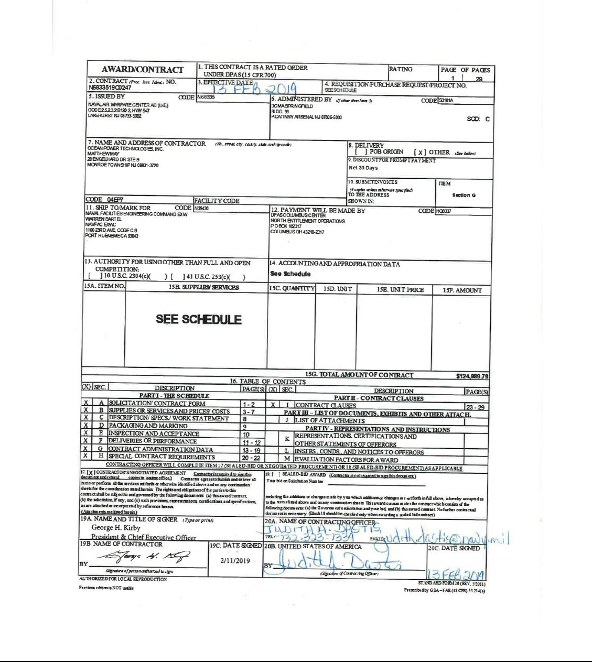

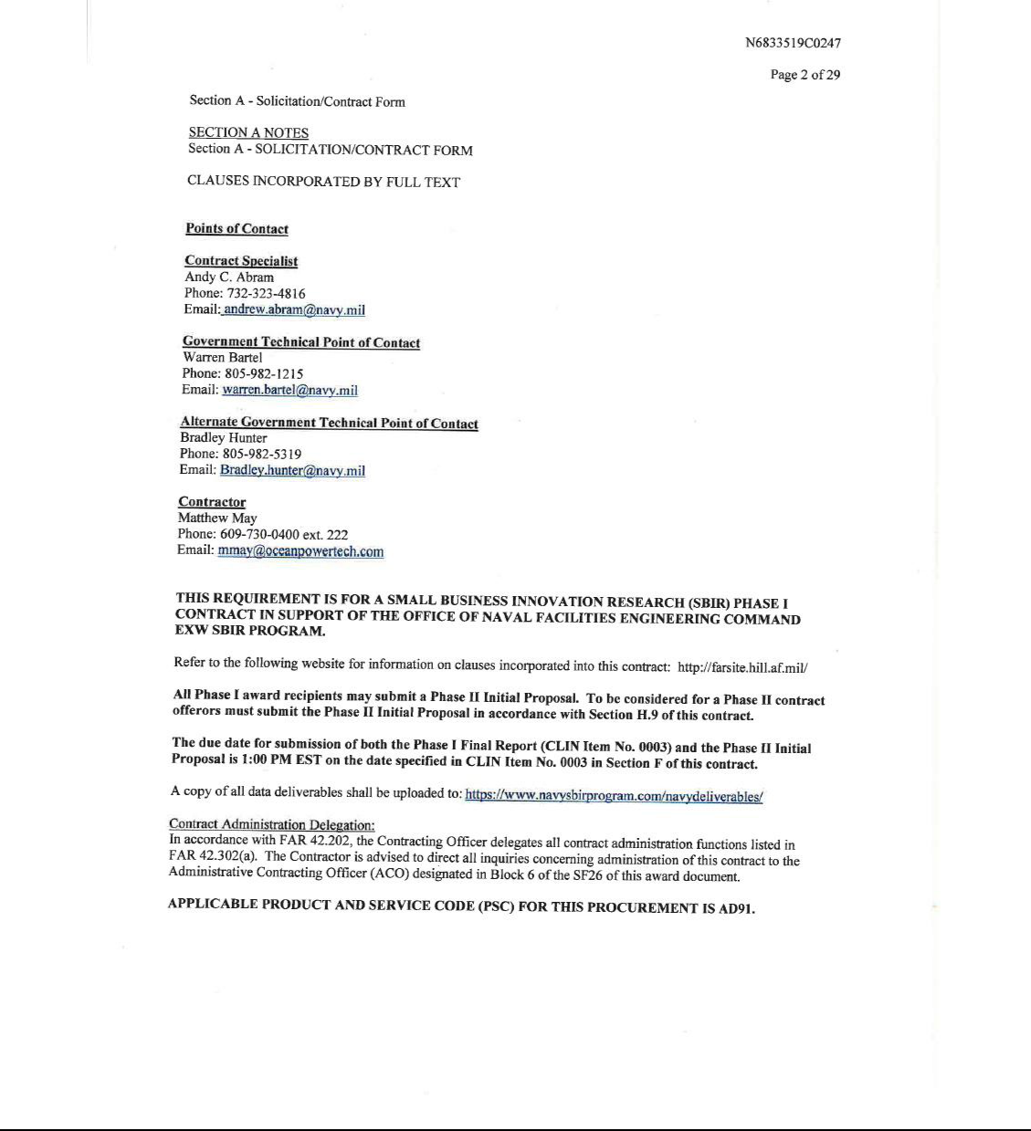

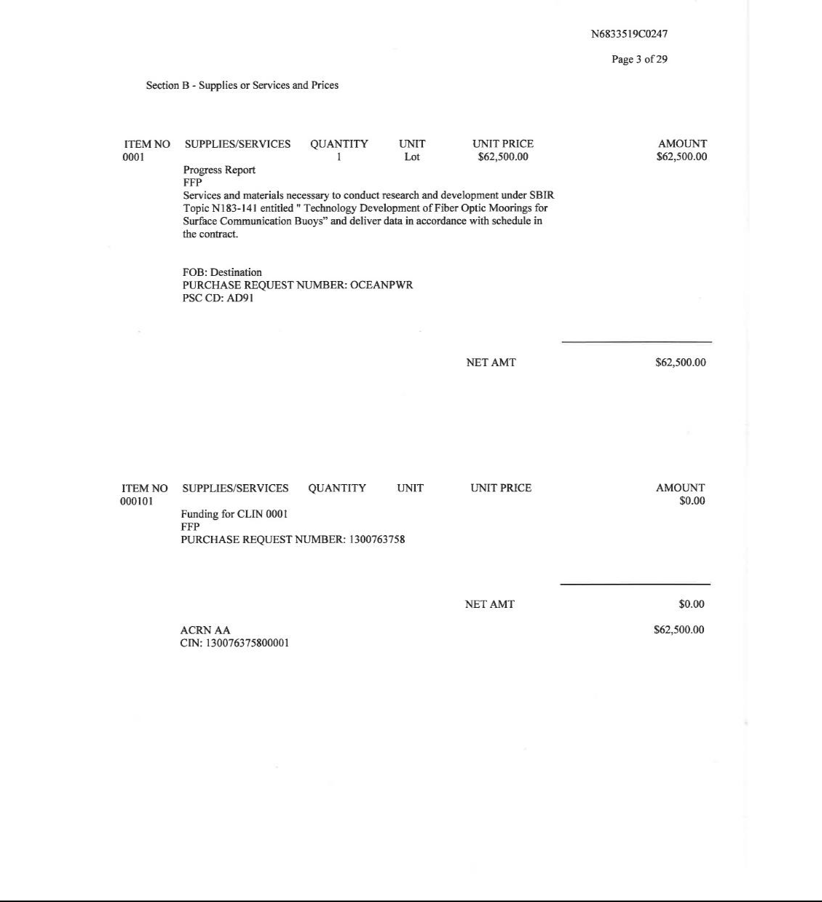

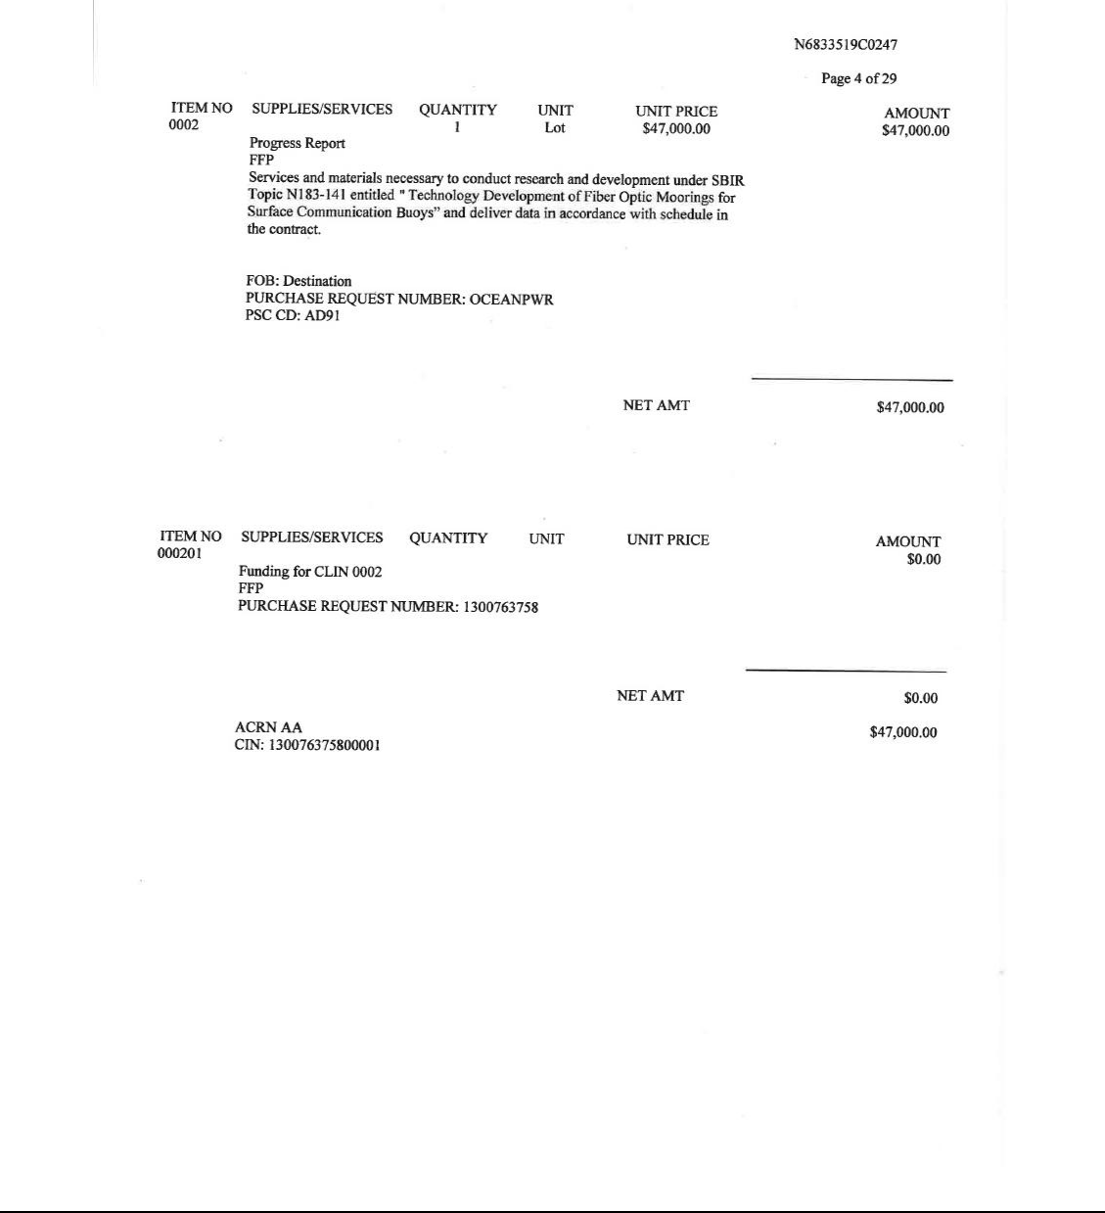

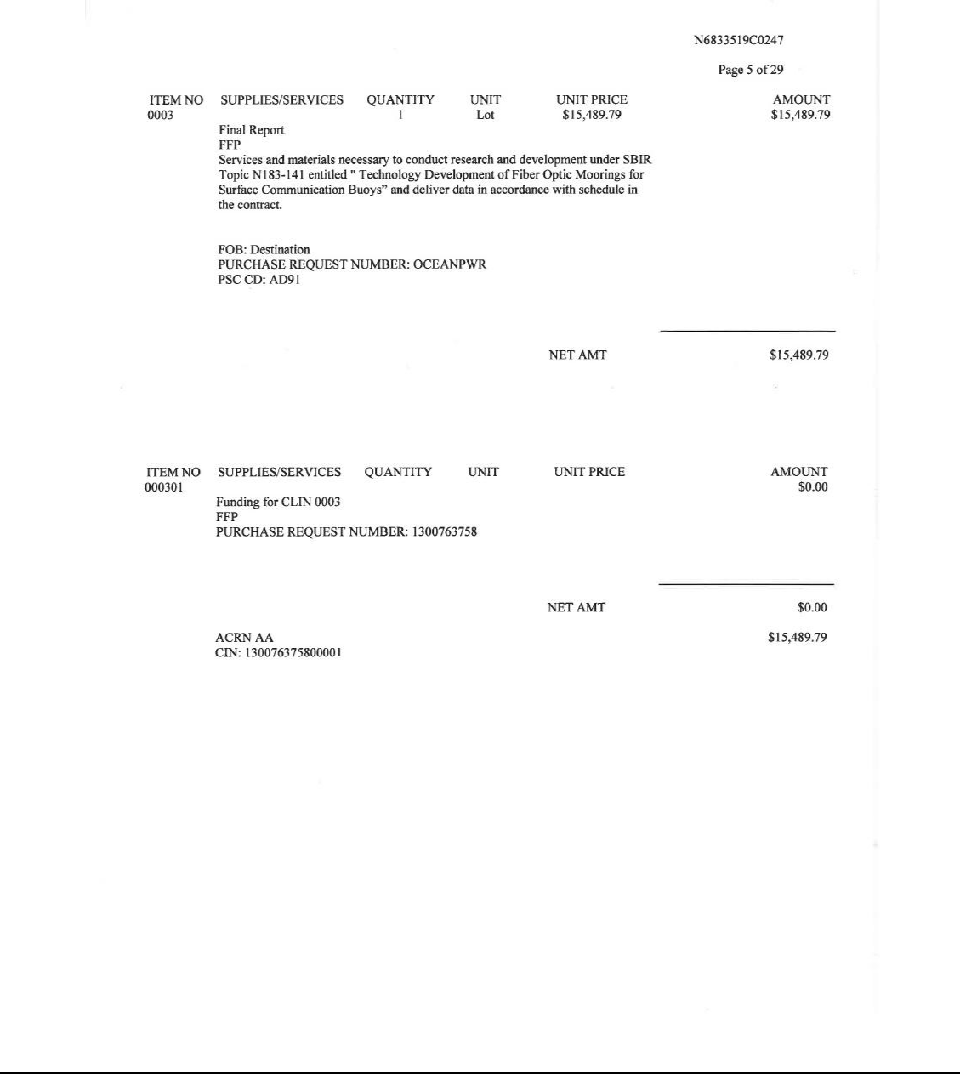

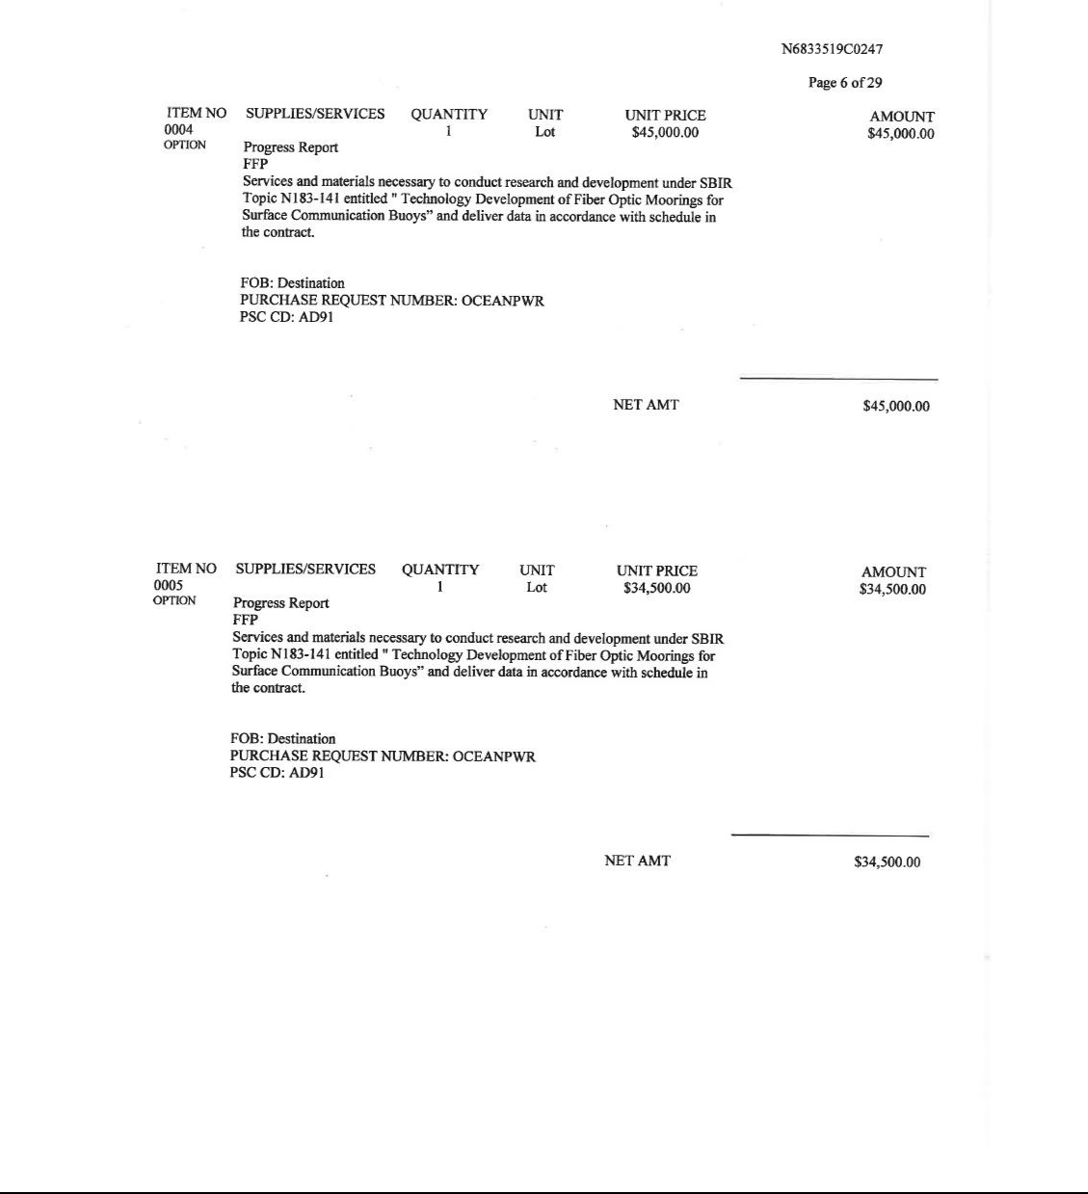

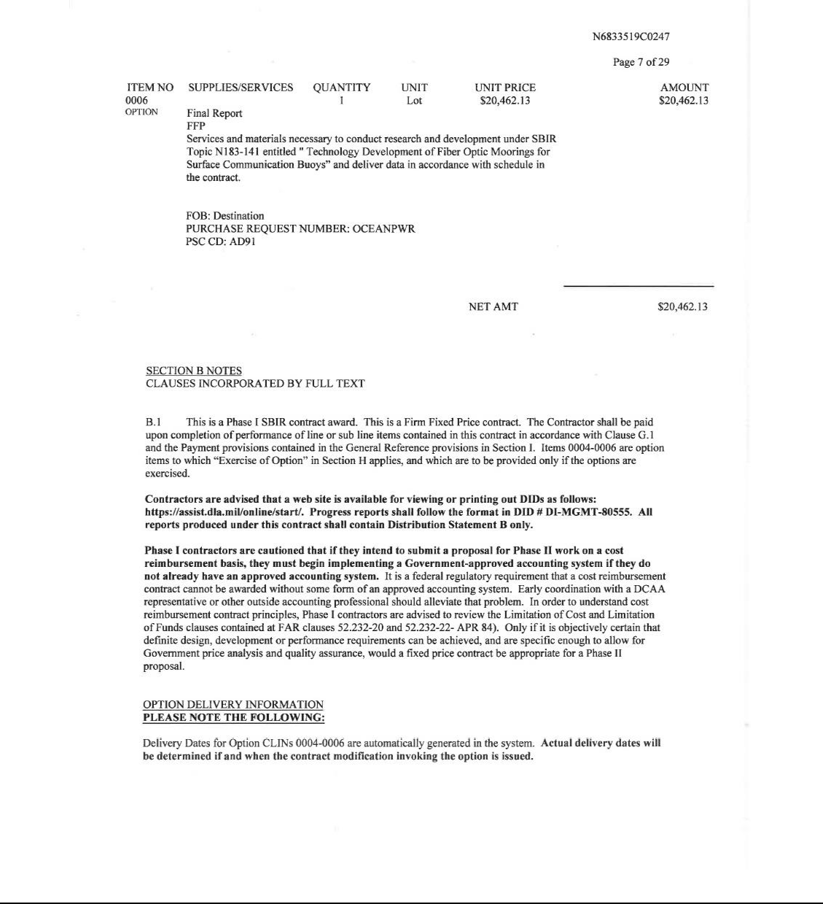

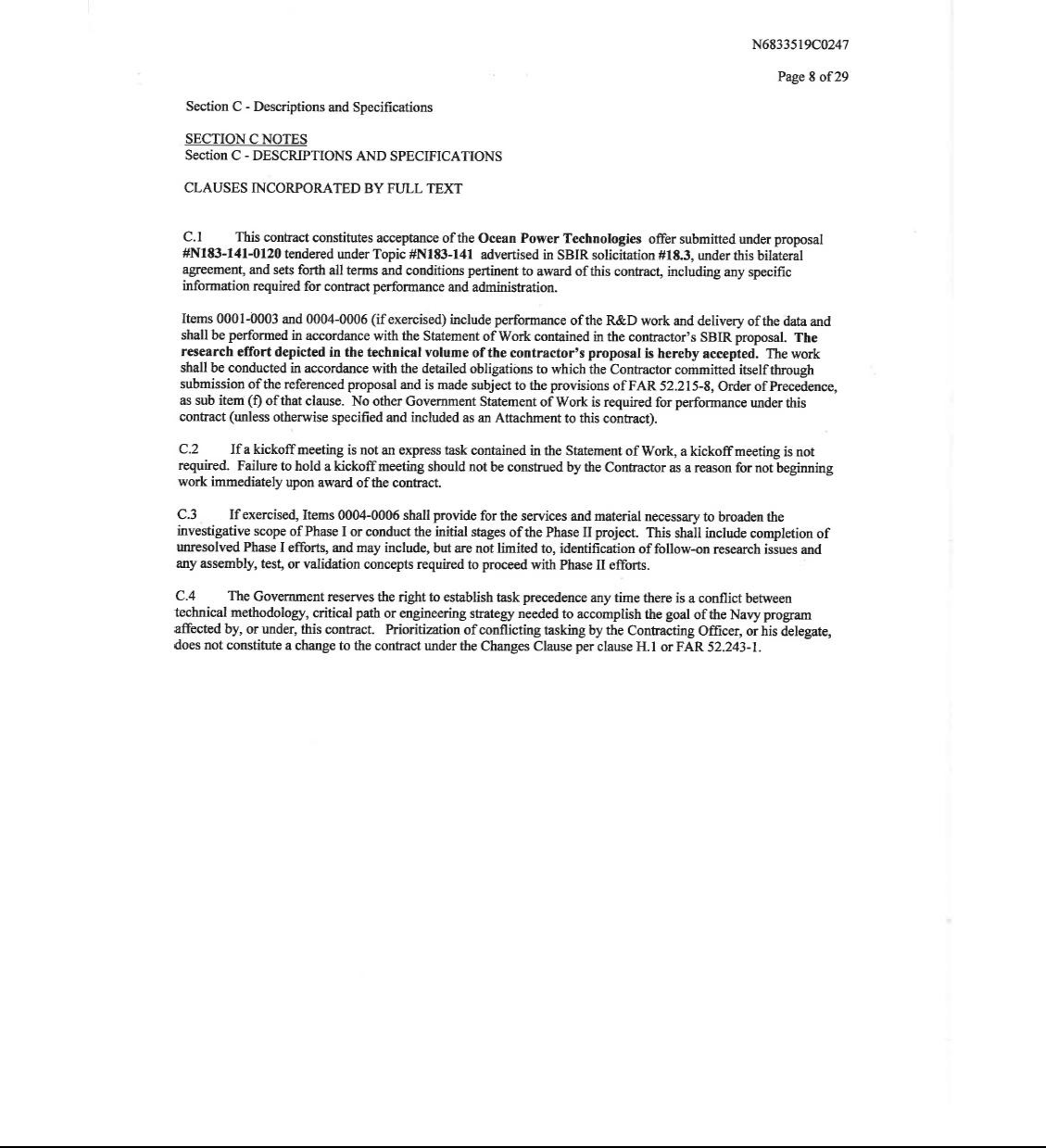

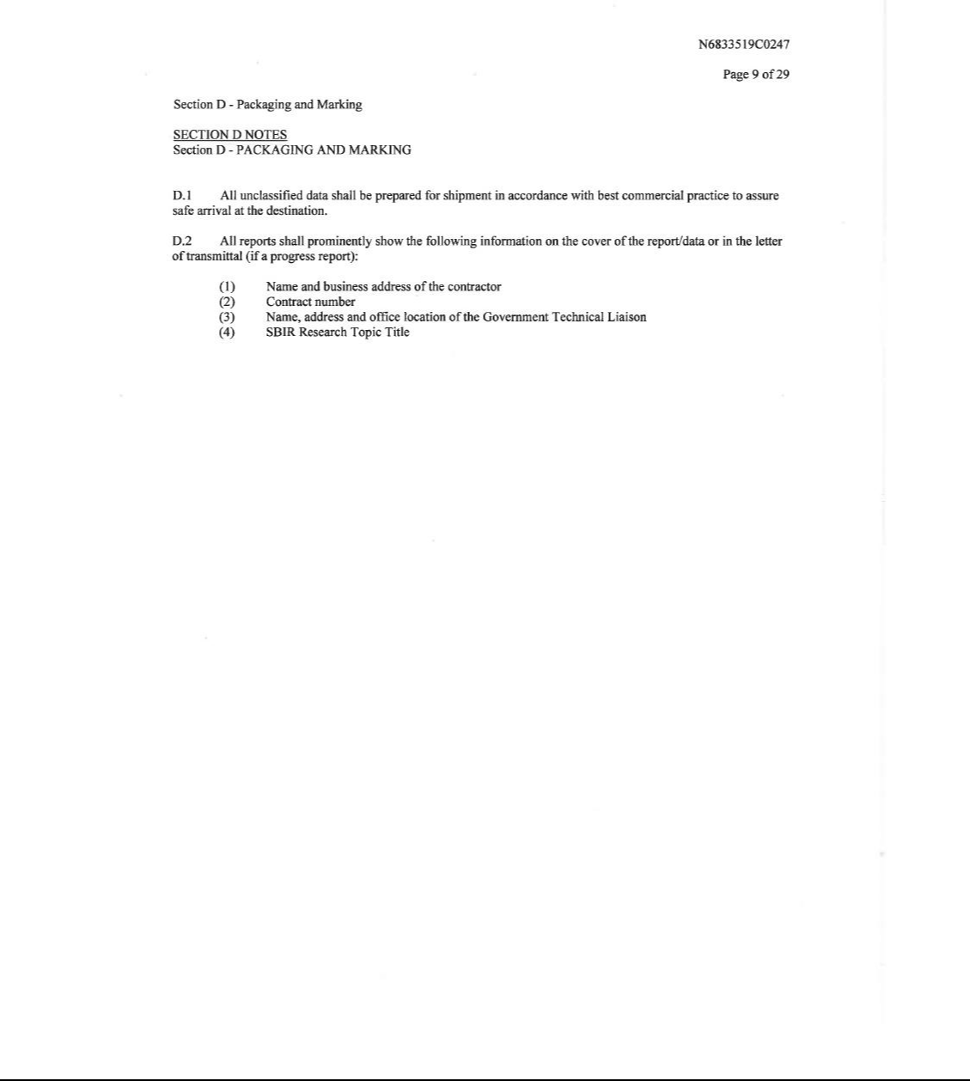

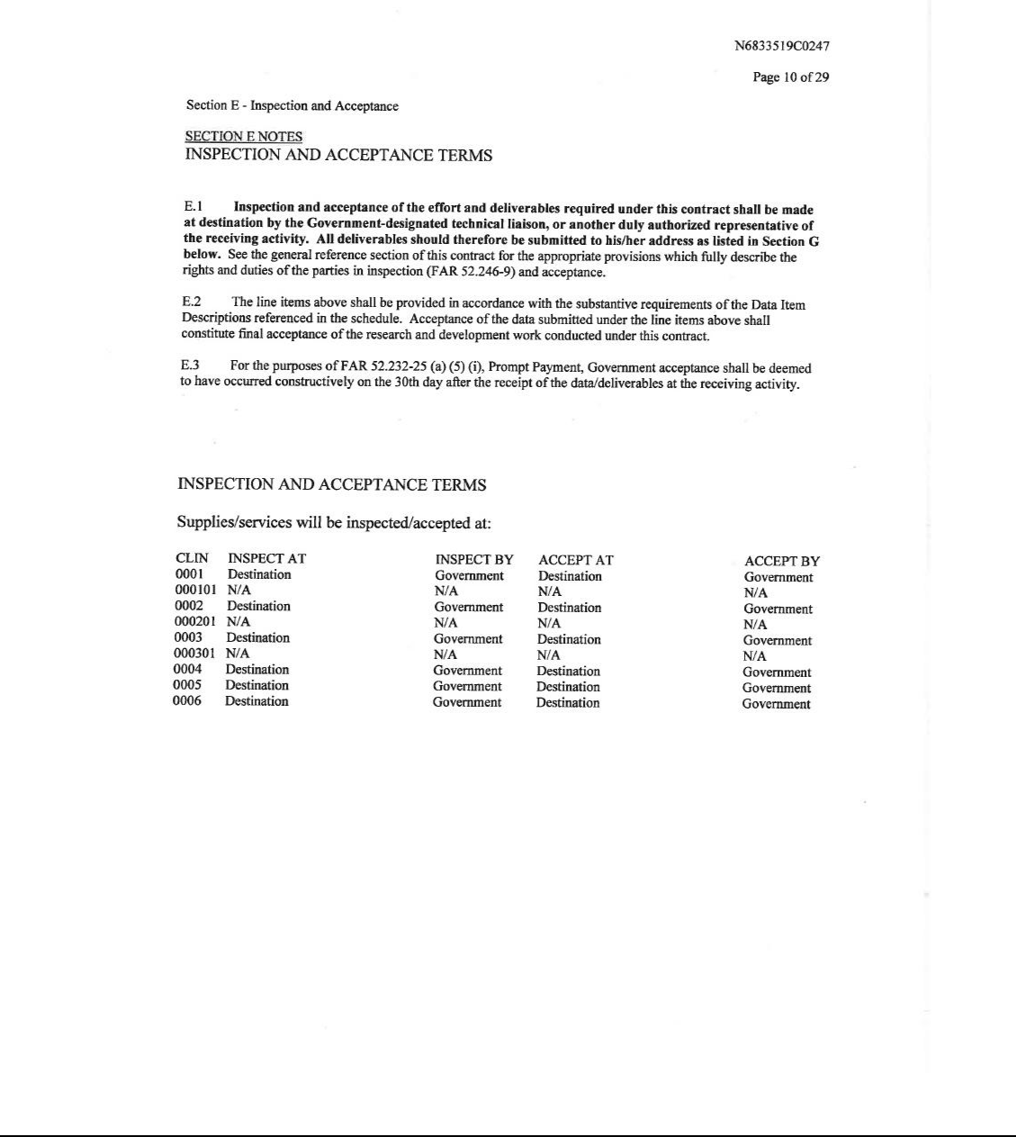

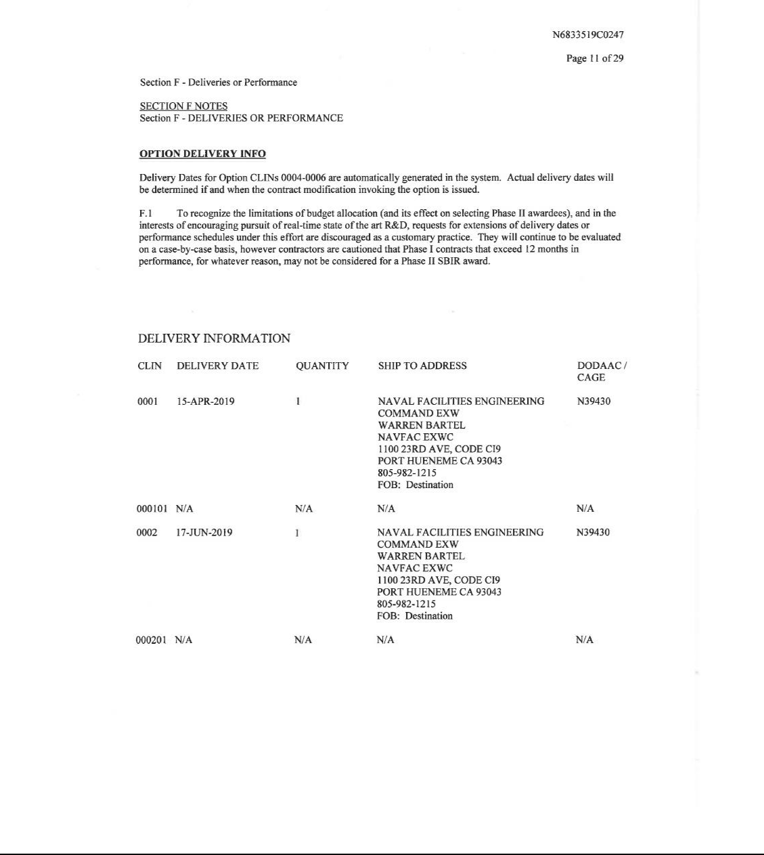

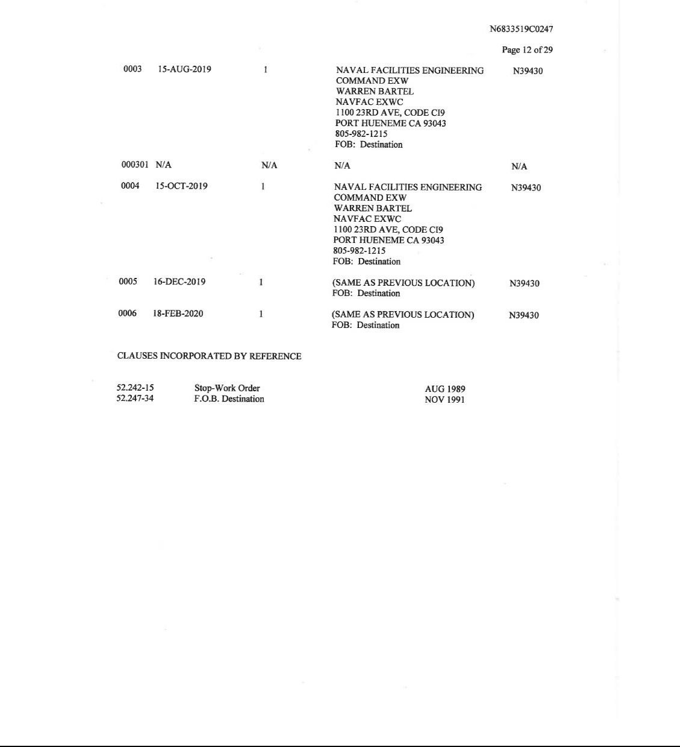

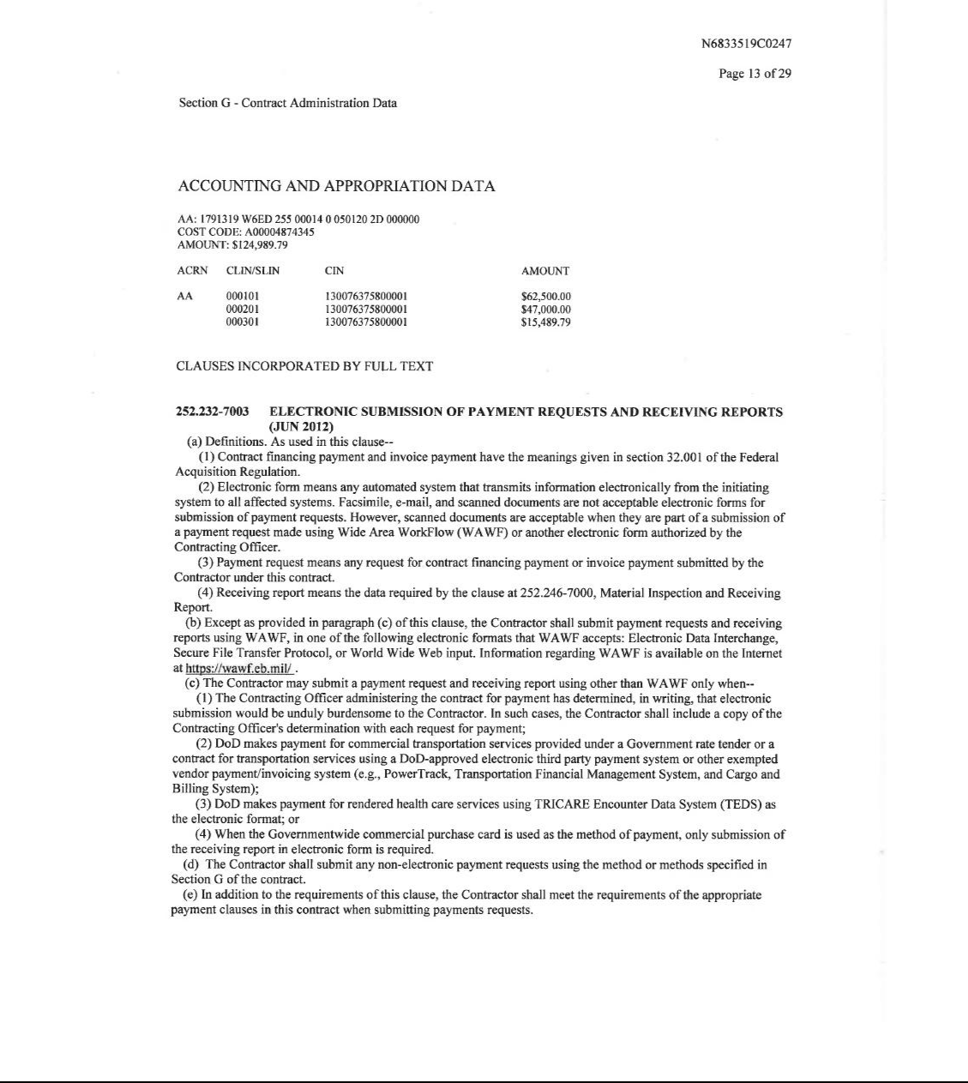

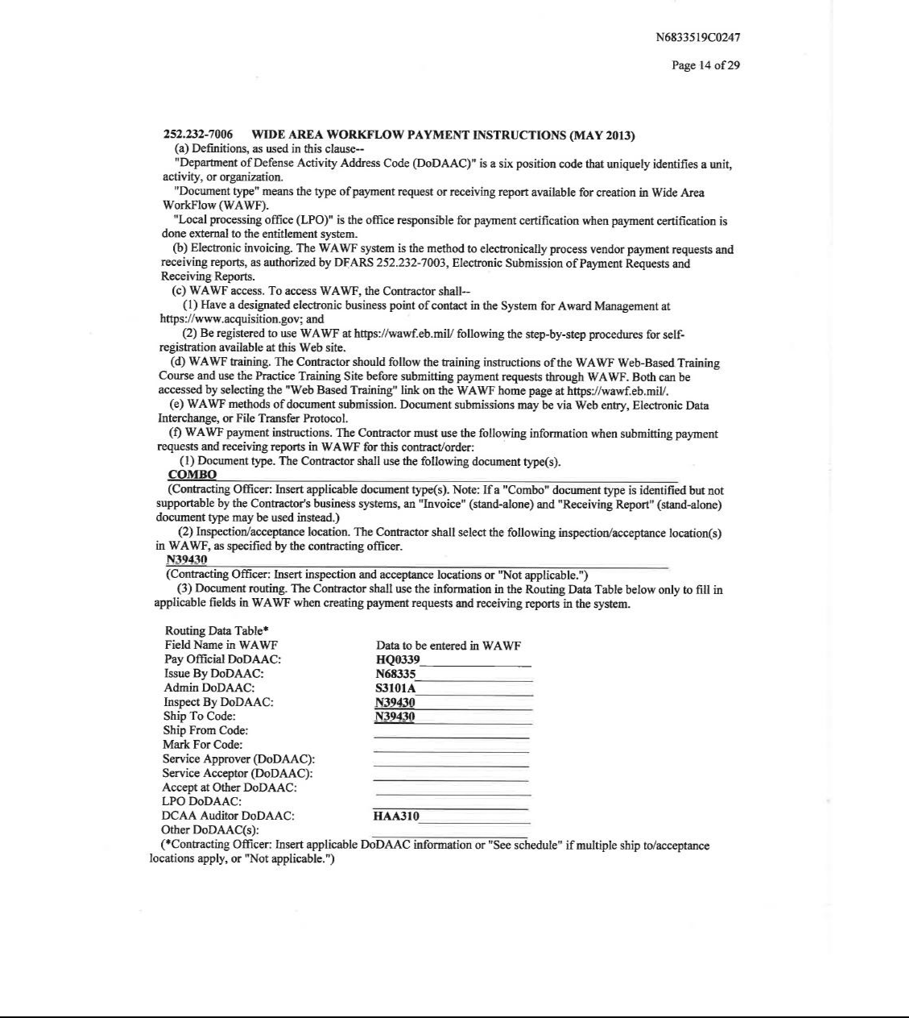

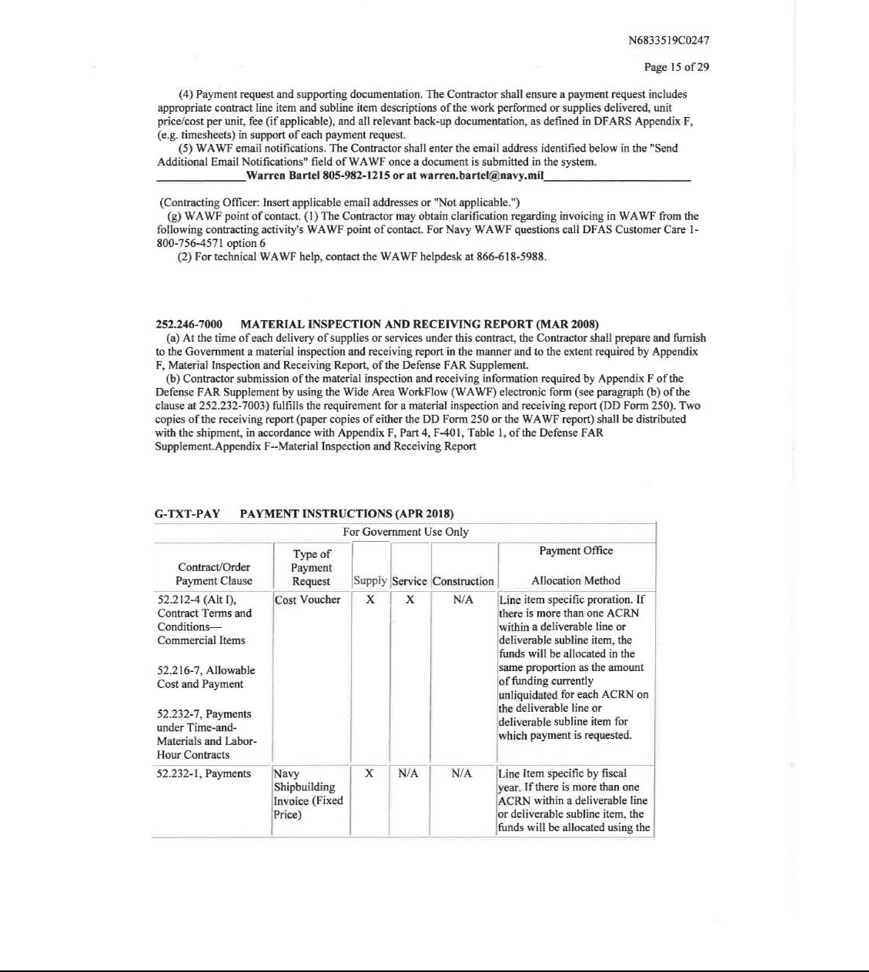

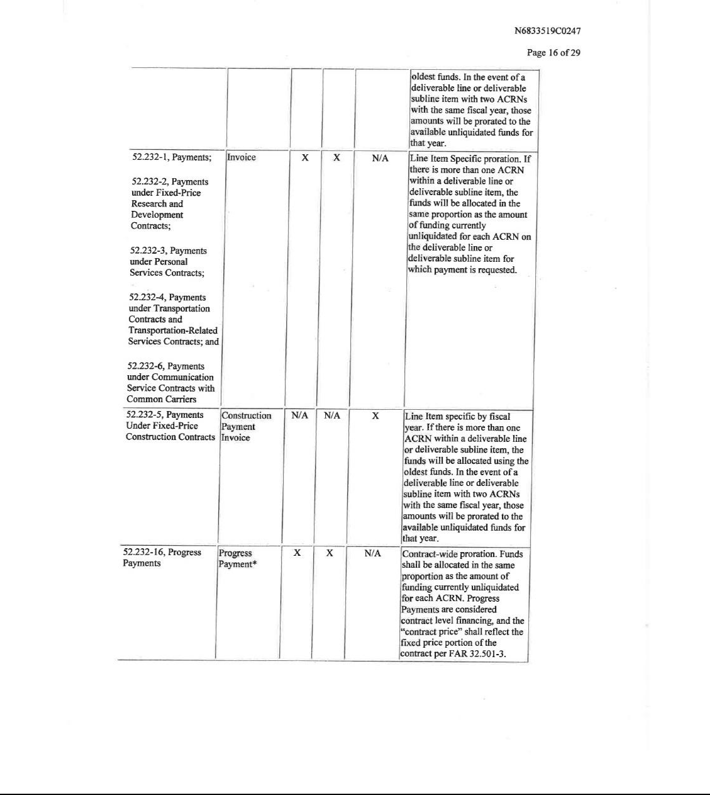

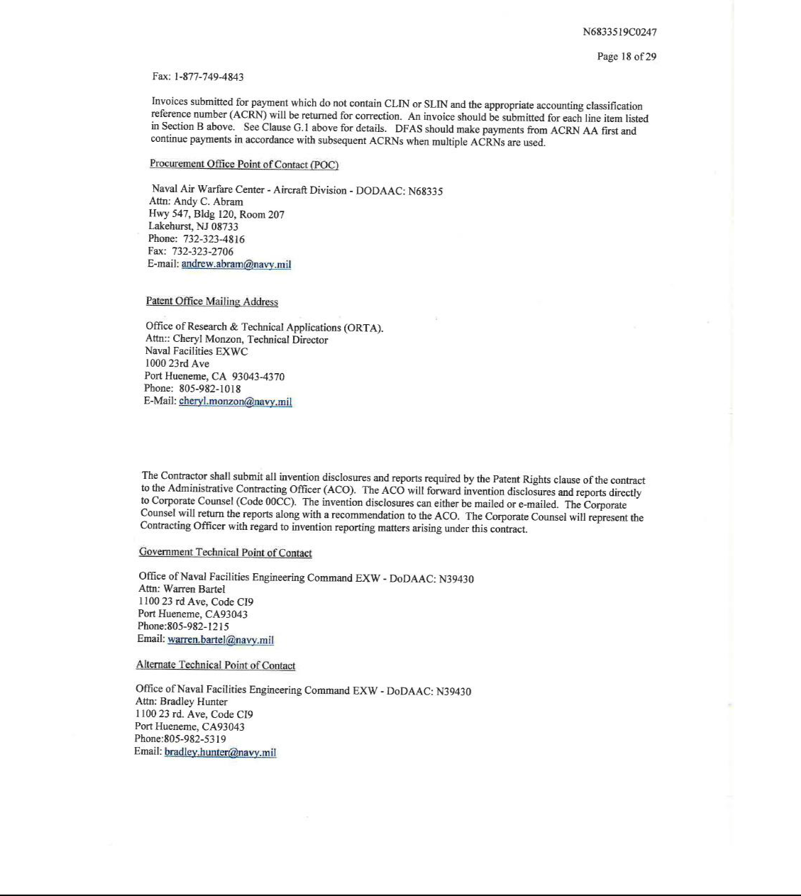

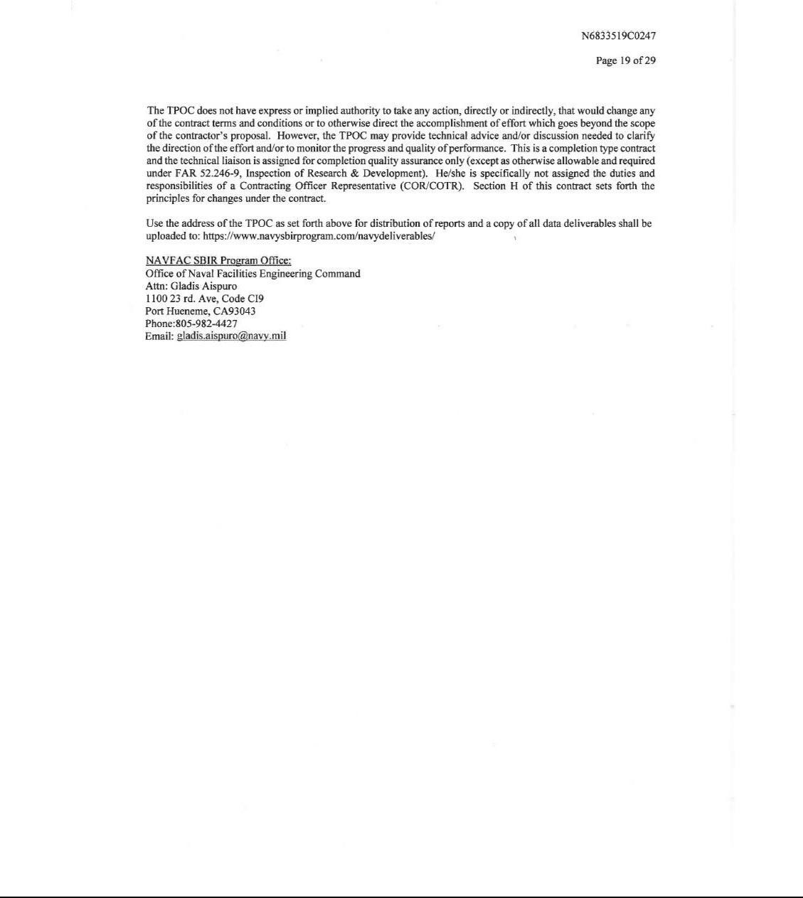

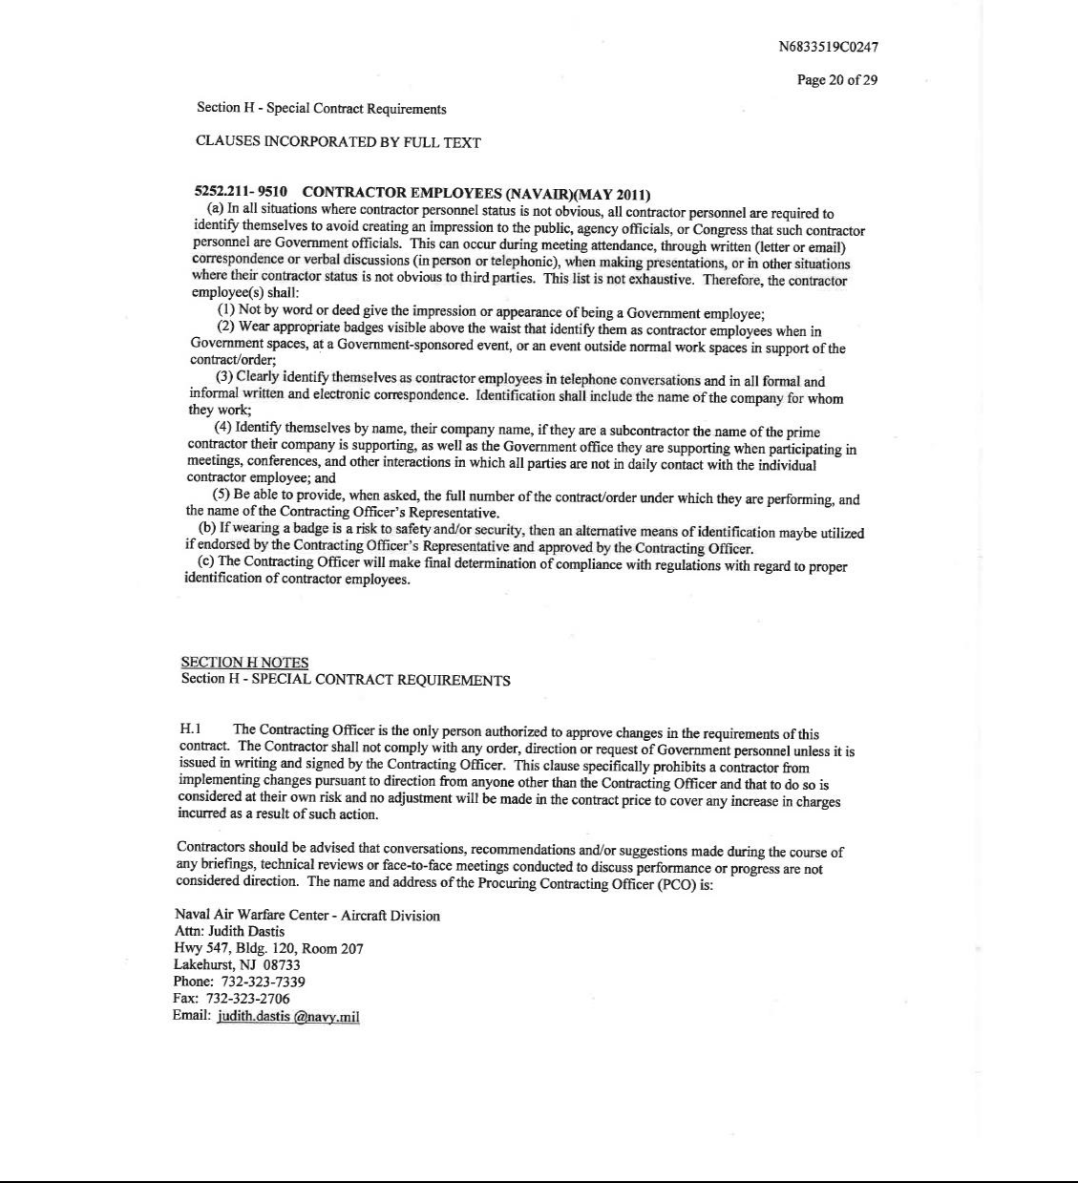

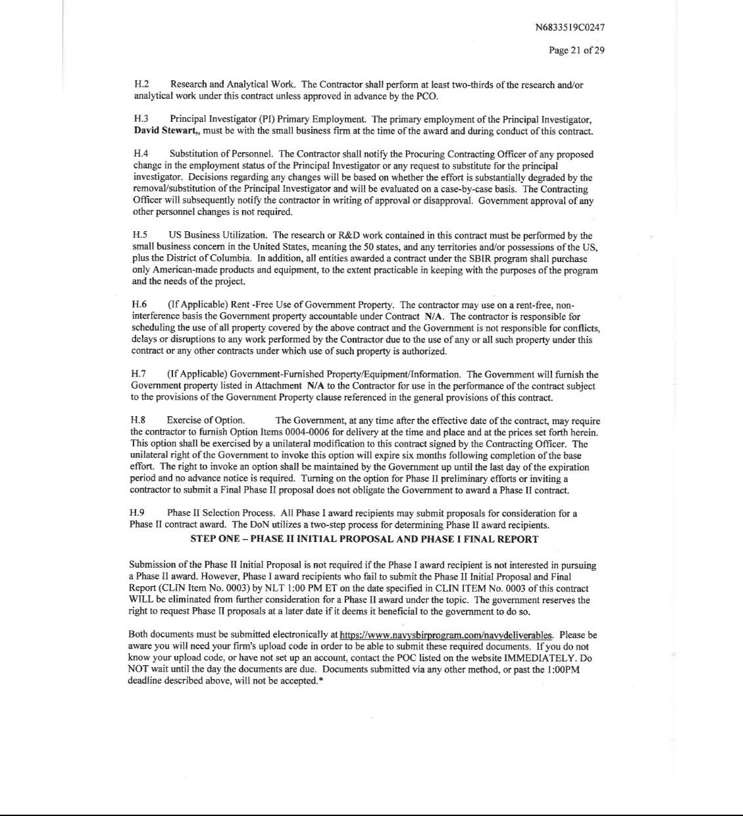

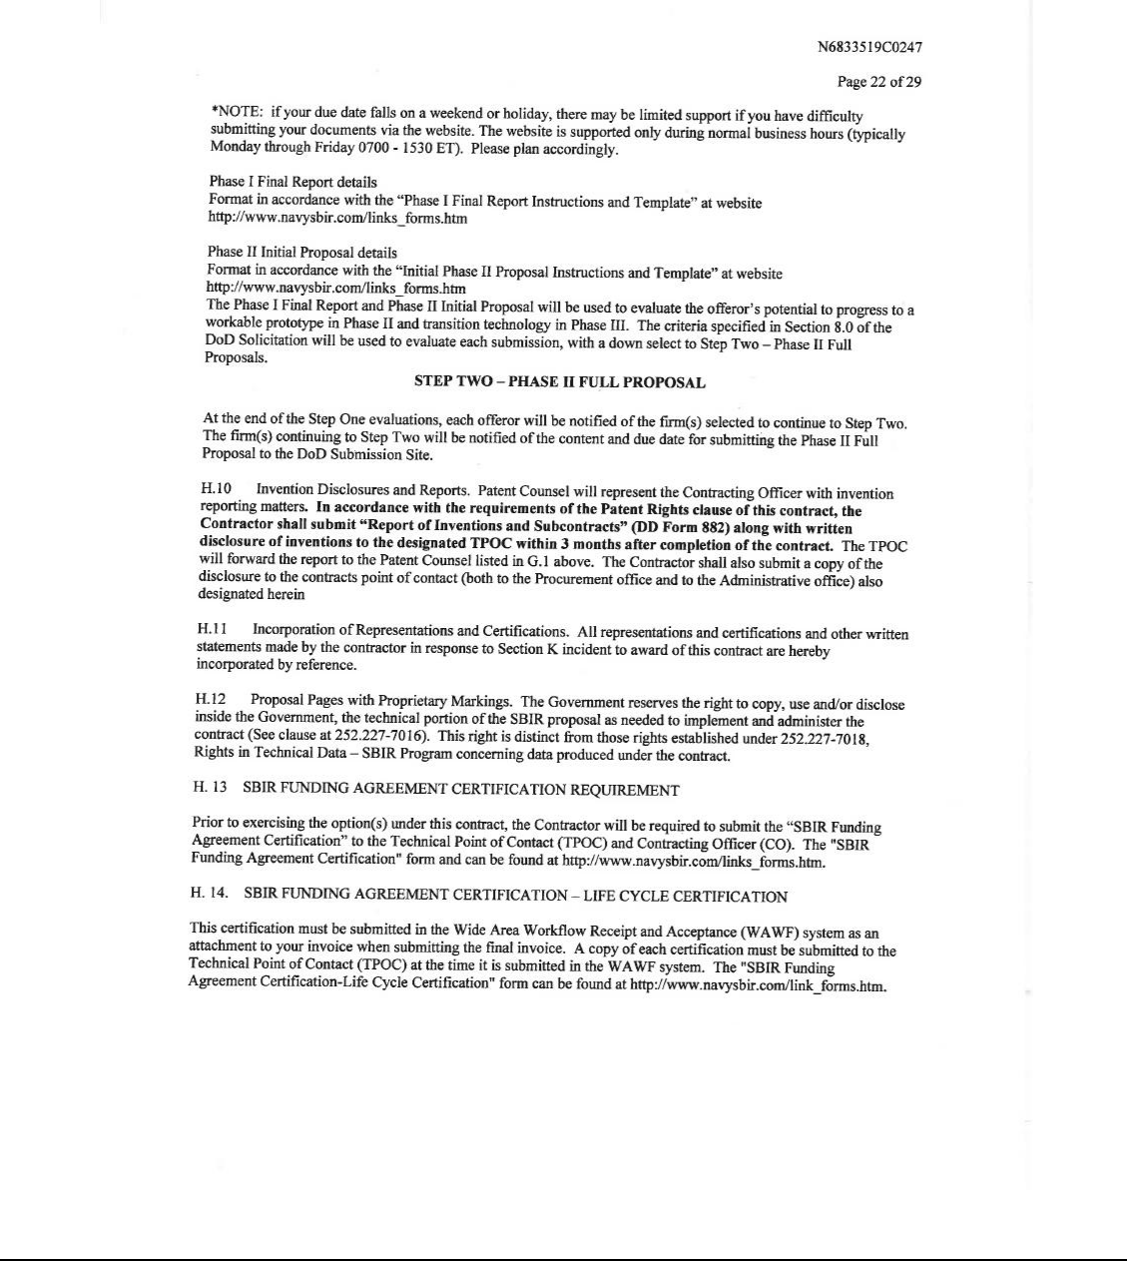

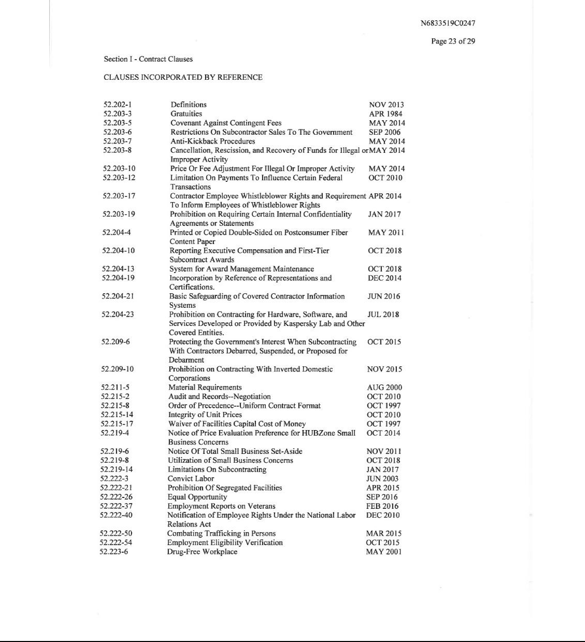

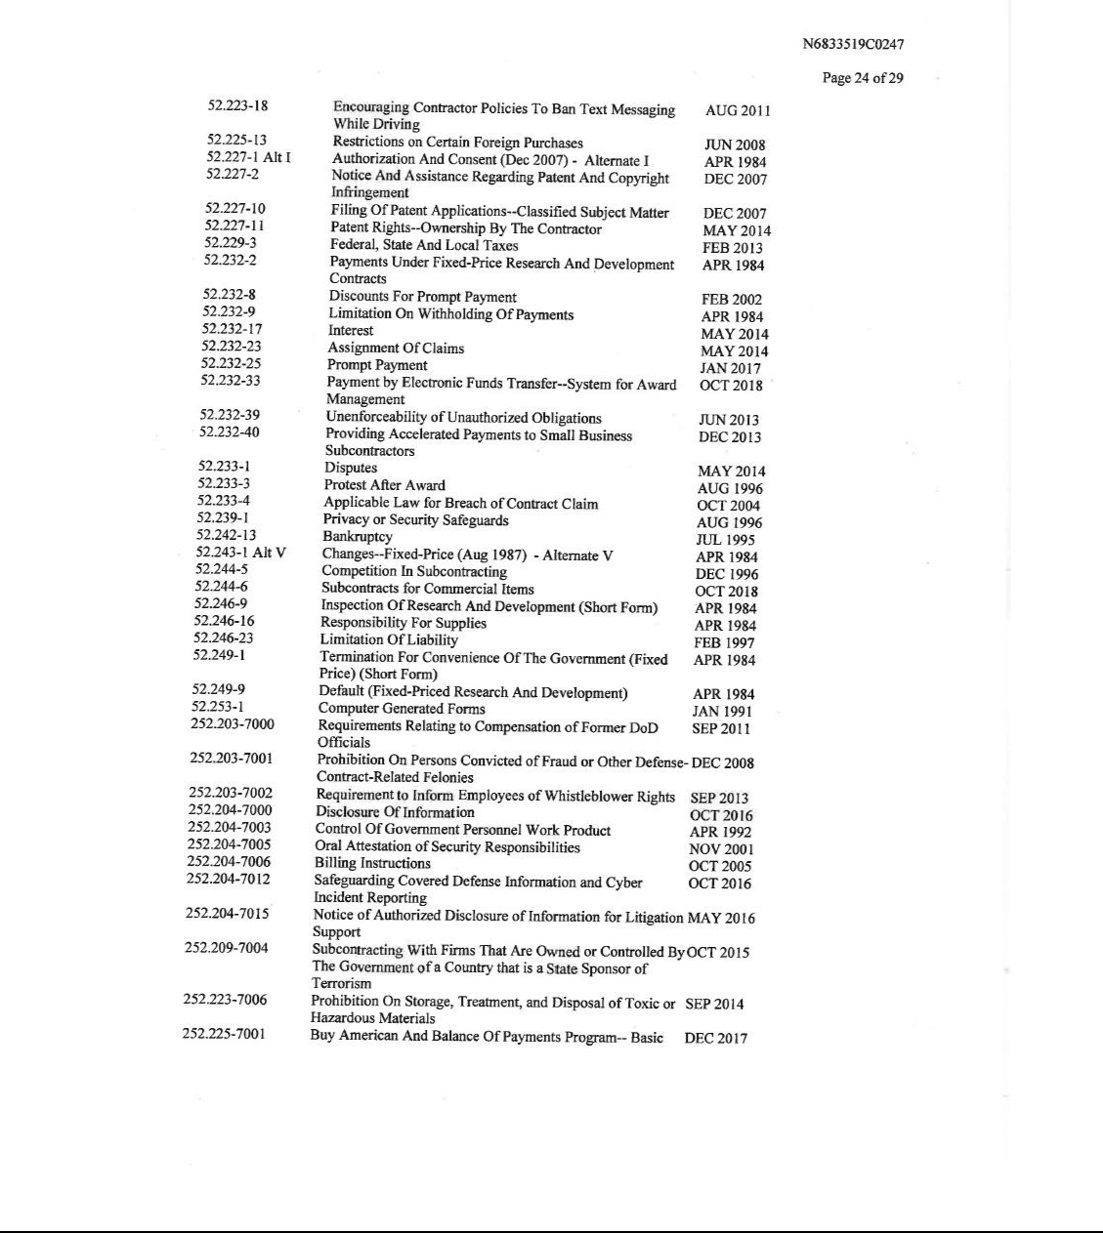

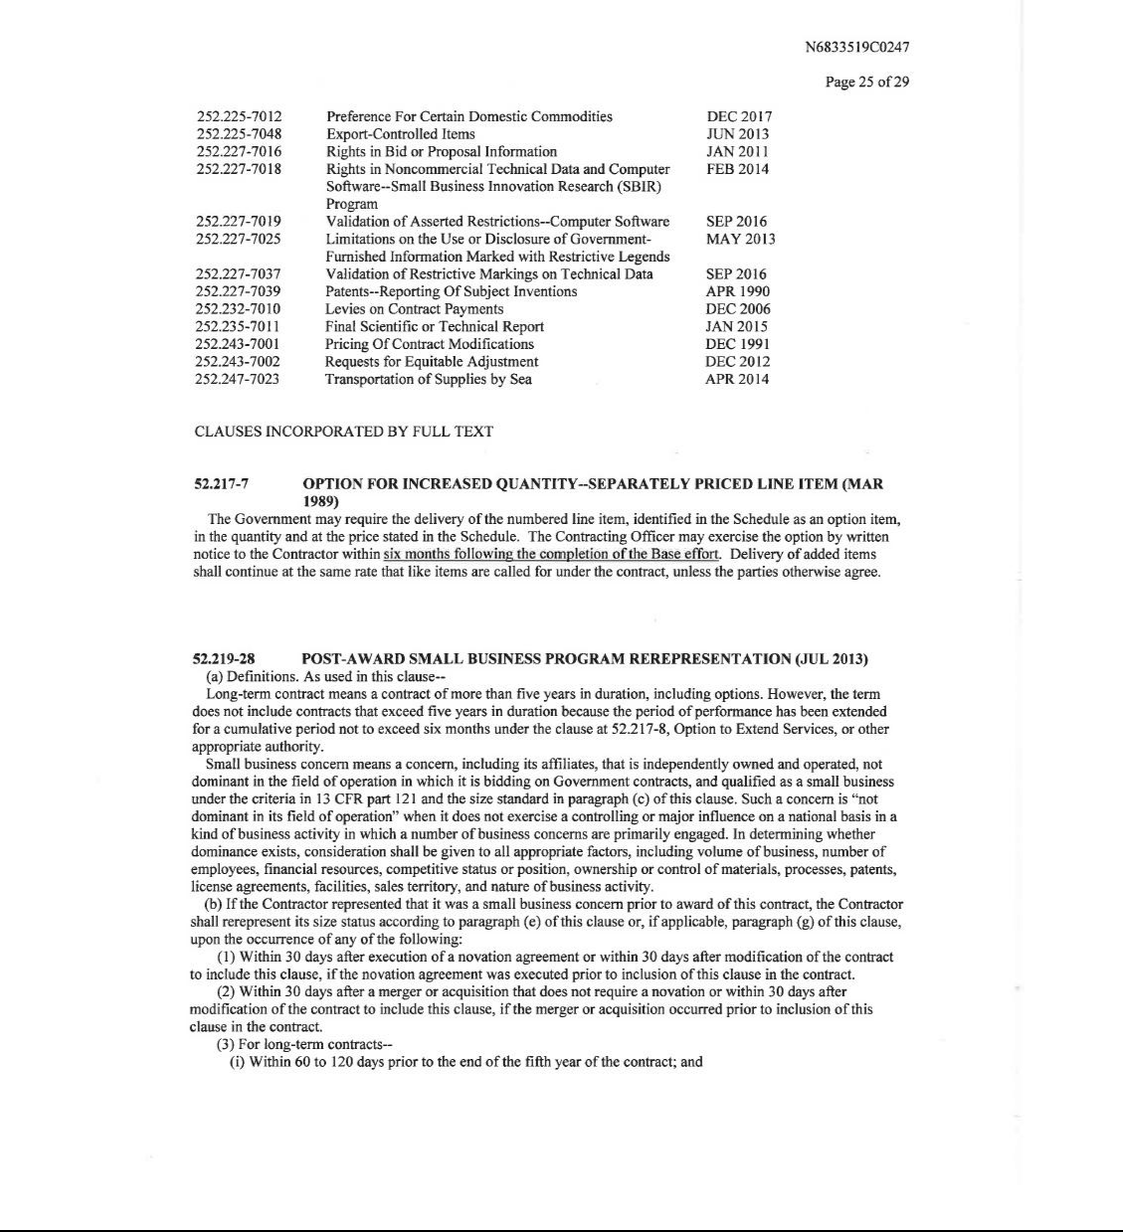

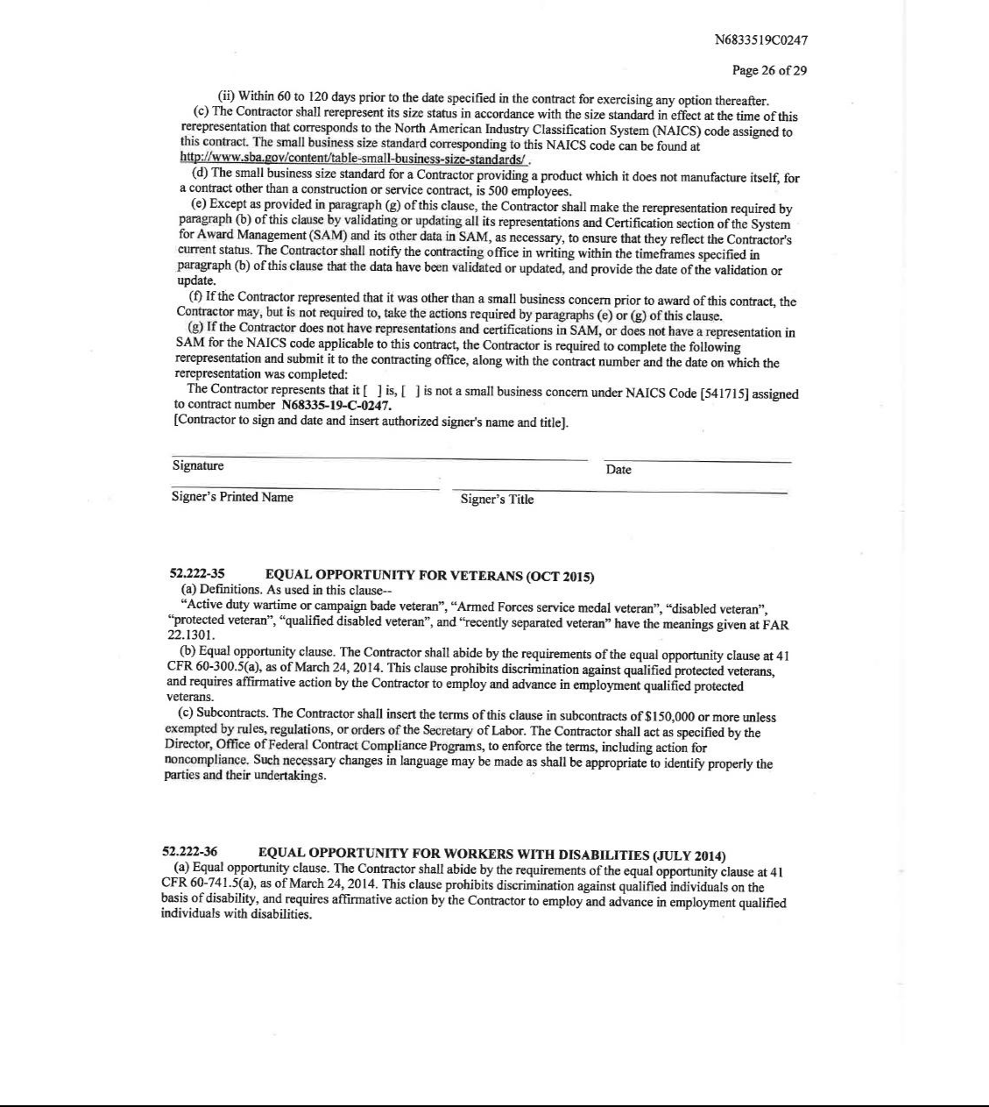

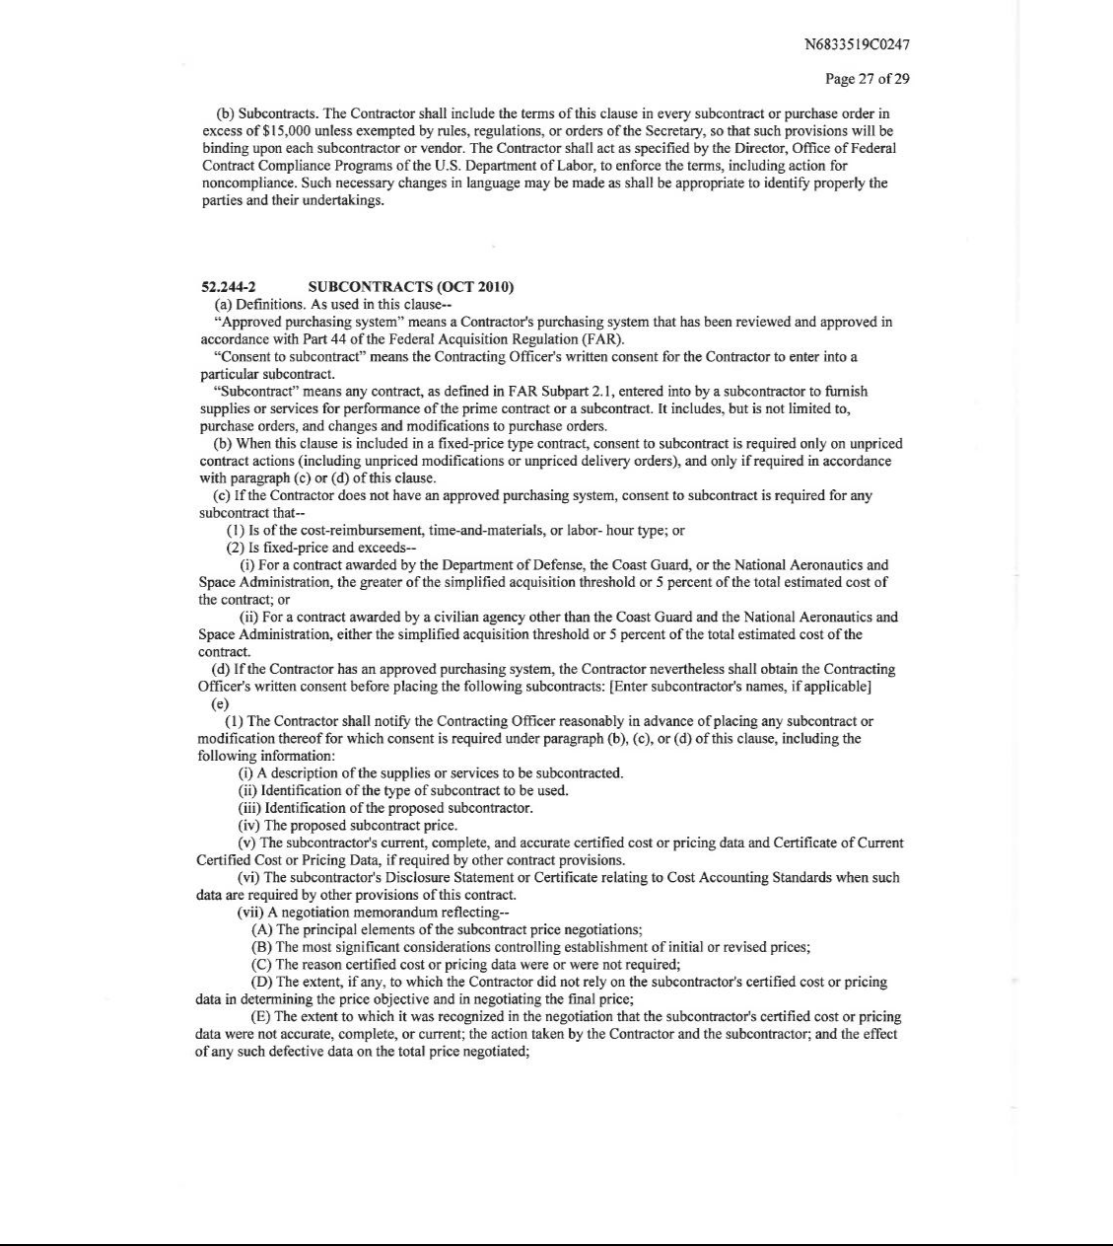

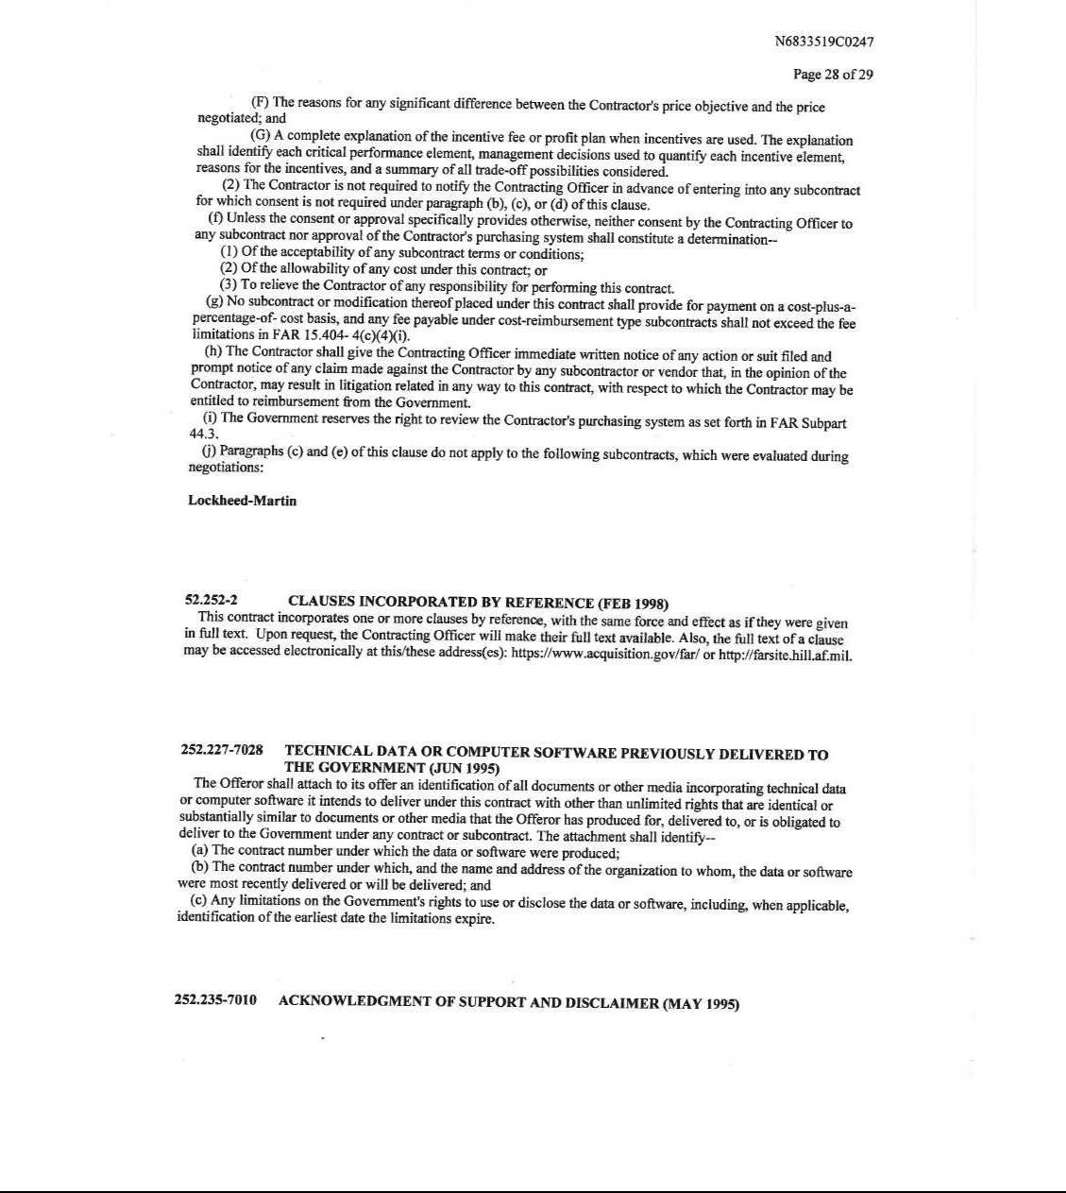

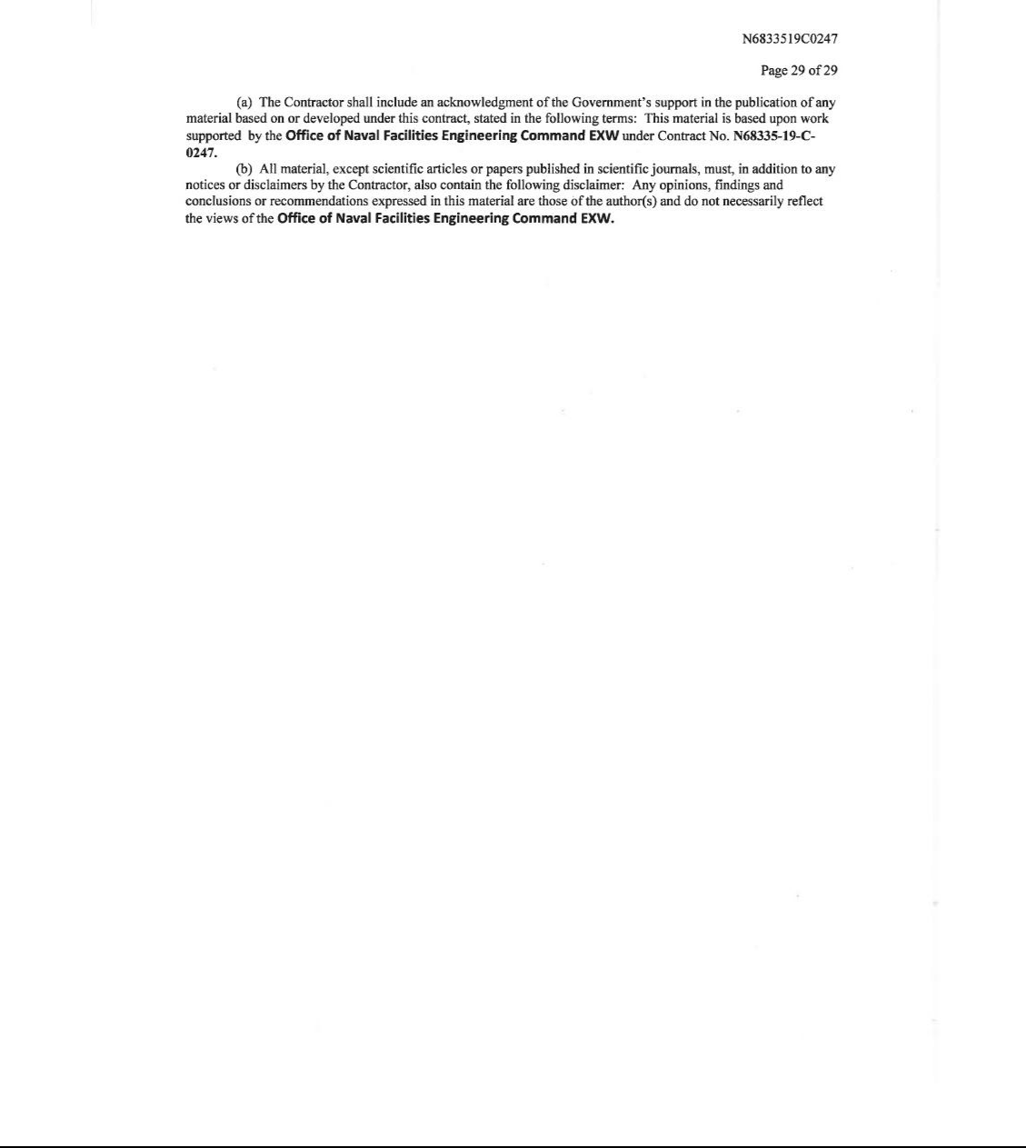

Exhibit 31.1

CERTIFICATION PURSUANT TO SECTION 302 OF SARBANES-OXLEY ACT

I, George H. Kirby III, certify that:

- I have reviewed this Quarterly Report on Form 10-Q of Ocean Power Technologies, Inc.;

- Based on my knowledge, this report does not contain any untrue statement of a material fact or omit to state a material fact necessary to make the statements made, in light of the circumstances under which such statements were made, not misleading with respect to the period covered by this report;

- Based on my knowledge, the financial statements, and other financial information included in this report, fairly present in all material respects the financial condition, results of operations and cash flows of the registrant as of, and for, the periods presented in this report;

- The registrant’s other certifying officers and I are responsible for establishing and maintaining disclosure controls and procedures (as defined in Exchange Act Rules 13a-15(e) and 15d-15(e)) and internal control over financial reporting (as defined in Exchange Act Rules 13a-15(f) and 15d-15(f)) for the registrant and have:

- Designed such disclosure controls and procedures, or caused such disclosure controls and procedures to be designed under our supervision, to ensure that material information relating to the registrant, including its consolidated subsidiaries, is made known to us by others within those entities, particularly during the period in which this report is being prepared;

- Designed such internal control over financial reporting, or caused such internal control over financial reporting to be designed under our supervision, to provide reasonable assurance regarding the reliability of financial reporting and the preparation of financial statements for external purposes in accordance with generally accepted accounting principles;

- Evaluated the effectiveness of the registrant’s disclosure controls and procedures and presented in this report our conclusions about the effectiveness of the disclosure controls and procedures, as of the end of the period covered by this report based on such evaluation; and

- Disclosed in this report any change in the registrant’s internal control over financial reporting that occurred during the registrant’s most recent fiscal quarter (the registrant’s fourth fiscal quarter in the case of an annual report) that has materially affected, or is reasonably likely to materially affect, the registrant’s internal control over financial reporting; and

- The registrant’s other certifying officer and I have disclosed, based on our most recent evaluation of internal control over financial reporting, to the registrant’s auditors and the audit committee of the registrant’s board of directors (or other persons performing the equivalent functions):

- All significant deficiencies and material weaknesses in the design or operation of internal control over financial reporting which are reasonably likely to adversely affect the registrant’s ability to record, process, summarize and report financial information; and

- Any fraud, whether or not material, that involves management or other employees who have a significant role in the registrant’s internal control over financial reporting.

Date: March 11, 2019

/s/ George H. Kirby III

George H. Kirby III

President and Chief Executive Officer

Exhibit 31.2

CERTIFICATION PURSUANT TO SECTION 302 OF SARBANES-OXLEY ACT

I, Matthew T. Shafer, certify that:

- I have reviewed this Quarterly Report on Form 10-Q of Ocean Power Technologies, Inc.;

- Based on my knowledge, this report does not contain any untrue statement of a material fact or omit to state a material fact necessary to make the statements made, in light of the circumstances under which such statements were made, not misleading with respect to the period covered by this report;

- Based on my knowledge, the financial statements, and other financial information included in this report, fairly present in all material respects the financial condition, results of operations and cash flows of the registrant as of, and for, the periods presented in this report;

- The registrant’s other certifying officers and I are responsible for establishing and maintaining disclosure controls and procedures (as defined in Exchange Act Rules 13a-15(e) and 15d-15(e)) and internal control over financial reporting (as defined in Exchange Act Rules 13a-15(f) and 15d-15(f)) for the registrant and have:

- Designed such disclosure controls and procedures, or caused such disclosure controls and procedures to be designed under our supervision, to ensure that material information relating to the registrant, including its consolidated subsidiaries, is made known to us by others within those entities, particularly during the period in which this report is being prepared;

- Designed such internal control over financial reporting, or caused such internal control over financial reporting to be designed under our supervision, to provide reasonable assurance regarding the reliability of financial reporting and the preparation of financial statements for external purposes in accordance with generally accepted accounting principles;

- Evaluated the effectiveness of the registrant’s disclosure controls and procedures and presented in this report our conclusions about the effectiveness of the disclosure controls and procedures, as of the end of the period covered by this report based on such evaluation; and

- Disclosed in this report any change in the registrant’s internal control over financial reporting that occurred during the registrant’s most recent fiscal quarter (the registrant’s fourth fiscal quarter in the case of an annual report) that has materially affected, or is reasonably likely to materially affect, the registrant’s internal control over financial reporting; and

- The registrant’s other certifying officer and I have disclosed, based on our most recent evaluation of internal control over financial reporting, to the registrant’s auditors and the audit committee of the registrant’s board of directors (or other persons performing the equivalent functions):

- All significant deficiencies and material weaknesses in the design or operation of internal control over financial reporting which are reasonably likely to adversely affect the registrant’s ability to record, process, summarize and report financial information; and

- Any fraud, whether or not material, that involves management or other employees who have a significant role in the registrant’s internal control over financial reporting.

Date: March 11, 2019

/s/ Matthew T. Shafer

Matthew T. Shafer

Chief Financial Officer

Exhibit 32.1

CERTIFICATION PURSUANT TO 18 U.S.C. SECTION 1350,

AS ADOPTED PURSUANT TO

SECTION 906 OF THE SARBANES-OXLEY ACT OF 2002

In connection with the Quarterly Report on Form 10-Q of Ocean Power Technologies, Inc. (the “Company”) for the period ended January 31, 2019, as filed with the Securities and Exchange Commission on the date hereof (the “Report”), the undersigned, George H. Kirby III, Chief Executive Officer of the Company, hereby certifies, pursuant to 18 U.S.C. Section 1350, as adopted pursuant to Section 906 of the Sarbanes-Oxley Act of 2002, that, to the best of my knowledge:

- The Report fully complies with the requirements of Section 13(a) or 15(d) of the Securities Exchange Act of 1934, as amended; and

- The information contained in the Report fairly presents, in all material respects, the financial condition and results of operations of the Company. Date: March 11, 2019
/s/ George H. Kirby III

George H. Kirby III

President and Chief Executive Officer

A signed original of this written statement required by Section 906 of the Sarbanes-Oxley Act of 2002 has been provided to the Company and will be retained by the Company and furnished to the Securities and Exchange Commission or its staff upon request.

Exhibit 32.2

CERTIFICATION PURSUANT TO 18 U.S.C. SECTION 1350,

AS ADOPTED PURSUANT TO

SECTION 906 OF THE SARBANES-OXLEY ACT OF 2002

In connection with the Quarterly Report on Form 10-Q of Ocean Power Technologies, Inc. (the “Company”) for the period ended January 31, 2019, as filed with the Securities and Exchange Commission on the date hereof (the “Report”), the undersigned, Matthew T. Shafer, Chief Financial Officer of the Company, hereby certifies, pursuant to 18 U.S.C. Section 1350, as adopted pursuant to Section 906 of the Sarbanes-Oxley Act of 2002, that, to the best of my knowledge:

- The Report fully complies with the requirements of Section 13(a) or 15(d) of the Securities Exchange Act of 1934, as amended; and

- The information contained in the Report fairly presents, in all material respects, the financial condition and results of operations of the Company. Date: March 11, 2019
/s/ Matthew T. Shafer

Matthew T. Shafer

Chief Financial Officer

A signed original of this written statement required by Section 906 of the Sarbanes-Oxley Act of 2002 has been provided to the Company and will be retained by the Company and furnished to the Securities and Exchange Commission or its staff upon request.

